Kennedy High School
Advisor: Barry Wilson
4545 Wenig Rd. NE, Cedar Rapids, IA, 52402
319-784-7697
bwilson@cr.k12.ia.us
Jamie Voorhees, Grade 12, Driver/Crew Chief
John Tedesco, Grade 10, Crew Chief
Molly Sullivan, Grade 12, Documentation Writer
S30 Car: March 29th – April 25th, 2018
The 30 team put in many hour this month. The car had a lot of work that needed to be done prior to attending our first race, so Jamie spent over 30 hours a week in the shop to get her car ready for West Point. Although this race ended up getting cancelled, the car was significantly closer to being finished. The two weeks before Stout were then used for any and all final touches to the car as well as some braking and handling practice. This hard work proved its worth after we attended our first race and did pretty well. Upon arriving home, minor tweaks have been made to the car such as cleaning wheel bearings, making new wheel covers, and cleaning out the car. There have not been many struggles this month, aside from hustling to finish the car. The rest of the season will be dedicated to racing and only fixing things as needed. We hope to bring home plenty of trophies again this year.

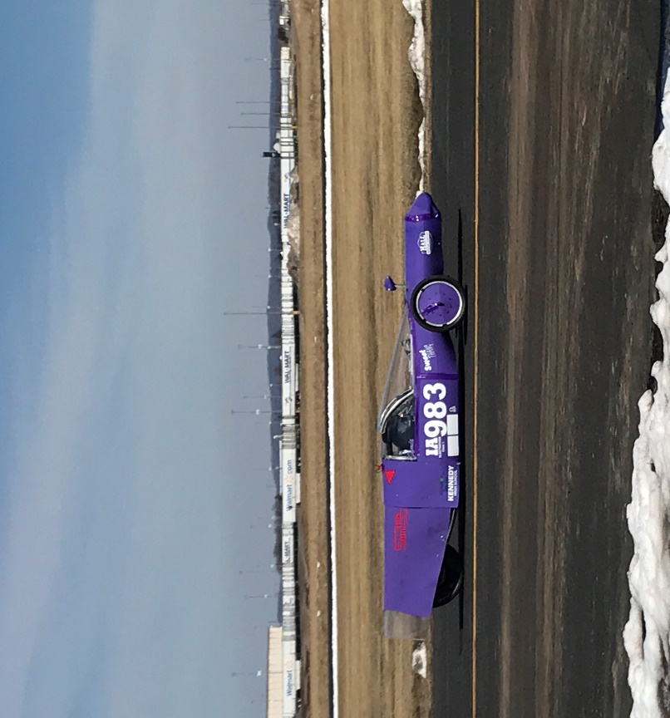
Kennedy High School
Advisor: Barry Wilson
4545 Wenig Rd. NE, Cedar Rapids, IA, 52402
319-784-7697
bwilson@cr.k12.ia.us
Derek Severson, Grade 11, Crew Chief
Molly Sullivan, Grade 12, Driver/Documentation Writer
A40 Car: March 29th – April 25th, 2018
There hasn’t been much to do this month with the 40 car. The car itself was ready to go, so all that really needed done was some testing and braking and handling practice. We were planning to get a feel for the car at West Point but instead had to make do with the parking lot. Over the weekend we traveled to Stout for a race and had some new experiences. Since braking and handling were scored at this event, we decided to practice beforehand. The teams got up and arrived at school by 6am Thursday morning and ran for about 45 minutes in the parking lot. During this, we learned that the initial angle on our axle was not what it needed to be, causing the steering to be stiff. Our project prior to attending our next race this upcoming weekend is to modify the axle so that the steering works better. Aside from this, we have not found any other problems and do not see any ahead (aside from time).

Kennedy High School
Advisor: Barry Wilson
4545 Wenig Rd. NE, Cedar Rapids, IA, 52402
319-784-7697
bwilson@cr.k12.ia.us
Natalie McAllister, Grade 12, Driver/Documentation Writer
Bryan Becker, Grade 10, Crew Chief
Lillie Wood, Grade 11, Maintenance
S50 Car: March 29th – April 25th, 2018
The 50 car faced a few changes in management this month, as Noah was removed from crew chiefing the car and Bryan took his place. Bryan had to quickly learn a lot about the car including how to change a gear, change a tire, fill up tires, and much more. This was the biggest struggle the team faced. Bryan was learning quickly, but with Noah occasionally trying to reclaim his former position, there were some conflicting instructions. The team overcame this however and performed wonderfully at our races in Stout over the weekend. Bryan is making a few tweaks to the car this week to have it ready for races this upcoming weekend as well.

