Eco Orca’s NOVEMBER 2024 Salmon, Habitats, Eco-system
SUNDAY |  |  | MONDAY | TUESDAY | WEDNESDAY | THURSDAY | FRIDAY | SATURDAY
 |  | 27 | 28 | 29 | 30 | 31 | 1 | 2
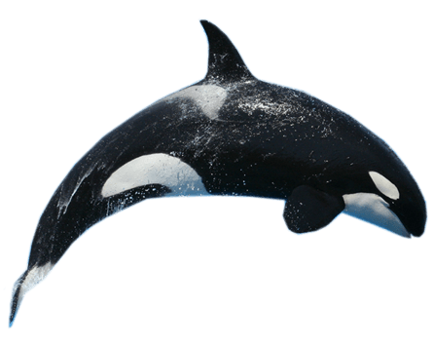 |  |  |  |  |  |  | Honey Crisp Park
 | 3 |  | 4 | 5 | 6 | 7 | 8 | 9
 |  |  | Military Museum $3 | Charter’s Fish Hatchery $5 | Fort Rodd  Hill $2 | View Royal Park | Lower Sooke River Trails
 | 10 |  | 11 | 12 | 13 | 14 | 15 | 16
  This Photo by Unknown Author is licensed under CC BY-NC |  |  | Closed  Remembrance Day | Royal Roads Fish Ladder | Goldstream Salmon Run | Esquimalt Boat Park | Aylard Farm
 | 17 |  | 18 | 19 | 20 | 21 | 22 | 23
 |  |  | Upper Sooke River Salmon Run | MT Doug Tinker Town | JDF Park Habitat Building | Class 9-11am  Early Dismissal | Pro-Day  OSC-Island View Beach
 | 24 |  | 25 | 26 | 27 | 28 | 29 | 30
 |  |  | Witty’s Lagoon | Beaver Lake Trails | Albert Head Lagoon | Swan Lake Trails | Goldstream Park  Eagles | 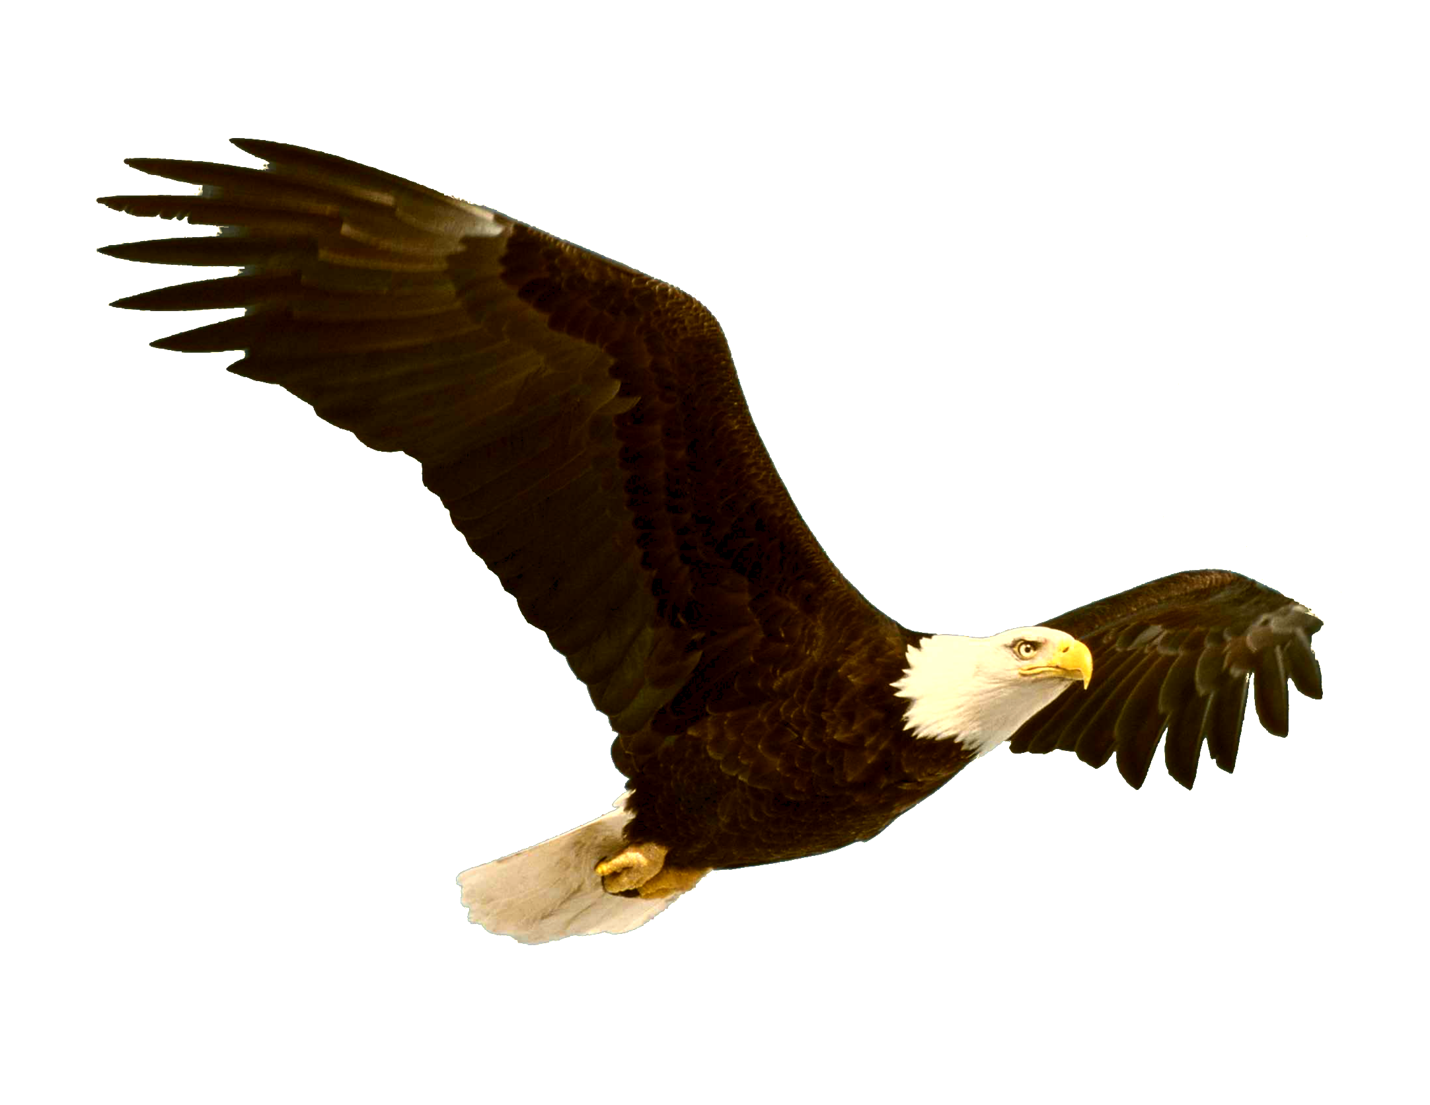  This Photo by Unknown Author is licensed under CC BY-NC

