RSAI Legislative Update
Apr. 6, 2018
These updates are posted on the RSAI web page http://www.rsaia.org/legislative.html. This week’s RSAI Capitol Recap video is posted here.

April 17 is the 100th day of Session, after which there is no per diem payment for legislators. With only 12 days left, there are still no budget targets, no appropriations bills, and no further movement on tax reform. But some priorities for RSAI are making progress!!! Operational sharing gets out of the Senate Education Committee. SAVE extension is amended and now on the House debate calendar for Monday. HF 2369, Bonding Elections in November, is still on the Senate Unfinished Business Calendar and we have concerns. New discussion on Commercial and Industrial Property Tax Backfill and a new Expenditure Limitation bill gets consideration in a House Subcommittee. This weekend, thank your legislators for forward progress on many RSAI priorities, and specifically mention SAVE extension and operational sharing. Let us know if you need assistance with any of your advocacy work. Thanks for all you do to advocate for Iowa’s children. margaret@iowaschoolfinance.com

HF 633 Operational Sharing Incentives Extension, a priority for RSAI, was amended in the Senate Appropriations Committee, sending it to the Senate Calendar. Thanks to all who contacted Senators since last week’s Operational Sharing call to action!!! Keep those contacts coming through the weekend and into next week. Call to Action: Extension of Operational Sharing Incentives is Critical to Rural Schools (3.28.18) Send a thank you to your senator, especially if on the Senate Appropriations Committee. A position paper with talking points, background and fiscal impact is found here. Find members of the Senate Appropriations Committee here. The bill, as amended:

- extends the operational sharing incentives for 5 years, with the budget year beginning July 1, 2024 as the final year (so through the 2024-25 school year).
- eliminates the 5-year limitation on any shared position
- maintains the cap of funding at the maximum of 21 student weighting for any district.
- Although the 2019-20 school year is the final year for the incentives, the 2018-19 school year is effectively an end for many of the positions that were limited to 5 years for those districts that shared in the first year of the incentives.
- Without extension this year, rural schools will experience a reduction in funding of essentially $19 million FY 2019-20. Talking points are included in the Call To Action.
Also noteworthy, HF 2406 adds social workers to the list of positions. It was approved unanimously in the House, approved unanimously in Senate Appropriations and also sits on the Unfinished Business Calendar in the Senate. RSAI supports of both of these bills.
HF 2481, (formerly HF 2438) and SF 2393 SAVE Extension: HF 2438 was amended in the House Ways and Means Committee on Monday, April 3. The bill, as amended, has a new bill number, HF 2481. The Senate Committee moved their bill with unanimous support on March 21, but work with Senators for successful floor passage is still needed. RSAI supports the extension of the state penny for another 20 years and appreciates the collaborative process underway. Continue to contact your legislators, both House and Senate, encouraging their support of the extension. The RSAI position paper with talking points about school security and property tax relief is posted on the RSAI web site here. RSAI is registered in favor of these bills and supports the House Ways and Means Committee amendment. The bill, as amended:
- Extends State Penny to Jan. 1, 2050
- Property tax equity/relief. Transfers to two funds increase if SAVE fund grows by a certain percent:
  - PTER fund (currently at 2.1%) gets 2/3ds of the transfer. This brings districts with the highest additional levies in the state down closer to the average.
  - A new Foundation Based Percentage Fund (FBPF) gets 1/3 of the transfer amount, raising the foundation percentage so all property tax payers get some reduction.
  - Total for PTER and FBPF combined is capped at 12%.
- Creates a new Career Academy Fund, with $1.0 million in FY 2019, which then grows up to $5 million annually if SAVE grows.
  - DE controls the fund, which allows for competitive grants not to exceed $1 million, to school corporations for career academy infrastructure, equipment or both.
  - First priority for grants is to new academies with 3 or more districts collaborating.
  - Second priority is for expanding and updating existing facilities and infrastructure.
- Revenue Purpose Statement sunset: Requires existing RPS to expire the earlier of Jan. 1, 2030 or the expiration date in the RPS.
- Board submits a new RPS to voters to use SAVE for new purposes or bond against the extended funding beyond 2030:
  - Prior RPS stays in force until it expires or is replaced
  - Must state what happens if the RPS fails, both in the notice of publication of the election and on the district web site, which essentially states:
If a majority of eligible electors voting on the question fail to approve this RPS, revenues received by the school district from the SAVE fund shall first be expended for . . . (State the purposes in the order listed in subsection 1 for which the district is collecting property taxes, ie., Debt Levy, Voted PPEL, Board Approved PPEL, PERL)
  - Protects validity of bonds in place or other obligations or contracts in place prior to the expiration of the RPS.
- Certificate of Need: keeps the current threshold in place (certified enrollment fewer than 250 students in the district or 100 in high school) but adds two criteria to the CON decision that DE must consider;
  - Cost benefit analysis of remodeling, reconstructing or repairing existing buildings (instead of the infeasibility of the above)
  - Benefits and effects of the new construction on student learning. (RSAI requested this provision)
- Athletic Facilities: whether specified in the RPS or if the district doesn’t have an RPS, the board must pass a resolution setting forth a proposal for athletic facility construction and must hold an additional public hearing on the proposal noticed in the newspaper with general circulation in the district not less than 10 nor more than 20 days before the hearing. After the public hearing, the district must wait 14 days for petition. The petition threshold is the greater of 100 or 30% of those voting in the last regular school election. The board may rescind or call for an election if a petition arises. If no petition comes forward, after 14 days, the board may proceed. The bill defines athletic facility as a building or structure not physically attached to a student attendance center.

Send a thank you note to your legislators on the House Ways and Means Committee found here, all of whom voted for the bill except for Reps. Pettengill and Baltimore. Encourage your House members to support the bill during floor debate on Monday.

Bills Signed by the Governor:
SF 2114: DE Code Corrections: this bill relates to matters involving the State Board and DE to reflect current practices, delete redundancies and inaccuracies, and resolve inconsistencies (eliminated the mandate to have a second local assessment of core content areas.) This bill passed the Iowa Senate on Feb. 20, 48-0 and the Iowa House on March 20, 99-0. RSAI is registered in support. The Governor signed it.
HF 2253 Lease Purchase Bids: this bill requires construction projects and improvements that are built by a private contractor under a lease or lease-purchase contract with state or local governments (including schools, regents universities, cities, counties and community colleges) be subject to competitive bidding requirements. The bill defines a public improvement as one that has been paid for by a government or there is a government commitment to pay. This bill passed the Iowa Senate on March 27, 27-20 and the Iowa House on March 38, 59-41. The Governor signed it. RSAI is registered as undecided.
HF 2390 World Languages: this bill changes references from “foreign language” to “world language” in the Iowa Code and includes American Sign Language as a world language. The House passed it bill 98-0. The Senate passed the bill 47-0. The Governor signed it. RSAI supports it.
SF 2274: an Act requiring the DE to include references to state or federal statutory or regulatory provisions necessitating the inclusion of information in data collection from school districts by the department. This bill passed the Senate on Feb. 20, 37-11 and the House on March 20, 94-5, and the Governor signed it. RSAI is registered in support.

Bills Receiving House or Senate Action:
SF 475 Education Omnibus: the House amendment included ½ unit of financial literacy for high school graduation requirement, which changed RSAI registration to opposition. Sen Sinclair said she plans to fix that piece in the appropriations bill. Other provisions in SF 475:
- Online learning issues: lifts the open enrollment cap on the online academies, but allows local school districts the authority to offer online coursework locally. Requires DE to approved private vendors. The House amendment prohibits online providers from offering any payment to parents.
- Concurrent enrollment CTE exemption allows small districts (<600) to work with community colleges in offering CTE courses to students and have those courses meet offer and teach requirements, only if there is difficulty in finding a qualified teacher. (RSAI requested this provision)
- Limits DE guidance to specifics in Iowa Code and federal law.
- Health screenings work group to examine and report on the impact of vision and dental screenings to schools, with recommendations to minimize the administrative burden on schools of providing the screenings.
The Senate concurred in the House Amendment, 28:19, sending it to the Governor.
SF 2155 Local Operating Funds: this bill allows a local government to invest operating funds which are 33% in excess of what is needed, in CDs that mature in 63 months and meet interest guidelines. The Senate concurred with the House amendment, 47-0, sending the bill to the Governor. RSAI is undecided on the bill.
SF 2318 High School Credits: after several attempts at getting the right language in an amendment, this bill winds up requiring that a student who receives high school credit in an accredited Iowa school be granted that credit in a new school they attend, unless the course does not meet the requirements of the school of enrollment or the student does not show proficiency in the coursework. Requires the school denying the credits to notify the parents in writing why the credit was denied. The House approved the bill as amended, 99-0. The Senate concurred with the House amendment, 47-0, which RSAI supports, sending the bill to the Governor.
SF 2360 Dyslexia Task Force; this bill requires DE to convene a task force and specifies the membership of the task force The bill requires the task force to study an overview of the symptoms and effects of dyslexia, the current practices in Iowa schools, description of current concerns, recommendation of any proposed legislation or rulemaking, additional personnel or funding needed, recommendations related to dyslexia response for stakeholder groups, and suggested timeline for implementation. The report is required by November of 2019. The House passed the bill as amended, 97-0 and sent it back to the Senate. The Senate concurred, 47:0, sending it to the Governor. RSAI is undecided on the bill.
SF 2364 School Security Plans: the Senate replaced the House amendment, which was fairly prescriptive about an annual drill, with the requirement that local school boards determine the school personnel involved in the drill, whether students and law enforcement are involved and other details related to the drill. The House concurred with the Senate amendment, 100-0, sending it to the Governor. RSAI is undecided on the bill.
SF 2400 Library Risk Pools: this bill classifies library districts as municipalities for the purposed of joining a local government risk pool to protect the municipality against liability, loss of property and other risks. The Senate passed the bill 46-0, sending it to the House. RSAI is undecided on the bill.
HF 2441 Education Flexibility: this bill allows the early intervention class size supplement per pupil to be used for any general fund purpose, removes DE from DoP application approval, and allows reconditioning of athletic equipment from a general fund transfer to the student activities fund. The bill also allows materials purchased for HSAP to be used elsewhere in the district as long as HSAP students still have access. The bill allows excess afterschool funding to be transferred to the flexibility fund after a public hearing. The bill prohibits DE and the State BOE from issuing guidance that imposes a legal obligation unless that obligation is required or implied by law. The Senate amended the bill to better align the DoP process timing of the district request of and SBRC approval of MSA with SBRC meetings, which RSAI requested. The House concurred with the DE amendment, 99:0, sending it to the Governor. RSAI supports it.
HF 2442 High School Collision Sports: this bill includes the following requirements:
- requires the DPH and the HS associations to develop training materials on concussions/brain injury.
- requires coaches and referees to complete such training every two years.
- requires the extracurricular contest officials to have registered with the HS associations.
- requires a student to be removed from an extracurricular contest if the student shows any sign of brain injury.
- requires the development of return to play/return to learn protocols.
- requires local districts to provide required protective gear.
- adds liability protections for schools that have a licensed health care provider at contests and liability for a volunteer health care provider examining a student and making a play or no play determination.
The Senate amended the bill and RSAI supports the Senate amendment: The amendment limits the extracurricular contests to those sponsored by the HS associations and identified as contact/limited contact by the American Academy of Pediatrics. The amendment also limits the requirement that parents provide concussion information sheets to parents of 7-12 students. Requires the DPH to work with the HS associations on a Return-to-Play protocol which school boards must adopt by July 1, 2019. Requires school boards to adopt a Return-to-Learn plan based on guidance by the Brain Injury Association of America, in cooperation with the student’s parents and health care provider. Adds Emergency Medical Services workers as allowable for being at the game. The bill is effective for the 2018 school year. RSAI is registered as undecided and appreciates the Senate’s amendment to improve the ability of school districts to implement the provisions. The Senate passed the bill as amended 49-0; now back to the House.
HF 2467 School Meals: this bill allows schools to use money from flexibility accounts to pay for the student meal debt. The bill requires schools to notify parents at least twice a year, and if the student has five unpaid lunches, of the availability of free or reduced school lunch programs and encourages schools to offer students reimbursable lunches unless the parent authorizes withholding lunches from a student. The bill requires schools, if practicable, to determine at the beginning of a lunch line whether a student has funds for a lunch, and prior to the replacement or disposal of a lunch. The bill prohibits posting lists of students who cannot pay for lunch or otherwise shaming or identifying those students or prohibiting the students from various school activities. The bill requires the DE to develop best practices regarding school lunch debt. Regarding Setoff procedures, which is a process by which the Department of Revenue assists local government in collecting unpaid debt: the bill allows schools to use setoff procedures to collect debts over $500 that are more than two years old.
The Senate amended the bill to allows the set-off process to be done annually. The amendment strikes provisions that schools place someone at the beginning of the lunch line if practicable and strikes provisions requiring the DE to determine the best practices. The amendment further allows the schools to determine which personnel can contact parents about unpaid lunch debt. The Senate amended and approved the bill 48-0; it now returns to the House. RSAI is registered as undecided on the bill.

Subcommittee Action: since Ways and Means and Appropriations bills are exempt from funnel deadlines, new bills can pop up or bills introduced earlier in the Session may have a subcommittee and begin work. The following two bills fall in this category.
HSB 678 Commercial and Industrial Property Tax Backfill Phase-out: this bill would reduce the C & I state backfill payment by 1/4th each year by setting a maximum reimbursement of the following schedule:
  - $100 million in FY 2019
  - $75 million in FY 2020
  - $50 million in FY 2021
  - $25 million in FY 2022 (and thereafter)
This bill is estimated to save the state $150 million by the time it is fully phased in. A similar bill, SF 2081, is in Senate Ways and Means Committee and it phases out the backfill completely over three years. The IALNS Newsletter reported in Bulletin #63 Vol. 54:
“Rep. Grassley, who is managing the bill, said the current payments to local governments are unsustainable. He said that he would like to see some action this session and said that reductions could be delayed by a year in order to give local governments time to prepare. House Democrats released the results of a survey on ending the property tax bill. They said that if the property tax backfill to local governments is approved, more than 90% of local governments will need to raise property taxes to continue to fund services. According to the Democrats, 90% of local officials said that they would need to cut services, with 76% saying they would make public safety cuts. About a quarter of the schools said that they would make cuts in teacher pay, increase class sizes or delay technology purchases.”
The phase-out of the backfill has several impacts on schools. First, for rate limited levies such as the PPEL, debt levy or PERL, the lack of state backfill reduces the capacity of revenues generated to those funds, although that impact may be more or less important to a school district based on the amount of property valuation in the district that is C&I property. When talking to legislators about this bill, remind them that extending the state penny would help to minimize this impact.
For school funding formula purposes, the phase-out of state backfill results in the use of district cash to make up the difference. When talking to legislators about this impact, remind them that extending the state penny includes increased funding for property tax relief, would help to offset the property tax rate impacts of this bill over time. Use the following process to estimate the impact on your school district property tax rates. This would be the first year impact on cash not received by the state, but does not impact spending authority. After you have completed your Certified Budget file,
- Go to the CI Est tab in the Certified Budget file
- Click on the yellow drop down – set it to 75%
- Scroll down to row 38 in Excel and look at the dollar amount.
- Take this dollar amount and divide by your Taxable Valuations with Gas and Electric Utilities (column A in top set of valuations in the valuations tab) and multiply that number by 1,000
An email from Sen. Jochum, Ranking Member of the Senate Ways and Means Committee, was sent to Superintendents and Board Presidents this week. The email provided the total local impact if there is no state backfill of the C&I property tax relief provisions, provided a sample board resolution to oppose the bill and requested school leaders to contact to Sen. Republicans in opposition. We can certainly understand how cities and counties are intensely impacted by these two bills but encourage you to find the extent of impact on your district so your leaders understand the capacity and property tax rate implications before taking this advocacy action.
HSB 684 Expenditure Limitation: this new bill, introduced this week in the House Appropriations Committee, was considered and approved by the subcommittee of Reps. Hinson, Rogers in favor and Hall not signing the report. The bill requires the REC to provide an extensive report to the general assembly which shall include all data considered by the members in reaching the estimates, an analysis of the data including projections of such data, and a comprehensive discussion supporting and substantiating the estimates of the conference. The bill also sets a lower expenditure limitation of 98% (current expenditure limitation is 99%.) This effectively removes $70 million of available revenue every year from appropriation considerations.
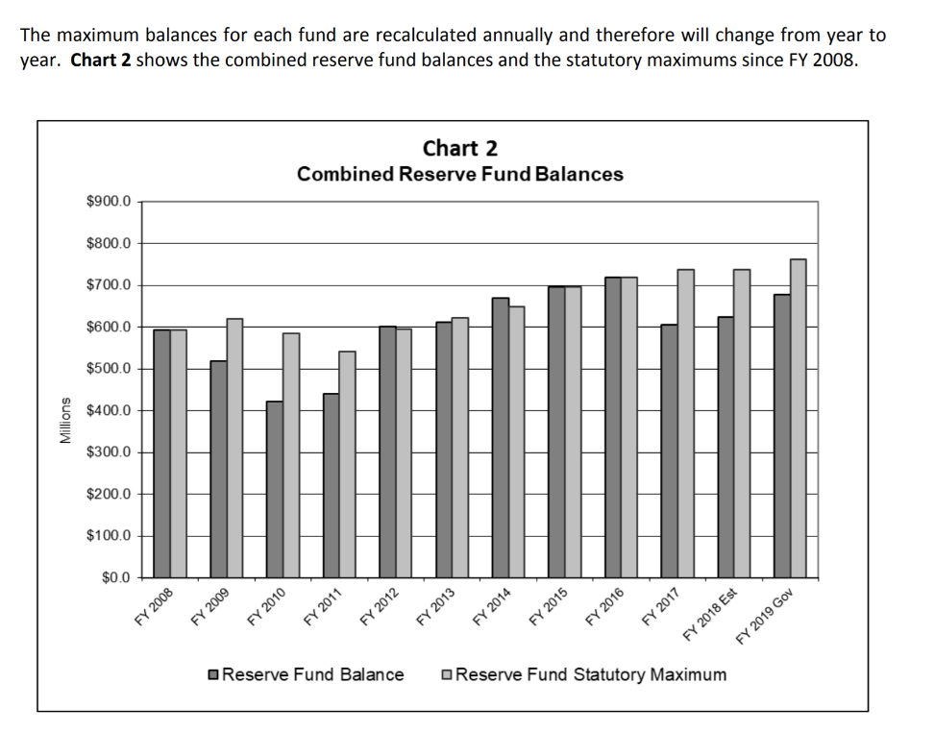
The bill also creates a new fund called the Revenue Estimating Stabilization Fund and sets the maximum in the fund as 2% of the revenue estimate (essentially $140+ million). This fund would be in addition to the Cash Reserve Fund and the Economic Emergency Fund, which combined deposits have not been lower than $410 million, even during the Great Recession. The current estimates of combined CRF and EEF are estimated to be close to $600 million in the Governor’s Budget Recommendation for FY 2019. The history of the state’s reserves can be seen in this chart from the LAGAR document found on page 16 of the Budget Overview Section found here.
The bill also sets criteria that the legislature can access the revenue stabilization funds if revenues are growing but not as much as a previous REC estimate. Rep. Hinson stated that their intention is to have a fund from which they can appropriate without having to do deappropriations like they did this year. Although that is a worthy intention, they have protected schools in the deappropriations process. This carves out the funds, removing them from the Iowa economy and the appropriations process, before they can be appropriated to schools in the first place. RSAI is registered in opposition to this bill.

Other Bills of Interest:
Tax reform SF 2383 and HSB 671 (Governor’s tax proposal) are both still in the House Ways and Means Committee. See March 8 report for details. There is still no Fiscal Note written describing the impact of HSB 671. RSAI is opposed to SF 2383 and will register on HSB 671 once we see fiscal impact.
HF 2369 School Bond Elections limited to November Ballot is in Senate on the Unfinished Business Calendar. See March 23 weekly report for details and talking points. RSAI is opposed.
SSB 3206 Vouchers: No further action has been taken on this bill, still in the Senate Appropriations Committee. See the March 23 report for a full analysis of the bill. Find background an talking points on RSAI website here. RSAI is opposed to this bill
Education Appropriations: We expect to see a line item appropriation for the costs associated with a new State Assessment, but as yet, no education appropriations bills have been introduced.
Advocacy Actions this week:
- Thank all Senators, Representatives and the Governor for addressing the transportation and formula inequalities for school districts through SF 455. Include a thank you for setting 1% SSA at a time when the state budget is challenging.
Senate Switchboard # 515.281.3371
House Switchboard # 515.281.3221
From links above or the legislative page https://www.legis.iowa.gov/legislators , find email addresses, home mailing address and home/work phone numbers for you legislators.
- Thank legislators for passing SF 475, allowing all districts to offer online learning programs and especially allowing small school districts to work with community college CTE programs to meet offer and teach requirements when they cannot find a teacher to fill the CTE position and under other circumstances. Let them know RSAI supports the effort to fix the financial literacy mandate in the an Appropriations bill before adjournment.
- Thank Senate Appropriations Committee members for moving HF 633 out of the Senate Appropriations Committee and encourage all Senators to support the bill as amended to send it back to the House. This is an RSAI priority. Share last week’s RSAI Call to Action: Extension of Operational Sharing Incentives is Critical to Rural Schools (3.28.18) with your senator, if you haven’t already done so.
- Continue State penny extension advocacy. Remind all legislators that extending the penny is critical to solve your infrastructure, school safety, equipment and technology needs without raising property taxes. An updated position paper is on the RSAI web site here. The bill is on the House Calendar, so this may be your last opportunity to reinforce your Representatives support.
RSAI Contacts
RSAI Professional Advocate, margaret@iowaschoolfinance.com 515.201.3755
Robert Olson, Chair, Clarion-Goldfield/Dows, Superintendent, robert.olson@rsaia.org ,
Paul Croghan, East Mills and Essex Superintendent, pcroghan@emschools.org ,
Lee Ann Grimley, Springville, Board President, leeann.grimley@rsaia.org ,
Dennis McClain, Clay Central Everly, Superintendent, dmcclain@claycentraleverly.org
Laurie Noll, Fairfield, Superintendent, laurie.noll@fairfieldsfuture.org
Dan Smith, Harmony, Board President, dan.smith@rsaia.org
Duane Willhite, Superintendent, North Fayette Valley, dwillhite@nfv.k12.ia.us

