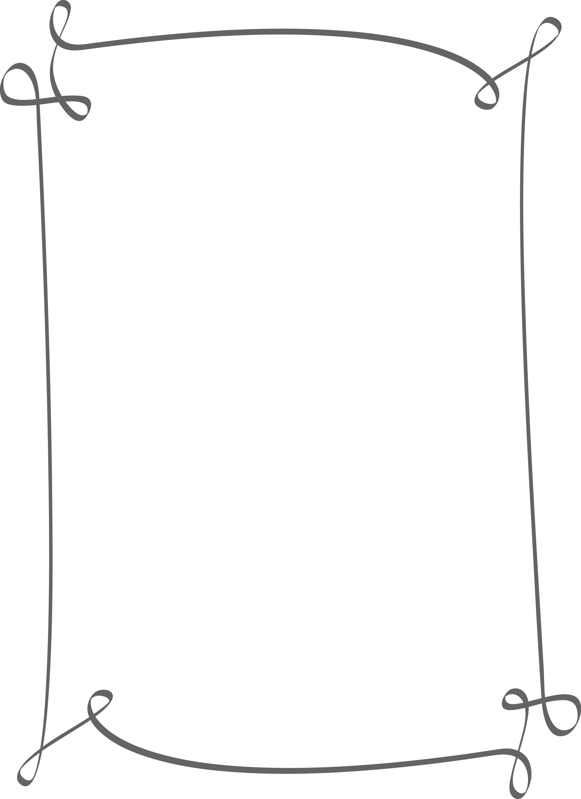

Holiday Schedule

Thanksgiving

Thursday11/28/2019

**CLOSED**

Friday 11/29/2019

**CLOSED**

Christmas

Tuesday 12/24/2019

**Closing at 3:00 p.m.**

Wednesday 12/25/2019

**CLOSED**

New Years-

Tuesday 12/31/2019

**Closing at 3:00 p.m.**

Tuesday 01/01/2020

**CLOSED**



