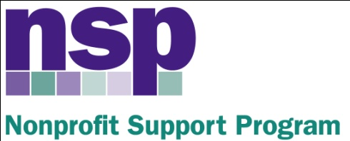

Hartford Foundation for Public Giving

Nonprofit Support Program
Building Evaluation Capacity (BEC) Program
Class of 2015, Session 2

February 10, 2016
8:30 – 12:00

AGENDA
EVALUATION LOGIC
8:30 | Feedback and Review
8:40 | Agency Introductions
9:00 | Evaluation Logic and Logic Models: Overview
9:20 | The Logic Model Scramble, and Assessment
9:45 | Pathway Maps/Logic Model Reminders
10:05 | BREAK
10:15 | Outcomes, Indicators and Targets
10:45 | Outcomes/Indicators/Targets Match Up
11:05 | Backwards Mapping
11:15 | Logic Model Development
11:45 0 | Varying Formats of Logic Models; Session Wrap-Up
HW | Complete the logic model for your selected project – Send to Anita by 2/17  BRING A SURVEY FROM YOUR ORGANIZATION TO NEXT CLASS

Anita Baker
Evaluation Services
www.evaluationservices.co

