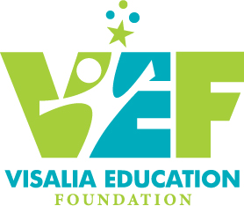

BOARD OF DIRECTORS
Laura Pace, President
Marilynn Mitchell, Past President
Myron Sheklian, Vice President
Paul Hurley, Vice President
Marilyn Gong, Treasurer
Elaine Rubio, Secretary
Erik Anderson
Allison Kleinsteuber
Juan Lopez
Susan Mathews
Barbara Mayeda
Destiney Nutt
Basil Perch
Terry Peterson
Suzy Plummer
Valarie Seita

Emeritus:
Terry Garrett
Carey Kajioka

VUSD Board Member:
Jacquie Gaebe

Mission: To identify and secure resources to promote educational excellence for students of the Visalia Unified School District
5000 West Cypress Avenue
Visalia, CA 93277
(559) 730-7518
www.visaliaedfoundation.orgTax ID: 94-2900046

