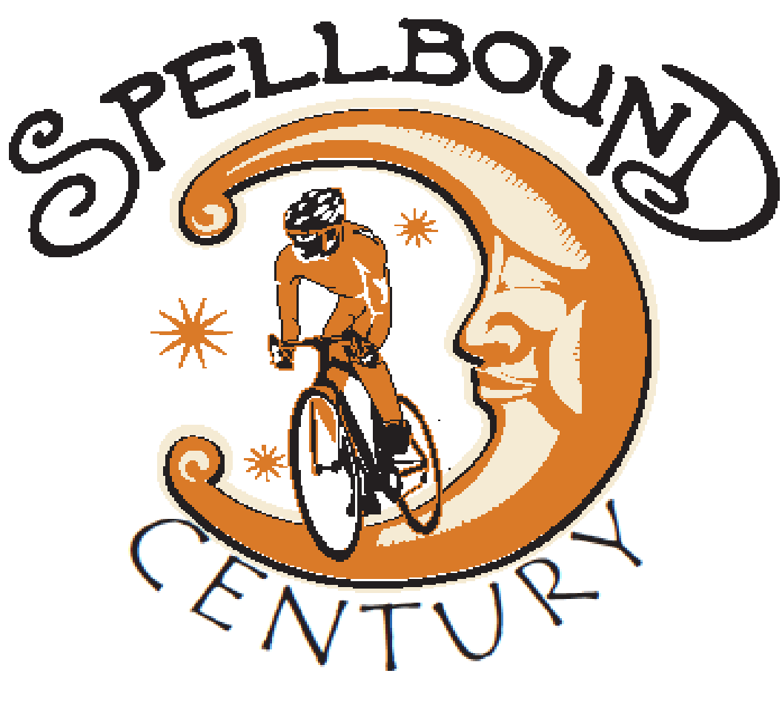

THE SPELLBOUND CENTURY
Saturday – July 27, 2019 - Mt. Holly, New Jersey

SPONSORSHIP
PLATINUM LEVEL
A $1,000 donation will have your company name added to the event promotion banner.
- Exposure and acknowledgement prior to and on the day off event by placing your name on the pamphlets, your company name & logo on event t-shirts and permission to set up an event tent.
- Recognition of your organization contribution on the Main Street Mount Holly and RV Patriots website for one year.
- Fees waived for up to four entries to the event

GOLD LEVEL
- A $500 donation will provide exposure and acknowledgement prior to and on the day off event by placing your name on pamphlets, your company name and logo on event t-shirts and permission to set up an event tent.
- Fees waived for up to three entries to the event

SILVER LEVEL
- A $350 donation will grant you the opportunity to have your company name on event advertisements by placing your company name on pamphlets and event t-shirts (including logo), have two fees waived to the event.

BRONZE LEVEL
- A $250 donation will grant you the opportunity to have your company name on event advertisements by placing the company name on pamphlets and event t-shirts, have one fee waived to the event.

BUSINESS SPONSORSHIP
- Be a part of the event by contributing food for the rest stops or the luncheon; providing a gift of equal value that can be used as a prize for the participants or volunteer your service.