CENTER DIRECTOR: NANCY LEE

ASSISTANT DIRECTOR: DEANA DILLON

TELEPHONE: (614) 837-3020 / FAX (614) 833-6471

HOURS: MON-FRI: 8:30 a.m. - 4:30 p.m.

WEB PAGE: http://pickeringtonseniorcenter.org
EMAIL: NLee@pickeringtonseniorcenter.com
EMAIL: DDillon@pickeringtonseniorcenter.com

Follow us on Facebook at:
Pickerington Senior Citizens Center

MEMBERSHIP INCENTIVE PROGRAM
Any member who signs up four new members will receive a $25.00 Visa Gift Card. Ask Deana to put your name on the form when you refer a new member.

THE BOOSTER CLUB
We appreciate any contributions made to our Booster Club. The money donated helps with funding activities for our members and with purchasing items needed for our kitchen, office, and other supplies.

Mike & Carol Aurnou, Duanita Booker, Rosetta Booker Brown, Denise Broomfield, Janet Cary, Tammy Cozart, Jessica Dalton, Dale Helsel, Sirina Jittkarunrat, John Iarussi, Shirley Massey, Barbara Matchack, Julie McFarland, Tammie Jones, Thomas Jones, Carolyn Moore, John Nestor, Vera Nixon, Susan Pape, Donna Potts, Susan Pryor, Carolyn Robertson, Tisha Smith, Michaelene Vincent.

We will not have a Pancake Breakfast this November.

TUESDAY, NOVEMBER 8TH
GENERAL ELECTION DAY
Pickerington Senior Center will be closed

SUNDAY / NOVEMBER 6TH
Daylight Savings Time ends the first Sunday in November. Remember to set your clocks back one hour before retiring on Saturday night.
This is also a good time to check the batteries in your smoke detectors, carbon monoxide detectors, and other electronic devices. Please don’t climb on ladders or chairs to change them. Ask one of your kids or a neighbor to take care of it for you.

VOLUNTEER OF THE MONTH
Our Center would like to honor Steve Tedrick as volunteer for the month of November. Steve helps out anytime we ask for help. He calls Bingo every other Tuesday and the yearly Bean Dinner and Bingo. Steve will receive a $15.00 gift card. Enjoy your reserved parking space for the month.

HEALT2TOE FOOT CARE SERVICES
Thursday /November 3rd & 22nd / 9 a.m.
Tonia is a State of Ohio Registered Nurse. She charges $35.00 for the following:
- 30-minute treatment – Trim, thin & file nails
- Corns & callouses filed & buffed smooth
- All tools are sterilized for each patient
- Payment due at time of service – Self-pay only
- No Medicare or Insurance will be billed
To schedule an appointment at our Center call: HEAL2TOE FOOT CARE SERVICES (614) 686-3646.

SOUP DINNER & BINGO
Thanks to Annabelle Marion for being in charge, Julia Archer and Patty Bond for making the bean and vegetable soups, and to all the kitchen helpers: Cecelia Behrens, Shirley Bowler, Jeanne Carroll, Linda Gearhart, and Mike Scudder for doing dishes.

NOODLE MAKING
We will be making noodles on Tuesday, November 15th^{th} & 29th.

BOARD OF TRUSTEES ELECTION
DECEMBER 1ST
We will be electing three members for our Senior Center Board of Trustees. They will be serving for the next three years. We have three members who have expressed a desire to join the Board.
Ed Drobina, Karen Edwards, and Vicki Witten.
We have three Board members that are up for re-election: Shirley Bowler, Jeannie Carroll and Doug Hoek.

UPCOMING ANNUAL BREAKFAST WITH SANTA
Saturday, December 10th.
Seating times: 8:00, 9:30, or 11:00 AM.
Pancake Breakfast, Music, Secret Santa Shop, Bake Sale, Crafts & fun for the whole family! The cost is $10 per person and 1 and under FREE! Everyone must purchase a ticket.
No tickets sold at the event. Tickets available online starting November1st WWW.PICKERINGTON.NET
Questions? Contact Parks and Recreation at City Hall
614-833-2211

EUCHRE TOURNAMENT

Thanks to Patty Bond and Sunny Schewe for hosting the 14th Euchre Tournament.

HUMANA
Friday, November 4th / 11:30 a.m.
Talk with a Doctor! Bring your questions and you’ll get answers. Come meet Cyndi with Humana Insurance and Laurie with Dedicated Senior Medical Center.

PICKERINGTON FOOD PANTRY
Some of the most needed items are personal hygiene products, soap, paper towels, toilet paper, toothpaste, toothbrushes, spaghetti & sauce, juices, condiments, Cooking Oil, tomato (paste, sauce or diced), baking & pantry staples (flour, sugar, salt, baking soda & spices), peanut butter & jelly, bread, and butter. We have a collection container in our library.

STRENGTH CLASS
Mondays and/or Wednesdays / 10 - 11 a.m.

Join us for our strength classes led by Kelley Deibert. The focus is on building upper and lower body strength, stretching, and improving your balance. Bring your own weights. If you need a stretch band Kelley has bands, you can purchase for $2.00.

LINE DANCING
Mondays / 11:15 a.m. - noon

Line Dance Classes run through November 21st. There will be a Holiday break for the remainder of the year and resume in January. You can sign up for 12 weeks for $12 or register to “pay-per-class” at $1 per class. Sign-up forms are available in our office or from our instructor Marilyn. Make checks payable to Marilyn Morgan.
For additional information contact Marilyn at: mnm@columbus.rr.com

BID EUCHRE
Mondays / 12:30 p.m.

We play bid euchre every Monday.

WATERCOLOR CLASS
Every Monday / 1-3 p.m.
Join Jenene Warmbier for adventures in watercolor painting. Jenene is a great teacher. No previous training, or talent necessary, just the desire to express yourself with “Paints and Brushes.” You can stop in our office and get a list of supplies you will need for the class.

CORNHOLE
Every Tuesday / 11 a.m.
We play Cornhole every Tuesday. We have a tournament on the last Tuesday of each month, with prizes for the winning team. The winning team for the September Cornhole Tournament was Carol Porter and Doug Hoek. Cornhole is open to both men and women. Come join in on all the fun!

MAH-JONGG
Tuesdays / 12:30 p.m.

We play Mah-Jongg on Tuesdays, both experienced and new players are welcome! Please call our office at (614) 837-3020 if you’re interested in joining us.

HAND AND FOOT
Tuesdays / 1:00 p.m.

We play the card game Hand and Foot on Tuesdays. Each player is dealt two sets of cards, the hand, and the foot. Come join us and learn how to play this fun game!

BINGO
Tuesday /November 22 / 1:00 p.m.
This month we will play Bingo on the 4th Tuesday. No Potluck this month. Bingo starts at 1:00 p.m. The cost is $1.50. We will resume playing on the 2nd and 4th Tuesdays of each month as of December.

TUESDAY AFTERNOON MATINEE
Tuesday, November 15 / 1:15 p.m.
Join us at our Center for a classic movie on our large screen t.v. The movie for the month of November will be ‘Cocoon” featuring Jessica Tandy, Brian Dennehy, Maureen Stapleton, Wilford Brimley, Don Ameche and Hume Cronyn. We will supply the movie, popcorn, snacks, coffee, and water. You may use our chairs or bring your own folding chair.

CRAFT GROUP
Every Wednesday / 10 a.m. – noon
Our craft group offers fun activities for our members, but also raises money for our Center. They provide tray favors for two carry out meals which our Center provides for our shut-in members. Another important fundraising activity the Craft Group participates in is our Breakfast with Santa, usually held on the first Saturday of December.

SEWING CIRCLE
Every Wednesday / 1:00 – 2:30 or 3:00 p.m.
We now have a sewing circle and would love to have anyone interested in sewing, knitting, crocheting, cross stitch or needlepoint come and participate. We get together to sew and socialize in our craft room. Bring along your own project and materials and join us!

DUPLICATE BRIDGE BRIDGE
Wednesdays Thursdays
9:30 a.m. 12:30 p.m.
We are looking for more members to play Bridge. Anyone interested in joining us, please call our Center and give your name and phone number. The cost to play either Bridge or Duplicate Bridge is $1.00 per week.

EUCHRE
Every Wednesday / 12:30 p.m.
Come in, join your friends, and play some Euchre. We start playing at 12:30 p.m. The cost is only $2.25 which includes the games and the loner pot. Please be here at least 10 minutes ahead of time to get signed up so we can begin on time at 12:30.

TITLE BOXING
Thursdays / November 3rd, 10th & 17th

Maria Manzo from Title Boxing will lead the class from 9:15 to 10 a.m. Sessions are around the Rock Steady Boxing curriculum which increases the neuroplasticity of the brain to help produce healthy brain cells. The exercises are designed to improve quality of life, have fun, and get results. You can purchase a bag and gloves for $25. 00 at the class.

CHAIR VOLLEYBALL
Thursdays / 11:30 a.m. /November 3rd, 10th
We play Chair Volleyball at our Center on Thursdays. It’s led by Darie Wilson. No need to sign up, just show up on Thursdays and join in the fun. We now have 2 nets. If you have any questions, please call Darie at (740) 358-6394.

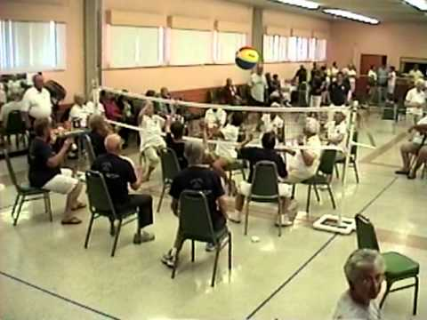
This Photo by Unknown Author is licensed under CC BY-SA-NC

FRIDAY FITNESS CLASS
Every Friday / 9:15 – 10:00 a.m.

This is a 45-minute Cardio Class. It’s a total workout. Come see the power you have and make great things happen for your health and well-being. We have plenty of room for you to move and groove to great music with instructor Maria Manzo.

SOCIAL EUCHRE
Every Friday / 11 a.m.

This is a relaxed pace Euchre game where we can meet and play cards non-competitively. If you like to play cards for fun and you don’t mind teaching others when needed, then please join us. We welcome anyone who wants to play.

NEW ACTIVITY

SHUFFLEBOARD
FRIDAYS /2:15 p.m.
Come join us! We will be starting a shuffleboard
league in our game room starting Friday, December 2, 2022. You are welcome to stop in and play
shuffleboard anytime during business hours.

LIBRARY

We have videos, puzzles, and a large selection of books to choose from. Come check out our cozy library. We are currently in need of large print
books. If anyone has any large print books to donate, we would appreciate it.

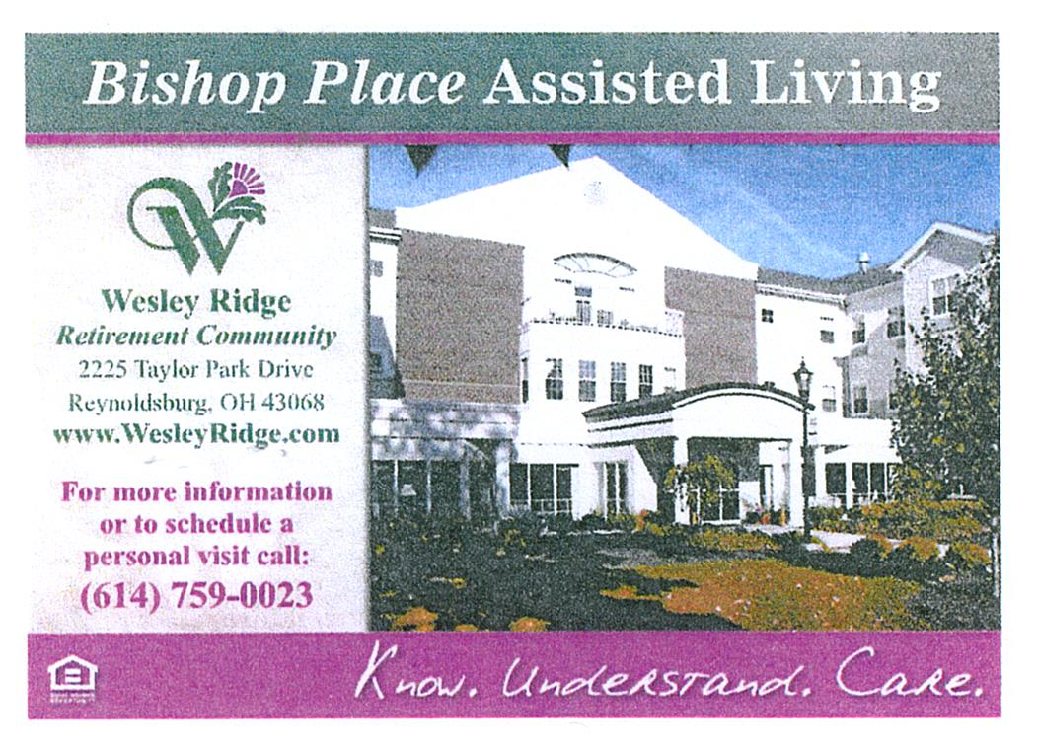

TRIPS FOR 2022

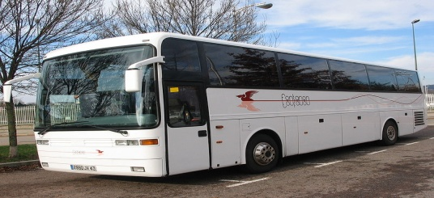

TIMELESS HOLIDAY TREASURES
Thursday / November 10th
The motorcoach will leave the Center for Hartsvillle at 7:30 a.m.
We start the day at Hartville Kitchen where we’ll shop at the bakery & roam around their shops to check out jewelry, clothing, handbags and the Candy Shop. Get your goodies before we depart for lunch & the Dazzling Diamond Variety Show, a 1-man performance featuring the music of Neil Diamond & the stories that inspired the songs. After the show we head to Hartville Flea Market featuring over 100 unique shops of fashion, crafts, antiques, home décor and more. If we have time, we’ll stop at the World’s Largest Hardware Store. It's so much more than a hardware store, it has
everything for men and women, and great Christmas items. SPACE AVAILABLE
Cost per person: $121.00 - due on sign up

LACOMEDIA DINNER THEATRE
White Christmas / Wednesday / November 16th

The motorcoach will leave the center at 8:00 am. The classic film White Christmas is the inspiration for this heartwarming musical comedy about two veterans who have a successful song and dance act after World War II. With romance in mind, they follow a duo of beautiful singing sisters to their Christmas show at a Vermont Lodge. It

features songs “Blue Skies,” “Sisters” and the most famous holiday song of all “White
Christmas.” Cost per person: $63.00 – due on sign up. SPACE AVAILABLE

NASHVILLE, TENNESSEE
December 4th – 7th
Enjoy 3 nights lodging at the Gaylord Opryland Hotel. During your free time at the hotel, you can walk around and visit the many shops and step aboard a Delta Riverboat and enjoy the lush indoor gardens while a guide offers unique facts about all the plants and fish. WAITING LIST

ONE NEW TRIP ADDED

OGLEBAY PARK
Wednesday, November 30th
Join us as we travel to Wheeling Park, a sister park to Oglebay for a buffet dinner. After dinner we’ll go to Oglebay Park for a driving tour to see
The beautiful Christmas lights and visit the gift shop for a little Christmas shopping. Dinner will be around 4:00 p.m., so you might want to bring a snack for the trip home. The cost is $63.00 per person, which includes dinner buffet, motorcoach transportation, taxes and gratuities on all included items. Sign up starts on Monday, November 7th. Payment is due on sign up.

NOTES FROM DEANA 😊

“HAPPY BIRTHDAY”
(1)Michelle Acquista, Ann Budreau, Pat Gemeinhadt, Bettie Hurley, Douglas Keadey,
Danny Mathew (2)Susan Couden, Donna Potts (3)Daniel Murphy, Cecelia Simeone, Mary Stemen (4)Melissa Bechtel, RuthAnn Garand, Nelda Johnson, Fran Skinner,(5)Joe Fox, Sharon Greedy (6)Eleanor Berry, Judy Creviston, Bill Taylor, Thomas Tooill, Lori Wagner (7)Marti Fisher, Carolyn Moore (8)Marlene Mueller (9)Pam Cheek, Mary Stafford, Kay Vankeuren (10)Brenda Albertini, Karen Callahan, Polly Kupniewski, Ellen Laughery (11) Susan Carr, Karen Hixenbaugh, Gene Luidhardt, Vera Nixon (12) Etha Brown, Linda Boisvert, Norman Hopkins, Jeannie Mathew (13) Mary Jane Brandt, Shirley Massey (14)Bessie Miller, Margaret Wolfinger (15) Jim Eringman, Charlene Newlon (16) Maggie Arendt, Brian Casner, Paula Gross (17) Sylvia Chadwell, Veronica Lamb (18)Becky Ashcroft, Denise Hoermle, Pam Knoblauch, Larry Larson, Sunny Schewe (19)Linda Scott, Rosalee White (20) Brenda Dunnette, Melody Fuller,Becky Todd (22)Lois Bushby, Mike Kilroy, Steve Knorr (23)Edward Akers, Jennie Chrysler, Jerry Howell, Vicki Hunt (24) Ann Hackworth, Vikki Perry, Patty Schlager (25) Donna Carr, Debbie Faiella, Cheryl Lewis, Beverly Wilson (26) Floyd Collins, Cheryl March, Susan Fetters, Sara Schwab, Janice Wharton(27)Joyce Collins, Jean Cox, Doris Moore, Stan Runyan (28)Lillian Delavo, Al Sharpless (29)Shirley Kotchou, Janet Kuhn, Leona Manzo, Frances Marchese, James Northrop, Rick Schulze, Frank Simeone (30) Rex Bentzinger, Denise Feeley, Nancy Johnson

MEMBERS IN SORROW
Bud Delong
Nancy Curran’s brother, Frank & sister in- law, Gretta
Ann Hackworth’s grandson, Matt

MEMBERS KNOWN ILL

Harold Worrix

This Photo by Unknown Author is licensed under CC BY-SA
BEAT MICHIGAN WEEK PARTY
Join us for our, “Beat that team up north party” on Thursday, November 17th from 1:00-3:00 p.m. Fun, snacks, games & prizes. We will be partnering up with Africa from Wesley Ridge.
RSVP IN THE OFFICE BY NOV. 10th

CHRISTMAS PARTY
Thursday, December 1st
1:00 – 3:00 p.m.
Entertainment : Pickerington High School Central Chorale, Heather Wilkins.
RSVP IN THE OFFICE BY NOV. 28Th

“HAPPY THANKSGIVING”

