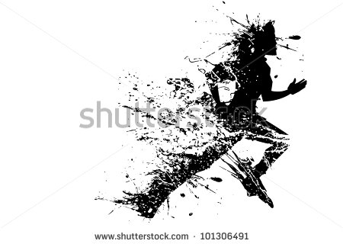

*Full Participants:150 meter swim followed by 5K run.*

*Novice swimmers:50 meter swim followed by 5k run.*

*8 and under racers:50 meter swim followed by one lap around Light Park (.8 of a mile)*

Name_______________________________ Address______________________________________

City­­­­­­­­­_________________________________ State______________________ Zip_______________

Sex: M F Age­­­­­­­­­­­­­­­­­­­­­­­­­­­­__________ E-mail______________________________________________

­­­­­____ Full Participant ____Novice Swimmer Race ____ 8 and Under Race

Estimated 150m/50m Swim Time:­­­__________ Shirt Size: Adult - XL L M S Youth - L M S

Participant Waiver: I hereby release the City of Liberal, the Recreation Department, their employees, and/or agents from any and all claims and/or responsibility for any injuries that may occur during the duration of this event.

­­­________________________­­­­­­____________­­­­______ ­­__________________________

Signature (Parent or Guardian if under 18) Date

Please register on or before July 5, 2017 at 1109 W. 7th Street, Liberal Kansas 67901; (fax) 620/626-0167; or ronna.stump@cityofliberal.org. Please call 620-626-0133 for questions. Registrations and payments will be accepted on race day, but swim placement according to estimated swim time is not guaranteed if registration is received on race day. To be guaranteed a t-shirt, please register on or before June 24.

**July 8, 2017**

**Adventure Bay Water Park,**

**1115 N. Kansas, Liberal, Kansas**

*Entry Fee: $15*

*Race Begins at 8 a.m.*

*Late/Race Day Registration at 7:00 a.m.*

Splash & Dash