***Woonsocket Police / IBPO - Local 404***



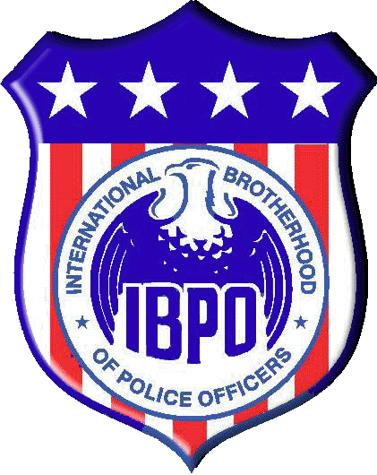

**__________________________________________________________________________**

The International Brotherhood of Police Officers -Local 404 is currently seeking donations and sponsors for our 15th Annual Woonsocket Police/IBPO 404 “COPSWALK.” On May 9th, thirteen officers from the Woonsocket Police Department will take part in a 4-day, relay-style walk from Woonsocket to Washington DC. Our mission is to raise funds for the organization, "Concerns of Police Survivors," a national (not-for-profit) organization that dedicates itself to helping the families of police officers who are killed in the line of duty, through counseling, retreats, legal services and scholarships.

The members of the Woonsocket Police/IBPO 404 feel strongly that we must stand together to support the families that these heroes leave behind. In the past few years our organization has become one of the highest single-agency donors to COPS in the nation. We would be sincerely grateful if you joined our noble cause, by picking up one of these shields:

*Blue Shield Donor* $200.00 or more

*Full page Ad in program*, listing on website*

*On May 2nd, we will host 400 supporters in our annual COPSWALK Comedy Dinner; programs will be at every table.

Gold Shield Donor $100.00 - $200

*Half-page Ad in program*, listing on website*

Silver Shield Donor $50.00 - $100.00

*Business Card Ad in program*, listing on website*

Business Name: ___________________________________________ Donation: _________________

Contact Name: _______________________________________________ Phone: ____________________

Address: _________________________________________________ City_______________________

Specific Advertisement: Y / N I prefer to keep my donation anonymous

(Instructions can be written on reverse side or e-mailed)

Please make checks payable to: **COPSWALK** // 242 Clinton St. Woonsocket, RI 02895

*For more information please contact* ***Lieutenant Ed Cunanan*** *at 766-1212 // ecunanan@woonsocketri.org*

*For more information on C.O.P.S.: www.nationalcops.org*

**www.wpdcopswalk.com**