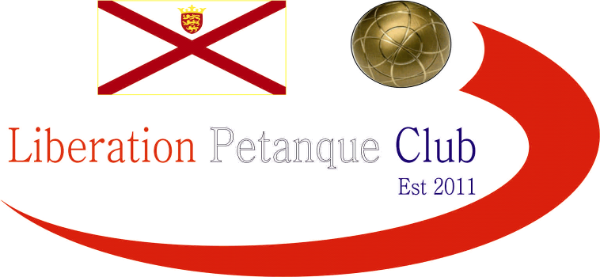

2024
DOUBLES OPEN

Just 7 teams entered this year, the lowest on record.

Round one saw Geoffroy & Toby hand out a 13 – 0 defeat to Colin & Jim and Callum & Ross won big against Cassie & Jean.

One match not going the distance with several ends seeing the jack go out and Gary & Wendy winning 9 – 4!

Round two saw Colin & Jim recover to get a good win over Keith & Mo 13 – 10, whilst Callum & Ross beat Ellis & John.

Big match in round two saw Geoffroy & Toby win 13 – 4 against Gary & Wendy.

Round three Gary & Wendy lost again against Callum & Ross and with the latter on a bye in the last round qualified for the final.

John & Ellis made the top four with a 11 – 10 win over Keith & Mo whilst Geoffroy & Toby won comfortably again against Cassie & Jean 13 – 5.

The top two teams played in the final and this was Geoffroy & Toby v Callum & Ross, whilst third place Gary & Wendy played 4th place

FINAL RANKINGS

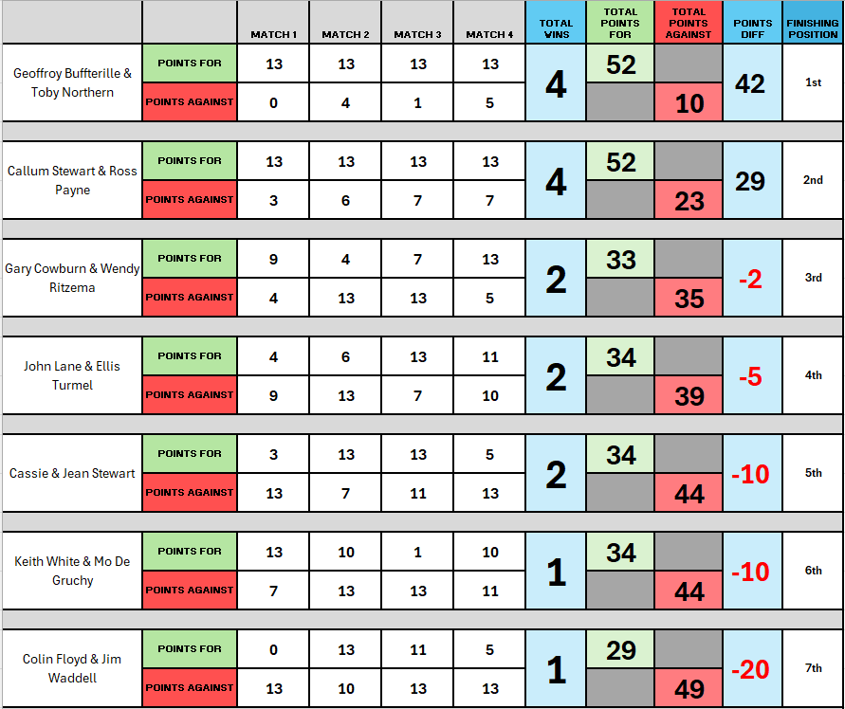

Therefore the third place play-off was between Gary & Wendy & Ellis & John who would have been looking for a better performance after losing 9 – 4 in round 1.

This was a close affair but Ellis & John redeemed themselves to take third place winning 13 – 11.

The final between Geoffroy & Toby and Callum & Ross who could have scored some big points in the first few ends in the final but failed to take their chances and were made to pay as Geoffroy & Toby hit top gear to win 13 - 5 with Geoffroy hitting a spot carreau for the title.

This was Geoffroy second win and Toby's first! in the competition.

2024 - Winners

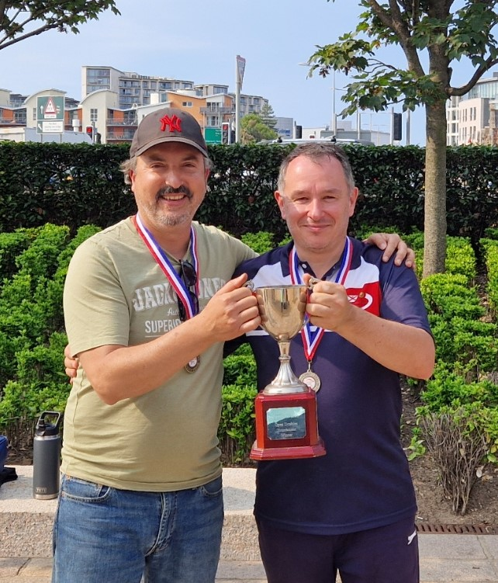

Thanks to all those who helped out on the day to make it another great competition.

Club email address - liberationpc@gmail.com

Club Website - www.liberationpetanque.co.uk

Kind Regards

Toby Northern

Chairman

Liberation Petanque Club

