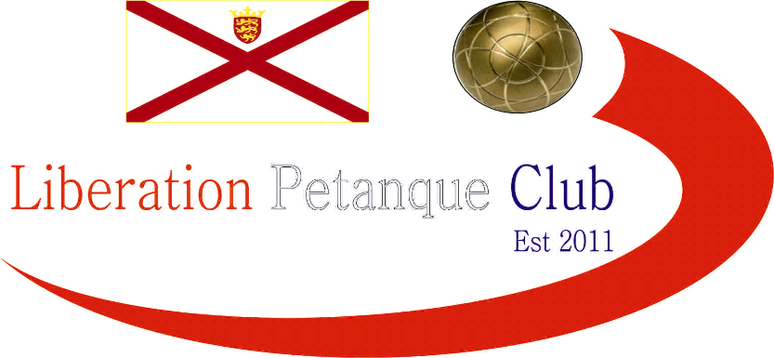

# Summer 2017 Season

# Week 22

# 23rd August 2017

# Doubles League

# LIBERATION MIXED DOUBLES OPEN – Saturday 26th August

# Entry form on club website

# Mark & Jake were just two points from a perfect match beating Cassie & Kat 13 – 2, 13 – 0 to continue their title form.

# David & Matt just beat Ian & Luke winning 13 – 12, 13 – 10 and Callum & Andrew drew a very close match 13 – 11, 11 – 13 with Brian & Paul. This draw see’s Callum & Andrews title chances slipping away.

# James & Geoffroy and Matt & Richard shared a draw to also slip further behind Mark & Jake.

# Joey & Jonny heaped more relegation woe’s on Nathan & Matt but it was a close match.

# Colin & Steve just can’t get a win with another draw (how many times has that been said) this time against Harrison & Richard.

# Alan & Craig look good for the title with a win against title rivals David & Susan and a big win it was 13 – 4, 13 – 1. Al;an & Mike also aiming for the Premier League beating Keith & Sue.

# Title challenges Ian & Jane also dropped points against Christophe & Iwona.

# 

***NEXT WEEK***

**Singles League – Start Time 6pm**

**WEBSITE** [**www.liberationpetanque.co.uk**](http://www.liberationpetanque.co.uk)

**EMAIL** [**liberationpc@gmail.com**](mailto:liberationpc@gmail.com)

**Kind Regards**

**Report Editor**

**Liberation Petanque Club**

# SPONSORED BY

# http://nebula.wsimg.com/135a1bd6338e1b589a50cdec98bd84d1?AccessKeyId=C6E923731F1A482DD910&disposition=0&alloworigin=1