REGULAR MEETING
DECEMBER 17, 2020

A Regular Meeting of the Town Board of the Town of Hampton, County of Washington and the State of New York was held via Zoom, 2629 State Route 22A, Hampton, New York on the 17th day of December 2020.

Due to the Corona Virus and inclement weather the meeting was held via Zoom. Attendance list read by Town Clerk.

PRESENT: David K. O’Brien------------Supervisor
Tamme Taran----------------Councilwoman
Donald Sady-----------------Councilman
Andrea Sweeney------------Councilwoman
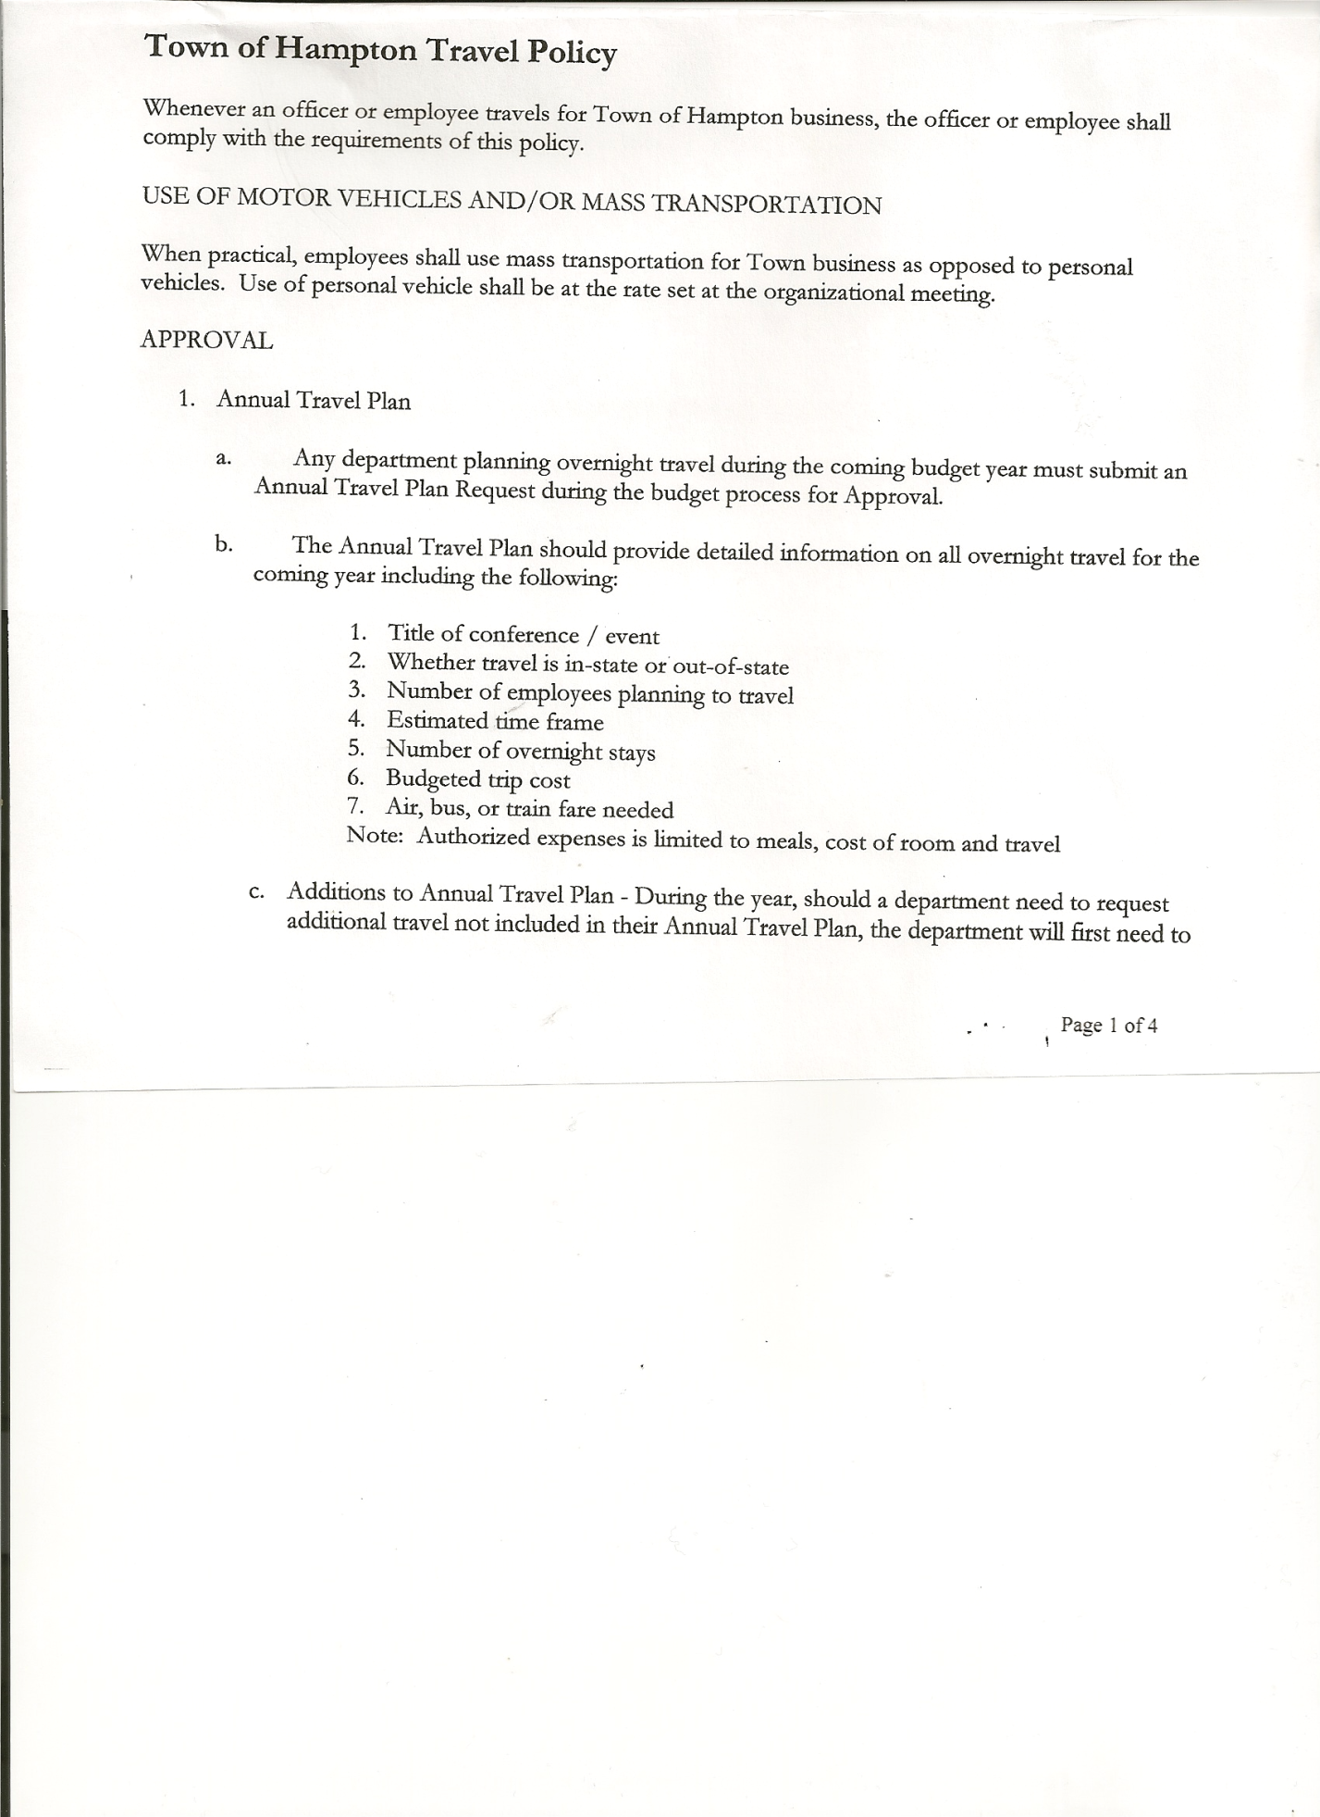
Michael Pietryka------------Councilman
Rebecca Jones---------------Town Clerk
Camilla Shaw----------------Tax Collector/Deputy Town Clerk
Herbert Sady, Jr.-------------Highway Superintendent

Planning Board Member(s): Bonnie Hawley and Matthew Pratt (via Zoom)

The Regular Meeting was called to order by Supervisor O’Brien at 7:30pm, followed by the Pledge of Allegiance. Quorum of board members present.

RESOLUTION NO. 100-2020
APPROVAL OF THE MINUTES
On a motion of Councilman Sady, seconded by Councilwoman Taran, the following resolution was ADOPTED: Ayes 5 O’Brien, Sady, Taran, Sweeney, Pietryka
Nays 0
RESOLVED, that the Regular Town Board Minutes for November 19th, 2020 are approved.

Tax Collector’s Report: Waiting for tax bills to be prepared for mailing later this month.
Bank statement will be available for Board members to view at the Town Hall.

Dog Control Officer no report.

Bonnie Hawley, Chair gave Planning Board Report…copy of report is attached.

Herbert Sady, Jr., Highway Superintendent submitted his report, copy of which, is attached.

2009 Intl bed of box is in bad shape. Is at Dick Hayward’s for a temporary fix. Dave O’Brien suggested talking with the County to see if they have any that they have switched out of their trucks. He also asked if there is any thought on how to fix Hickey Rd in the spring. Herb said possibly stone & oil. He has contacted Todd from Gorman’s to call him. Don suggested they wait to see what the road is like in the spring.

TOWN BOARD MEETING
DECEMBER 17, 2020 PAGE 2

SUPERVISOR’S REPORT/COUNTY UPDATES/COMMUNICATIONS

Tax bills will be out soon. Offices were closed today, so it may be next week before they are ready.

RESOLUTION NO. 101 -2020
APPROVAL OF SUPERVISOR’S MONTHLY REPORT
On a motion of Councilwoman Taran, seconded by Councilman Sady, the following resolution was ADOPTED: Ayes 5 O’Brien, Sady, Taran, Sweeney, Pietryka
Nays 0
RESOLVED that, the Supervisor’s Monthly report be accepted as submitted for NOVEMBER
10/31/2020 11/31/2020
ACCOUNT BALANCE RECEIPTS DISBURSEMENTS BALANCE
General Fund $ 91,420.01 $ 7,120.58 $ 58,977.61 $ 39,562.98 Highway Fund, $ 30,165.91 $ 49,473.98 $ 16,426.24 $ 63,213.65
Equipment Reserve $ 54,893.45 $ 2.25 $ 0.00 $ 54,895.70
Fire #1 $ 21,224.00 $ 0.00 $ 0.00 $ 21,224.00
Fire #2 $ 5,000.00 $ 0.00 $ 0.00 $ 5,000.00
Cemetery $ 1,740.67 $ 1.15 $ 0.00 $ 1,741.82
Totals $204,444.04 $ 56,597.96 $ 75,403.85 $ 185,638.15
All Board Members present will sign the Supervisor’s Report at the next regular meeting.

OLD BUSINESS: Spectrum has been working on Hickey and Hills Pond Rd expect to be done by the end of the year and have hook ups done in the 1st quarter of 2021. Slic Network is working on Low Hampton and also expects to be ready for the 1st quarter of 2021.

Herb Sady, Jr, Highway Superintendent was asked to confirm if he was planning to run for Highway Superintendent next year by Supervisor O’Brien. He confirmed he is not running. Supervisor O’Brien asked the board to consider starting a conversation about whether there should be a referendum to change from an Elected Highway Superintendent to an Appointed Highway Superintendent. Don inquired about what responsibilities would fall on the board if that happens. Pros and Cons will be discussed in upcoming meetings.

Annual Audits are due by January 20th
Mike/Don to do the Budget Officer books
Andrea/Tamme to do Town Clerk and Tax Collector books
Dave to do Judge books
Arrangements will be made between auditors and officers to meet with socially distant guidelines followed for a review of the books.

RESOLUTION NO. 102-2020
AUDIT OF CLAIMS
On a motion of Councilman Sady, seconded by Councilwoman Taran, the following resolution was ADOPTED: Ayes 5 O’Brien, Sady, Taran, Sweeney, Pietryka
Nays 0
RESOLVED, that the bills have been reviewed by the Town Board and are authorized for payment in the following amounts.

TOWN BOARD MEETING
DECEMBER 17, 2020 PAGE 3

General Fund No. 118 through No. 125 $2,793.94
Highway Fund No. 118 through No. 126 $1,371.03
Total both funds $4,164.97

On a motion of Councilwoman Sweeney, seconded by Councilman Sady, the meeting adjourned at 8:07pm All in favor Aye.

Respectfully submitted,

Rebecca S. Jones, RMC
Town Clerk

