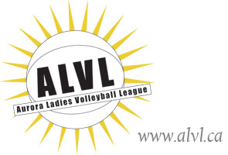

## **RETURNING Player Registration Form**

**2019/2020 Season**  **$175.00**

### NAME:

MAILING ADDRESS:

PHONE(s):      

E-MAIL ADDRESS:

DATE OF BIRTH (mm/dd/yyyy):      

EMERGENCY CONTACT PERSON:

EMERGENCY CONTACT PHONE NUMBER(S):

2018/19 CAPTAIN:

POSITION (S) PREFERRED: 1. 2.

1. Please list any medical conditions: (i.e. asthma, allergies, pregnancy etc.) *Note:* A doctor's certificate is required for pregnancy and the player may play up to the end of the FOURTH month. Cost of certificate is the responsibility of the player (ref. ALVL Constitution, Art.5)

1. **Players need to be able to commit to playing 8:30 p.m. to 10:30 p.m.** To the best of your knowledge, do you have any commitment(s) which would interfere with your ability to attend on a regular basis? (i.e. shift work)  Yes  No

**WAIVER FORM**

I hereby register and agree to hold harmless the Aurora Ladies Volleyball League (ALVL), the team, officials and executive from any and all injuries sustained while playing in this league or tryouts. I hereby waive and forever discharge the ALVL from all claims, damages, costs and expenses in respect to injury and or damage to my person or property however caused which I may sustain as a result of my participation in the league. I agree to abide by the Ontario Volleyball Association rules and the Aurora Ladies Volleyball Constitution, bylaws and playing rules.

I hereby grant permissions for photos of me to be published. Yes.  No

### July 26, 2019

### Signature Date

#### IMPORTANT NOTE

* No refunds will be issued after January 1, 2020. Notify your captain if you require a refund.
* Any player who does not pay the registration fee by October 23, 2019 will no longer be able to play in the 19-20 season.

Internal Use Only:

Paid By Cash  Paid by Cheque  Tryout ID#