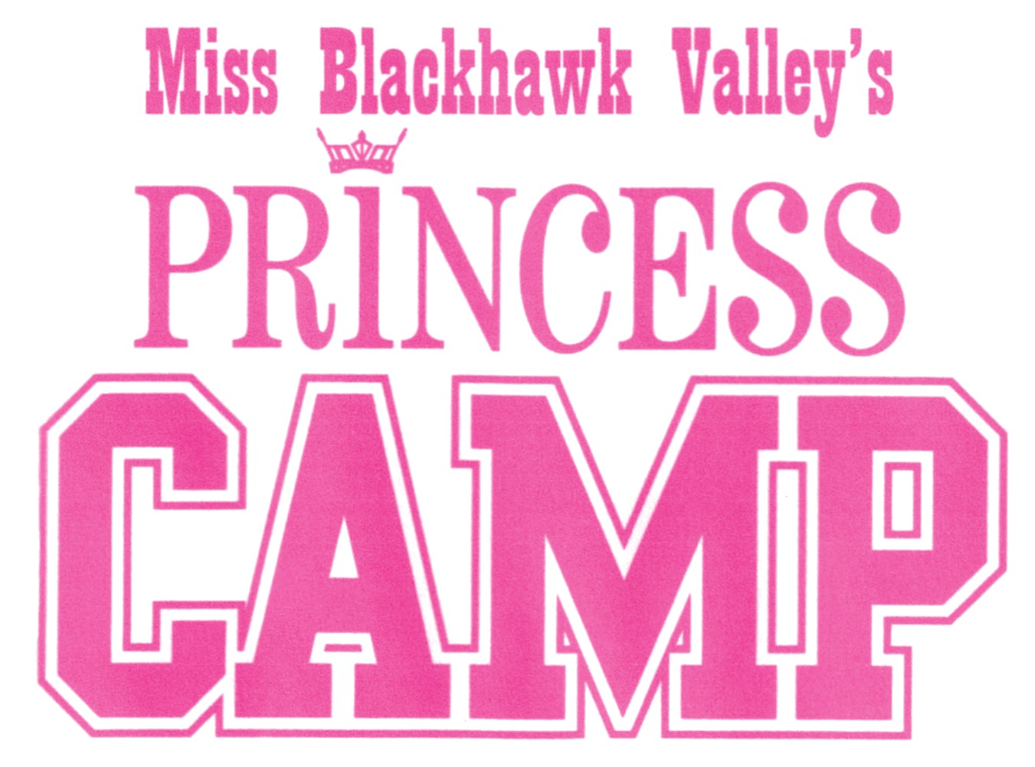

WHO: Young ladies, ages 5-12 looking to participate in a non-competitive youth mentoring program through the Miss Blackhawk Valley Scholarship Program
WHAT: Various events will be held throughout the year to allow your daughter opportunities to spend time with the Miss Blackhawk Valley titleholders, build friendships with peers, learn valuable life skills, perform in front of audiences, and grow as an individual. The goal of this program is to provide a mentoring relationship with older candidates and titleholders, teach well-rounded speaking skills, and allow an opportunity to develop performance skills.
HOW: A fee of $100 will enter your daughter into the Miss Blackhawk Valley's Princess Camp for the 2022 pageant year. By providing a digital photograph, her photo will appear on our social media accounts and during the competition production. The fee can be from multiple sponsors.
Participants in the Princess Camp will receive a T-shirt, admission to all Miss Blackhawk Valley sponsored events, a tiara and sash during the crowning ceremony, as well as many other benefits.
WHEN: Saturday, September 24th at Rockridge High School

Schedule of Events for this day TBA

Revised 7/27/22

