The Virginia Orthodontic Foundation
recommends lodging at
The Richmond Marriott
Short Pump Hotel

4240 Dominion Blvd.
Glen Allen, VA 23060
(804) 965-9500 or (800) 228-9290

Virginia Orthodontic Foundation rates:
$139 per night single or double
Other options are available.
Deadline 08/19/21

All reservations must be accompanied by a first night room deposit or guaranteed with a major credit card. The hotel will not hold any reservations unless secured by one of the above methods. Reservation cancellations must be received by the hotel at least 24 hours prior to arrival to avoid being charged one night’s Room and Tax.

Be sure to mention the name of the group when making reservations in order to obtain the group rate. Check-in time is 3pm; checkout time is 11am. Rate does not include a 13.3% tax (subject to change).

The Richmond Marriott Short Pump Hotel is conveniently located near I-64 (exit 178B) in the west end of Richmond on Dominion Boulevard in the Innsbrook Office Park (turn left at the first light on Broad Street after exiting the interstate, hotel is on the left).

Room reservations must be received by 5pm on Thursday, August 19, 2021 to receive this special rate. After this date, it will be on a space and rate availability basis.
About the Speaker
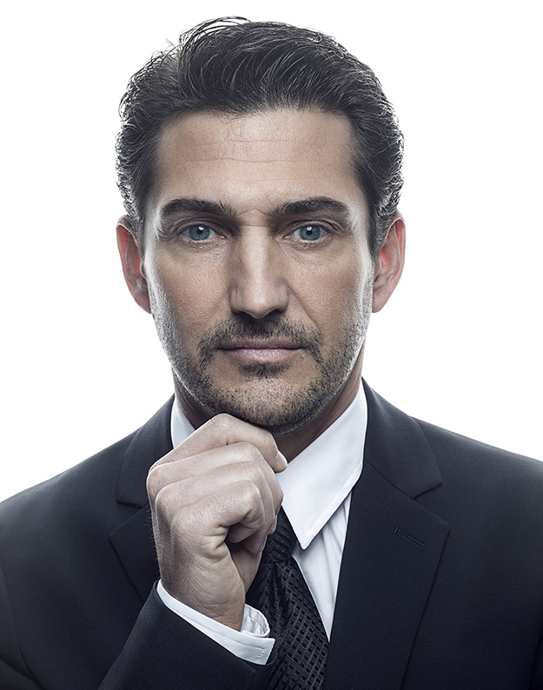
JASON B. COPE, DDS, PHD
Dr. Cope received his DDS, Orthodontic Certificate, and PhD from Baylor College of Dentistry. He has published 32 journal articles, 36 book chapters, and two orthodontic textbooks. In addition, he has given over 320 presentations around the world. Dr. Cope’s private practice is located in Dallas, Texas, where he treats patients 3 days a week.

Dr. Cope was a pioneer in the development of Temporary Anchorage Devices (TADs). In 2003, he partnered with IMTEC Corp to develop the Ortho Implant, the first US manufactured orthodontic MiniScrew Implant (MSI). He coined the term Temporary Anchorage Devices and the nomenclature system used to describe the various TAD systems. He also developed the Cope Placement ProtocolTM, the first minimally invasive protocol utilizing drill-free MSI placement with topical anesthetic only. Other MSI protocols and products he developed include the biomechanically-oriented palatal approach to openbite closure, a patented openbite-closing transplatal arch, biomechanically-oriented molar protraction, the temporary replacement of missing lateral incisors in adolescents, a patented locking closed coil spring, as well as Class II and Class III distalization protocols.

Most recently, Dr. Cope’s activities have been focused on the integration of digital 3D data into orthodontic workflows. A specific focus is merging the intraoral scan with CBCT data to create a functional working model for digital treatment planning and tooth movement in preparation for customized in-office aligner delivery and digitally guided bonding (DGBTM) with the fabrication of directly printed bonding, thereby avoiding the traditional laboratory process.
The 2021 Hybrid
Annual Meeting
of
The Virginia Orthodontic Education and Research Foundation
How to Become an In-House Aligner Power House
Presented by
Dr. Jason B. Cope
Dallas, TX
and
What is Your Aligner Prescription?
Presented by
Dr. Heather Hopkins
Columbia, SC

September 10 – 11
The Richmond Marriott
Short Pump Hotel

Lectures Sponsored in Part by:
The McIver Fund,
Dr. William E. Crutchfield,
Accutech Orthodontic Lab,
Align Technology,
American Orthodontics,
Cloud 9 Software,
Dental Monitoring,
and
uLab Systems, Inc.
About the Speaker
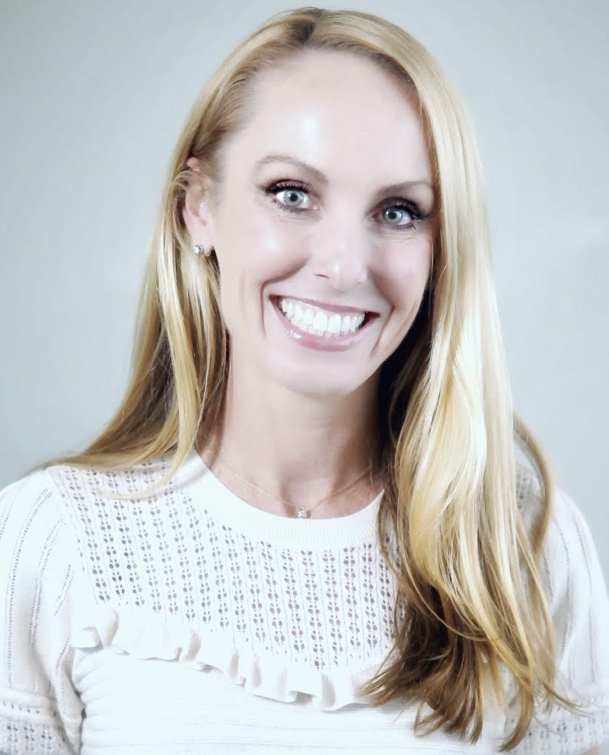
Heather Hopkins, DMD
Dr. Heather Hopkins is a partner in an ortho, pedo, GP practice in Columbia, SC. Dr. Hopkins attended the University of Kentucky for dental school, and the University of Louisville for her orthodontic residency. She is a pioneer when it comes to utilizing technology to deliver custom orthodontic care in her practice.

As a busy mom, wife, practice owner, and passionate educator, Dr. Hopkins values efficiency and effectiveness. She understands the struggle to maintain a good work life balance. This struggle is what led Dr. Hopkins reinvent her practice. Determined not to sacrifice quality in the pursuit of efficiency, she built a digital practice model that has allowed her to scale her practice without scaling up her stress. Currently, Dr. Hopkins uses 100% custom digital orthodontic therapy for her patients. She offers Invisalign aligners, in house aligners, and digital indirect bonding.

Virginia Ortho Foundation
Board of Directors

Dr. Daniel J. Lill, President
Dr. Lisa M. Babb, Vice President
Program Chair 2021
Dr. David L. Jones, Secretary
Dr. Frank P. Iuorno, Jr., Treasurer
Dr. Sheldon A. Bates
Dr. Matthew L. Eppright
Dr. Kristin L. Nelson
Dr. Christine F. Stang
Dr. Diana M. Almy, Past President
Dr. Steven J. Lindauer, Exec. Secretary

For Questions, call Darlene Johnson
at 804-828-9326
(Executive Administrative Director)

Dr. Jason Cope
How to Become an In-House Aligner Power House
Have you ever thought that doing in-house aligners (IHA) is too much of a hassle or too expensive upfront to justify taking the leap? If you have, think again! Current technology provides today's orthodontist everything they need to get started at historically low costs and manage their own IHA production facility with their own brand that represents and builds their own reputation instead of an outside lab’s brand. Modern software allows us to maintain quality, while considerably reducing the expense of outsourcing labwork and delaying treatment starts or refinements. This presentation will introduce the major steps of the Digital Workflow utilizing In-House Aligner Fabrication as the example. Various cost examples and pros/cons of different systems will be presented to answer the question “is it worth going all in”.

We will also cover the basics of setting up a digital lab as well as 3D printing. Multiple clinical examples will be used to demonstrate which clinical cases are most appropriate for in-house aligners. While many see the future of orthodontics as doomed by market disruption, it is actually an exciting time to reinvent ourselves and create even better experiences and outcomes for our patients. Welcome to the future of Orthodontics! Its bright, and more importantly, we are in control of it!

Objectives:
-Learn to appreciate the factors critical to implementing a digital workflow.
-Understand how to setup a digital lab.
-Learn to evaluate important features of tooth movement software.
-Learn to appreciate what cases are most appropriate for in-house aligners.
-Understand the essentials of becoming your own aligner manufacturer.
Dr. Heather Hopkins
What is your Aligner Prescription?
Most of us use the same prescription with a few variations to treat all of our patients. What are the limitations of treating all of your patients with a handful of bracket prescriptions? How much of your day is spent customizing brackets for your patients. Whatever the answer, your clinical team probably spends even more time waiting for you to do these customizations chairside. What if you could treat every single patient with a custom prescription? How could this improve efficiency and outcomes? In this lecture, you will learn how to apply Tweed mechanics to your 0-0-0 aligner set-ups.

Objectives:
-Learn differences in mechanics between brackets and wires
-Learn how to avoid common side effects from improper mechanics with aligners
-Learn how Aligners and other custom treatment options can improve efficiencies and clinical outcomes
-Recognize what amount of first, second, and third order forces to apply to your case set-ups

Registration Fees:
$0 VAOF Member (w/paid VAOF dues)
$100 Orthodontic Resident
$800 VAO/SAO/AAO Member
$1500 Non-VAO/SAO/AAO Member
$1500 Non-Orthodontist

Click Here to Register for the Meeting!

Click Here to Reserve Your Hotel Room!

2021 Annual Meeting
Program Schedule

Friday, September 10
8:00 am Registration, Coffee, Danish, etc.
8:30 am Introductions & Opening Remarks
8:45 am Lecture – Dr. Jason Cope
10:00 am Break
10:30 am Lecture continued – Dr. Cope
11:45 am Membership Meeting
12:30 pm Lunch (Round Table Presentations)
1:30 pm Lecture continued – Dr. Cope
3:00 pm Break
3:15 pm Lecture continued – Dr. Cope
5:00 pm Adjourn

6:30 pm Table Clinics
6:45 pm Reception

Saturday, September 11
7:30 am Coffee, Danish, etc.
8:00 am Lecture – Dr. Heather Hopkins
9:45 am Break
10:00 am Lecture continued – Dr. Hopkins
11:15 am Q & A, Concluding Discussion
11:30 am Membership Meeting
12:00 pm Adjourn
12:15 pm Board of Director’s Meeting

10.25 CE Hours

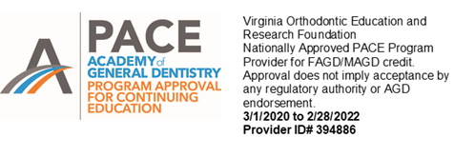

Total 10.25 CE credits available

if all lectures are attended.

Virginia Ortho Foundation
Board of Directors

Dr. Erin L. McCutchen, President

Dr. Zachary A. Casagrande, VP
Program Chair 2017

Dr. Thomas L. Roberts IV, Secretary

Dr. Pamela F. Regimbal, Treasurer

Dr. Steven J. Lindauer, Exec. Secretary

Dr. Diana M. Almy

Dr. Lisa M. Babb

Dr. Jason T. Gladwell

Dr. Daniel J. Lill

Dr. Joe Rebellato

For Questions, call Darlene Johnson
at 804-828-9326
(Assistant and Meeting Coordinator)

Virginia Ortho Foundation
Board of Directors

Dr. Erin L. McCutchen, President

Dr. Zachary A. Casagrande, VP
Program Chair 2017

Dr. Thomas L. Roberts IV, Secretary

Dr. Pamela F. Regimbal, Treasurer

Dr. Steven J. Lindauer, Exec. Secretary

Dr. Diana M. Almy

Dr. Lisa M. Babb

Dr. Jason T. Gladwell

Dr. Daniel J. Lill

Dr. Joe Rebellato

For Questions, call Darlene Johnson
at 804-828-9326
(Assistant and Meeting Coordinator)

