REGULAR MEETING
MAY 19, 2022
The Regular Meeting of the Town Board of the Town of Hampton, County of Washington and the State of New York was held at the Town Hall, 2629 State Route 22A, Hampton, New York, also via Zoom and live streaming on the You Tube Channel for “Town of Hampton New York” on the 19th day of May 2022.

Supervisor O’Brien did provide a link to join the meeting via Zoom.

PRESENT: David K. O’Brien------------Supervisor
Donald Sady-----------------Councilman
Tamme Taran----------------Councilwoman
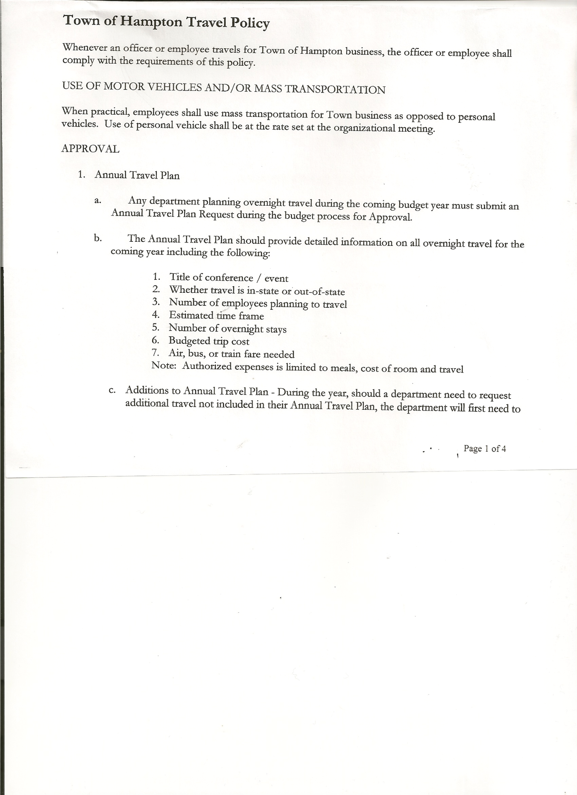
Michael Pietryka------------Councilman
Travis Dean------------------Councilman - absent
Rebecca Jones---------------Town Clerk
Camilla Shaw----------------Tax Collector/Deputy Town Clerk – absent
Tyler McClure---------------Highway Superintendent

Planning Board Member (s):… Bonnie Hawley, Chair;
Others present at the Town Hall: Artie Pratt, Leonard Reed and Rebecca Winship

The Regular Meeting was called to order by Supervisor O’Brien at 7:30pm, followed by the Pledge of Allegiance. Location of Fire Exits were given. Quorum of board members present.

Supervisor O’Brien asked for a moment of silence in memory of Scott Lily and Marion Dewey

RESOLUTION NO. 39-2022
APPROVAL OF THE MINUTES
On a motion of Councilwoman Taran, seconded by Councilman Sady, the following resolution was ADOPTED: AYES 4 O’Brien, Sady, Taran, Pietryka
NAYS 0
ABSENT 1 Dean
RESOLVED, that the Regular Town Board Meeting Minutes for April 21, 2022 are approved.

PERMITS/SUBDIVISION
Rebecca Winship, Agent for John Mashak, came before the board regarding a Boundary Line Adjustment with Joyce & Maurice Disorda.

RESOLUTION NO. 40-2022
SHORT ENVIRONMENTAL ASSESSMENT FORM/NEGATIVE DECLARATION
On a motion of Councilman Sady, seconded by Councilwoman Taran, the following resolution was ADOPTED: AYES 4 O’Brien, Sady, Taran, Pietryka
NAYS 0
ABSENT 1 Dean
RESOLVED, that the Short Environmental Assessment Form for John Mashak is complete and to adopt a negative declaration and finding that there will be no adverse environmental impacts and to consider it a minor subdivision, therefore waving the public hearing.

TOWN BOARD MEETING
MAY 19, 2022 PAGE 2

RESOLUTION NO. 41-2022
APPROVAL OF BOUNDARY LINE ADJUSTMENT
On a motion of Councilman Sady, seconded by Councilwoman Taran, the following resolution was ADOPTED: AYES 4 O’Brien, Sady, Taran, Pietryka
NAYS 0
ABSENT 1 Dean
RESOLVED, to approve Mashak boundary line adjustment upon receipt of the fee.

Larry Carman, Dog Control Officer submitted his report dated 5/15/22 which was read by Supervisor O’Brien, copy of report is attached.

Camilla Shaw, Tax Collector….. no report submitted

Bonnie Hawley, Chair gave Planning Board Report……copy of the minutes of their meeting held May 11, 2022 are attached. Next meeting is planned for June 8th, 2022 at the Town Hall.

Tyler McClure, Highway Superintendent submitted his report, copy of which, is attached.
Highway Employee, Jimmy Brown hoping to be back to work the end of May.

SUPERVISOR’S REPORT/ COUNTY UPDATES/ COMMUNICATIONS

RESOLUTION NO. 42-2022
APPROVAL OF SUPERVISOR’S MONTHLY REPORT
On a motion of Councilwoman Taran, seconded by Councilman Sady, the following resolution was ADOPTED: AYES 4 O’Brien, Sady, Taran, Pietryka
NAYS 0
ABSENT 1 Dean
RESOLVED that, the Supervisor’s Monthly report be accepted as submitted for APRIL
03/31/22 04/30/22
ACCOUNT BALANCE RECEIPTS DISBURSEMENTS BALANCE
General Fund $ 56,661.39 $ 8,494.27 $ 6,917.62 $ 58,238.04
Highway Fund $367,718.05 $ 9.02 $ 25,048.89 $ 342,678.18
Equipment Reserve $114,929.61 $ 2.83 $ 0.00 $ 114,932.44
Fire #1 $ 44,163.00 $ 0.00 $ 0.00 $ 44,163.00
Fire #2 $ 10,404.00 $ 0.00 $ 0.00 $ 10,404.00
Cemetery $ 1,757.63 $ 1.39 $ 0.00 $ 1,759.02
Totals $595,633.68 $ 8,507.51 $ 31,966.51 $ 572,174.68
All Board Members present signed Supervisor’s Report.

NEW BUSINESS
Videoconferencing….extended time for Zoom Meetings until June 15th. If Board wants to continue offering video conferencing for board meetings will need to pass a local law and have a Policy. Following a lengthy discussion on pros and cons of video conferencing, the board decided not to continue with Zoom Meetings.

TOWN BOARD MEETING
MAY 19, 2022 PAGE 3

PUBLIC COMMENTS/COUNCIL COMMENTS
Rebecca Jones, Town Clerk shared that her daughter Hannah Jones would be graduating from University of New England, Portland, Maine on Saturday, May 21st, 2022 with her Doctorate in Physical Therapy.

RESOLUTION NO. 43 -2022
AUDIT OF CLAIMS
On a motion of Councilwoman Taran, seconded by Councilman Sady the following resolution was ADOPTED: AYES 4 O’Brien, Sady, Taran, Pietryka
NAYS 0
ABSENT 1 Dean
RESOLVED that the bills have been reviewed by the Town Board and are authorized for payment in the following amounts.
General Fund No. 59 through No. 70 $ 2,666.09
Highway Fund No. 48 through No. 56 $ 4,249.03
Total both funds $ 6,915.12

The Town Clerk’s report for April 2022 was submitted to the Board. The Town Clerk had Board Members review and sign bank reconciliation statements for the Town Clerk Account and Special Clerk Account dated April 30, 2022.

RESOLUTION NO. 44-2022
MEETING ADJOURNED
On a motion of Councilman Sady, seconded by Councilman Pietryka, the following resolution was ADOPTED: AYES 4 O’Brien, Sady, Taran, Pietryka
NAYS 0
ABSENT 1 Dean
RESOLVED that the meeting adjourned at 8:24pm.

Respectfully submitted,

Rebecca S. Jones, RMC
Town Clerk

