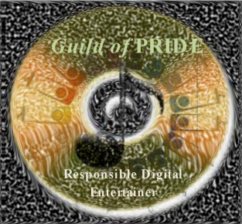
Application for Membership
THE GUILD OF PRIDE
(Professional Recorded Instrumental Digital Entertainers)

The Guild of PRIDE
6901 Berkridge Court
Hazelwood, MO 63042
Sharon Frank, Executive Director
Phone: 1-314-839-0046 Fax: 1-818-705-2513
Website: www.guildofpride.org Email: sharon@guildofpride.org

Please print your name as you would like it to appear on your Membership Card and in the general listing.

Name: _____________________________________________Partner:________________________________________________

Mailing address: __________________________________________________________________________________________

City: __________________________________________ State: ____________Zip Code: _________________

Country: _________________________________________Email:___________________________________________

Telephone: (Home) ______________________ (Work) _____________________ (Cell) ________________________

Please list the local, state, regional, national, and/or international association(s) to which you belong?

__________________________________________________________________________________________________

Invitation to join the Guild extended by: ______________________________________________________________

Membership Dues: 3 year Membership $15_________ 5 year Membership $20_________

Make checks payable to Guild of PRIDE and send to address listed above. Payments using PayPal can be made on the website: www.guildofpride.org . If using one the these credit cards (Visa, American Express, Discover, or Master Card) without access to the website, please provide the following:

Printed name as it appears on card:____________________________________#:________________________________

Exp. Date: _____________ CID#:__________ (3 Numbers on Back, AMEX 4 on front)

Signature of cardholder: ________________________________________________ Date: ________________________

Please sign the following to fulfil Guild of PRIDE Membership requirements:

By signing below, I attest that I agree, and wholeheartedly support the mission of The Guild of Pride. This mission is to proclaim, promote, and practice the most ethical and legal methods of acquiring, maintaining, and protecting one's ownership in the use of recorded music for teaching and entertaining.

To achieve Elite Membership Status, I understand that I will begin the process of thoroughly reviewing all the music I use to ensure that every piece of music has been obtained in a manner which properly and completely compensates the artist(s) and producer(s) responsible for its creation and distribution. I will permanently maintain my music in this standard and will not enable others to copy or use copies of my music while I retain its ownership.

Name: ______________________________________________________________Date: _________________________
Teaching/Entertaining Professional

