April 30-Aug 9  Early bird discount has started for Adult SLow Pitch Coed and Men’s Softball  Slow Pitch Softball  Are you looking for a summer activity? Why not play adult slow pitch softball? Anchor Town Sports offers Coed and Men’s softball during the summer. We have leagues of competition for players of all skill levels. Coed play on Monday, Tuesday, Wednesday. Men play on Tuesday and Corec (7 guys, 3 girls) play on Thursday. All games are played at Dela Vega fields. There are also leagues that play on the Park Strip downtown. We also offer optional tournaments throughout the season. If you are interested or have questions, please contact us.  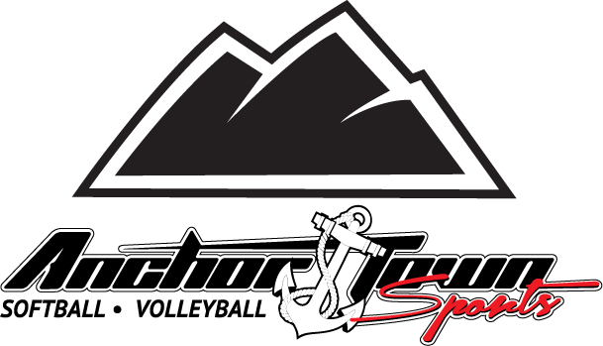 | Lowest Prices in Town!  ────  Coed Team Fee  $400  ────  Men’s Team Fee  $575  Player Fee  $60  ────  Early Bird sign-up savings of $50 on team fee  ────  Giveaways during the season  Anchor Town Sports  601 W 36th Ave. Suite 2  Anchorage, AK 99503  907-272-4200  Anchortownsports.com

