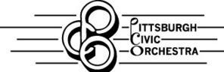
New Member Application

Printed Name: ___________________________________________________________

Main instrument: ___________________ Other instrument(s):__________________________

Kind of performance experience: Professional Community Collegiate Other

If “other,” please explain: ________________________________________________________
Years of performance experience on your main instrument: ________________
I want to join the PCO because:

____________________________________________________________________________

____________________________________________________________________________

____________________________________________________________________________

I learned about the PCO through:
_____________________________________________________________
____________________________________________________________________________

I have emailed my audition video sample to the PCO: Yes No

Contact information:

E Mail:_______________________________________________________________________

Phone #1__________________________ Phone # 2____________________________

Address: ____________________________________________________________________
____________________________________________________________________

Signature: ________________________________________________________
Parent/Guardian Signature (if under 18) ____________________________________________

Date: _______________

