**How do I… view my earnings statement?**

You can access your earnings statement by selecting the “Earnings” option on the menu panel.

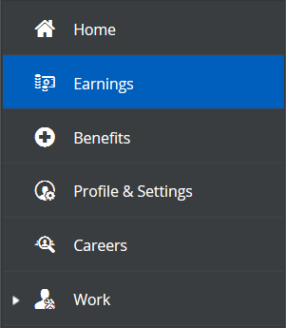

The “Earnings Statements” tab will list all your statements organized by the month.

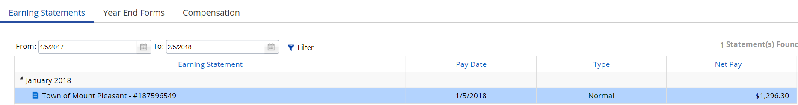

To view your earnings statement, click on one, then select “Statement”.

**Note:** The memo information shows what the Town is paying on employees’ behalf for certain benefits. The amounts listed are not being deducted from your pay check.

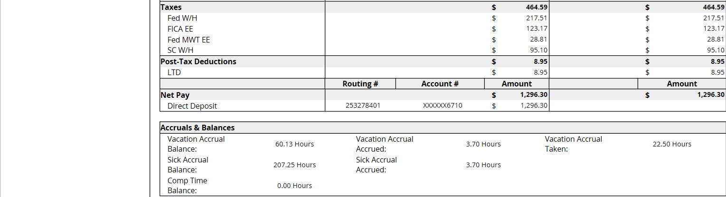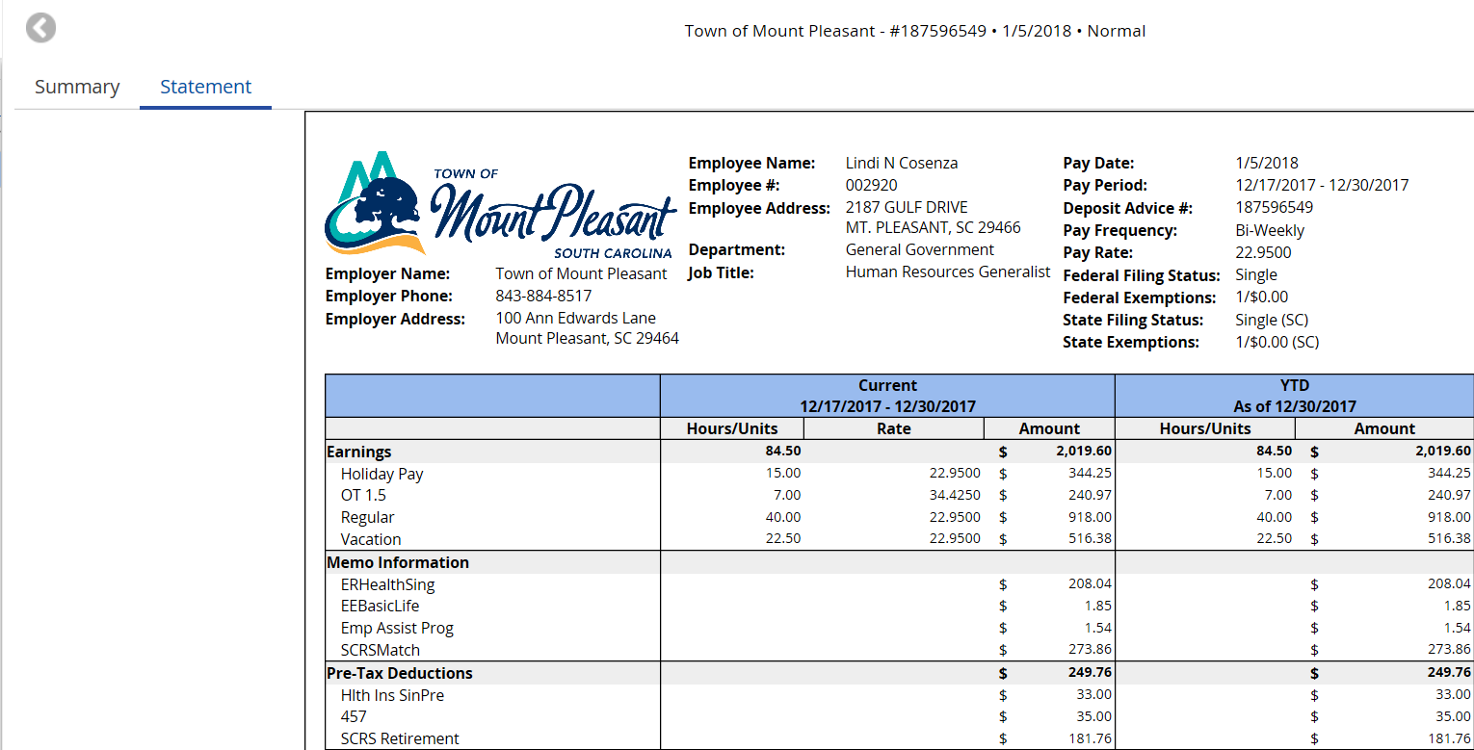

**You will not receive a paper pay stub. You will be able to view and print your earnings statements at any time.**