REGULAR MEETING
APRIL 16, 2014

A Regular Meeting of the Town Board of the Town of Hampton, County of Washington and the State of New York was held at the Town Hall, 2629 State Route 22A, Hampton, New York on the 16th day of April, 2014.

PRESENT: David K. O’Brien----------Supervisor
Tamme Taran--------------Councilwoman
David Jensen---------------Councilman
Donald Sady----------------Councilman
Andrea Sweeney-----------Councilwoman-came at 7:35pm
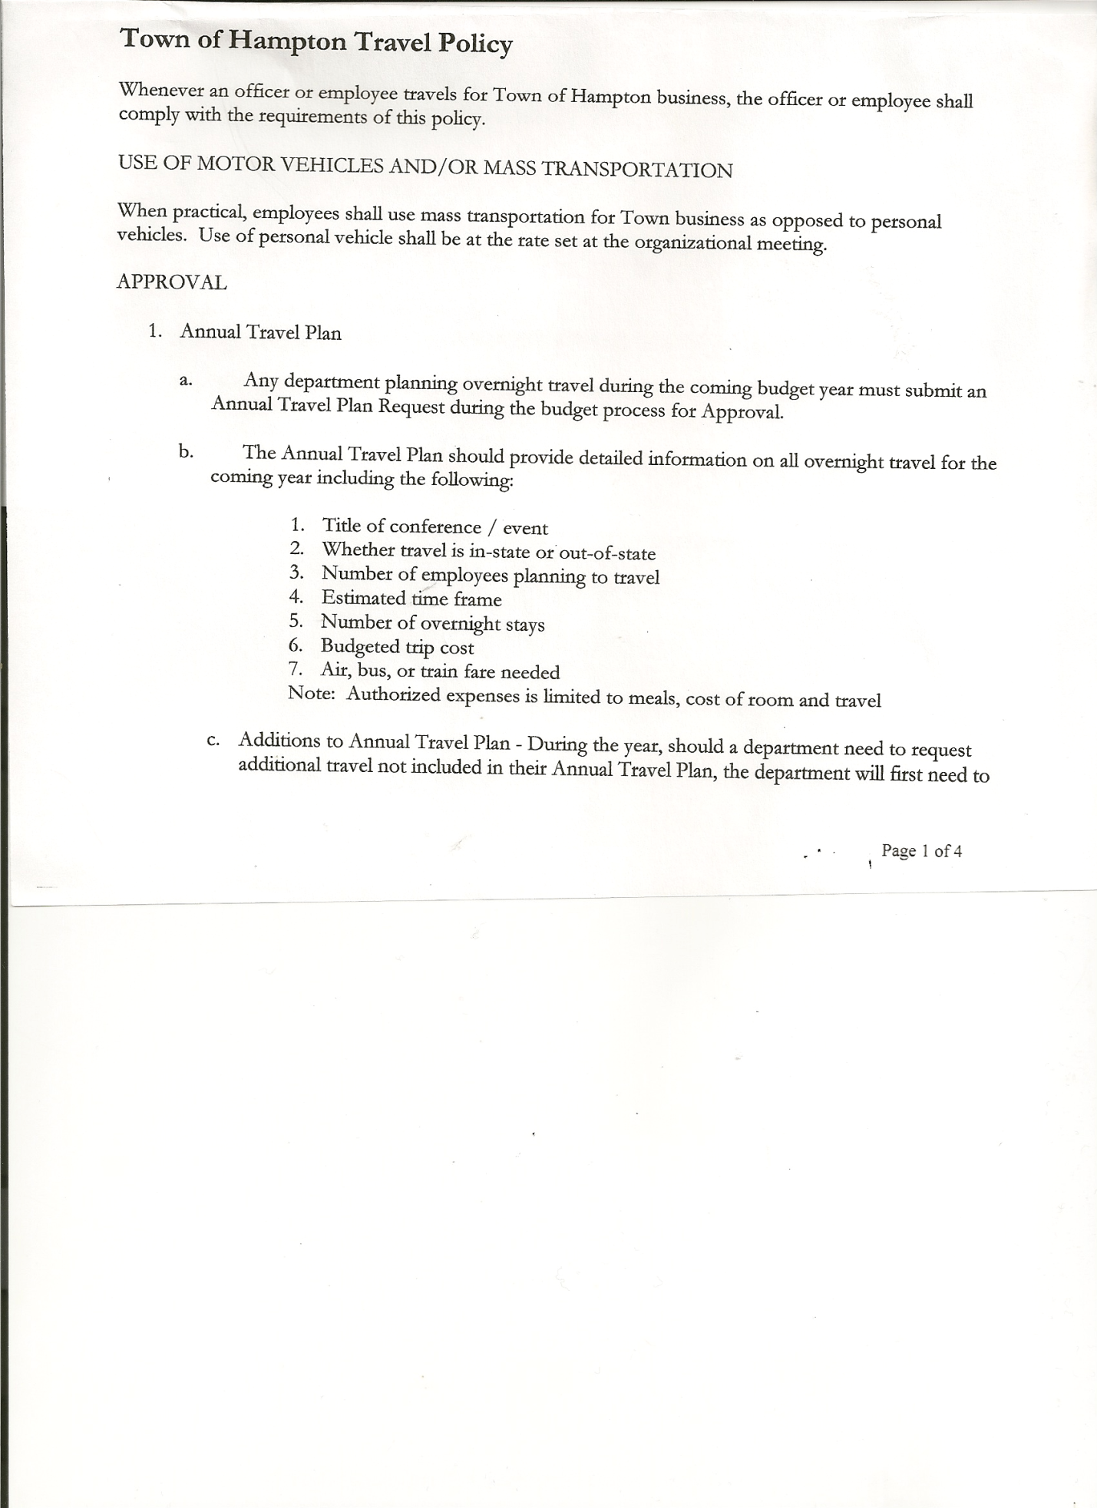
Rebecca Jones--------------Town Clerk
Camilla Shaw---------------Tax Collector/Deputy Town Clerk
Herbert Sady, Jr.-----------Highway Superintendent

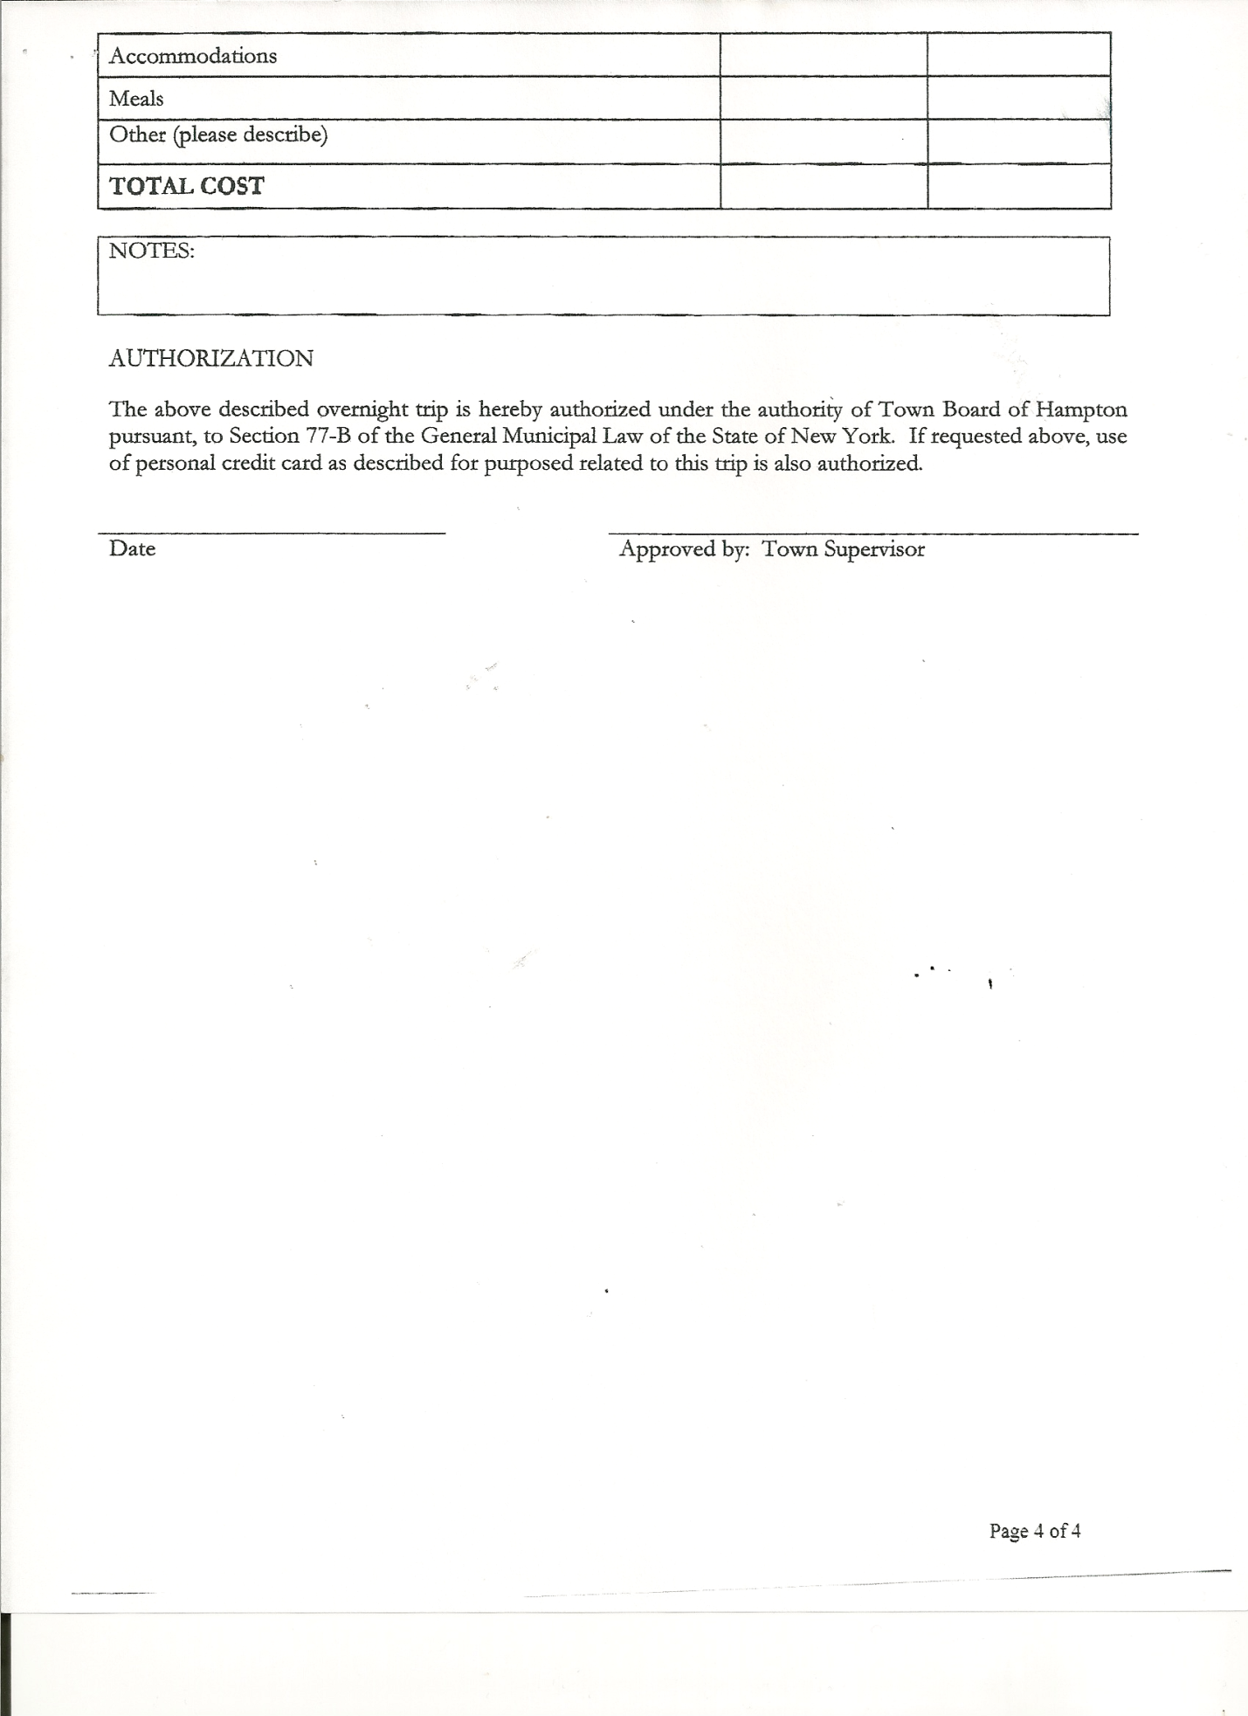
Planning Board Member(s): Bonnie Hawley, Chair and Francis Baker

Also present: Derek Liebig, Whitehall Times Reporter, Joseph Mead, Artie Pratt, Leonard Reed and Matthew Sears

The meeting was called to order by Supervisor O’Brien at 7:30pm followed by the Pledge of Allegiance. Location of Fire Exits were given.

RESOLUTION NO. 37-2014
APPROVAL OF THE MINUTES
On a motion of Councilman Sady, seconded by Councilman Jensen, the following resolution was
ADOPTED: Ayes 5 O’Brien, Taran, Jensen, Sady, Sweeney
Nays 0
RESOLVED that the Regular Town Board Minutes for March 19, 2014 are approved.

Planning Board Report…Bonnie Hawley, Chair gave report
- Mobile Home Law...corrections were done and sent back to Attorney Fuller for review
- Next meeting will be Tuesday, April 22nd, 2014 at 7:00pm at the Town Hall

Larry Carman, Dog Control Officer submitted his report, no activity to report for April and copy of report for March is attached.

Herbert Sady, Jr., Highway Superintendent gave his report: (a copy is attached)
- Cleaning out culverts
- Repairing potholes
- Water pump on John Deere is fixed and being installed
- Maintenance on the trucks and getting plows, wings and boxes ready for repainting
- Cleared down trees out of the road from the wind
- Door on loader is repaired and installed
- Will be grading dirt roads soon
- Highway Employees will be going to a 4 day, 10 hours a day starting April 16th til sometime in October.
Briefly spoke about CHIPS money for 2014, using on South Road.

TOWN BOARD MEETING
APRIL 16, 2014 PAGE 2

Highway Department received additional money from NYS in the amount $5184.29 for use to make road repairs following this year’s exceptionally harsh winter.
Equipment Replacement Plan info handed out to Board Members…need to be looking at increasing the amount to be put away each year.

Supervisor O’Brien spoke about Governor Cumo’s Shared Services and Tax Rebate Plan…
Town & County Shared Services Plan..2 possibilities are Highway Services and Villages
Dissolving
Equipment Funds….County could potentially buy all equipment..trucks, etc
Plan needs to be in place by June 2015.
Highway Superintendent, Herb Sady has spoke with Town of Whitehall…they are not interested in taking over any roads in Hampton as far as plowing….Supervisor O’Brien stated that the County pays so much per mile if Town plowed for them, Town may consider this option.

Deputy Tax Collector Jones submitted Tax Collector Report for March 2014.
She also had Board Members review and sign bank reconciliation statement dated March 31st, 2014.

Supervisor O’Brien reported that the County has revised its Foreclosure procedures….If taxes were are not paid for three (3) years, deeds were signed over to the County two (2) weeks before tax sale…this has been revised so that the County is not taking ownership until the day before the sale.

Supervisor O’Brien also reported that the County maybe making changes to certain Exemptions…Veterans/Income and Age.

RESOLUTION NO. 38-2014
APPROVAL OF SUPERVISOR’S MONTHLY REPORT
On a motion of Councilwoman Taran, seconded by Councilman Sady, the following resolution was ADOPTED Ayes 5 O’Brien, Taran, Jensen, Sady, Sweeney
Nays 0
RESOLVED that the Supervisor’s Monthly report be accepted as submitted for MARCH 2014.
02/28/14 03/31/14
ACCOUNT BALANCE RECEIPTS DISBURSEMENTS BALANCE
General Fund $ 83938.05 $ 1333.76 $ 8306.54 $ 76965.27
Highway Fund $143710.23 $ 11.99 $ 11543.51 $ 132178.71
Equipment Reserve $ 85081.19 $ 7.23 $ 0.00 $ 85088.42
Fire #1 $ 31985.00 $ 0.00 $ 0.00 $ 31985.00
Fire #2 $ 4724.00 $ 0.00 $ 0.00 $ 4724.00
Totals $ 349438.47 $ 1352.98 $ 19850.05 $ 330941.40
All Board Members present signed Supervisor’s Report.

Lease with Fire Department has been signed.
Joe Mead, Chief of Fire Department looking to set up meeting regarding fundraising…following a short discussion with committee members, Councilwoman Taran and Councilman Jensen…meeting will be April 24th at 7:00pm at the Firehouse.

Joe also announced that the Fire Department will be holding a Basket Party at the Firehouse on May 31st from 12pm to 4pm.
TOWN BOARD MEETING
APRIL 16, 2014 PAGE 3

OLD BUSINESS
Staso Road & Ballard Road….following a discussion, Highway Superintendent Sady will check on signage for weight limit and no trucks local traffic only. Will also check on getting some horse/carriage signs for Town Roads.

Councilman Donald Sady went over a draft of the Policy for Use of Town Hall…board members discussed and there were some recommendations for some changes, will discuss further at next board meeting.

RESOLUTION NO. 39-2014
MOTION BY: Councilman Donald Sady
SECONDED BY: Councilman David Jensen

TITLE: RESOLUTION INTRODUCING PROPOSED LOCAL LAW AMENDING LOCAL LAW 1 OF 2014 TO RESCHEDULE THE DATE FOR HEARING COMPLAINTS BY THE BOARD OF ASSESSMENT REVIEW

WHEREAS, pursuant to Section 512 of the Real Property Tax Law of the State of New York, the Town Board (the “Board”) of the Town of Hampton (the “Town”) has the authority to adopt a local law rescheduling the date for hearing complaints by the Board of Assessment Review pursuant to Real Property Tax Law Section 512; and

WHEREAS, the Board previously adopted Local Law 1 of 2014 changing the date for hearing complaints by the Board of Assessment Review which Local Law contained an error describing said date; and

WHEREAS, the Board finds that this law is necessary to coordinate the hearing date with the schedule of the Town’s assessor who also works with neighboring municipalities in Washington County; and

WHEREAS, a local law has been drafted to reschedule such date for hearing of complaints.

NOW, THEREFORE BE IT RESOLVED by the Town Board of the Town of Hampton as follows:

Section 1. A public hearing shall be scheduled for the consideration of the proposed Local Law to be held by the Town Board May 21st, 2014 at 7:25 pm.

Section 2. The Town Clerk is directed to post and publish a notice of said public hearing in The Granville Sentinel and The Whitehall Times at least five (5) days before the hearing.

Section 3. This resolution shall take effect immediately.
DATED: April 16, 2014 Supervisor O’Brien AYE
Councilman Sady AYE
Councilwoman Sweeney AYE
Councilman Jensen AYE
Councilwoman Taran AYE

TOWN BOARD MEETING
APRIL 16, 2014 PAGE 4

Supervisor O’Brien stated that
- the Capital Reserve Fund Resolution that was written back in 1998 needs to be revised and rewritten and that
- Quarterly Audits need to be done for Bookkeeper, Justice, Tax Collector and Town Clerk

RESOLUTION NO. 40-2014
PAINTING OF TOWN GARAGE
On a motion of Councilwoman Taran, seconded by Councilwoman Sweeney the following resolution was ADOPTED Ayes 5 O’Brien, Taran, Jensen, Sady, Sweeney
Nays 0
RESOLVED, to spend up to $1200.00 for paint to have Town Garage painted by Alternative Sentencing.

RESOLUTION NO. 41-2014
HIGHWAY WARRANT CORRECTION
On a motion of Councilwoman Taran, seconded by Councilman Jensen the following resolution was ADOPTED Ayes 5 O’Brien, Taran, Jensen, Sady, Sweeney
Nays 0
RESOLVED, to change January 15th, 2014 Highway Warrant, Vouchers #2 and #3, Fund Account from DA5110.4 to DA5142.4.

The Town Clerk’s report for March 2014 was submitted to the Board. The Town Clerk had Board Members review and sign bank reconciliation statements for the Town Clerk Account and Special Town Clerk Account dated March 31st, 2014.

RESOLUTION NO. 42-2014

AUDIT OF CLAIMS
On a motion of Councilman Sady, seconded by Councilwoman Taran the following resolution was ADOPTED Ayes 5 O’Brien, Taran, Jensen, Sady, Sweeney
Nays 0
RESOLVED that the bills have been reviewed by the Town Board and are authorized for payment in the following amounts.
General Fund No. 54 through No. 63 $ 3098.10
Highway Fund No. 45 through No. 53 $ 4334.68
Total both funds $ 7432.78

On a motion of Councilwoman Taran, seconded by Councilman Sady , the meeting adjourned at 9:07pm. All in favor Aye.

Respectfully submitted,

Rebecca S. Jones, RMC
Town Clerk

