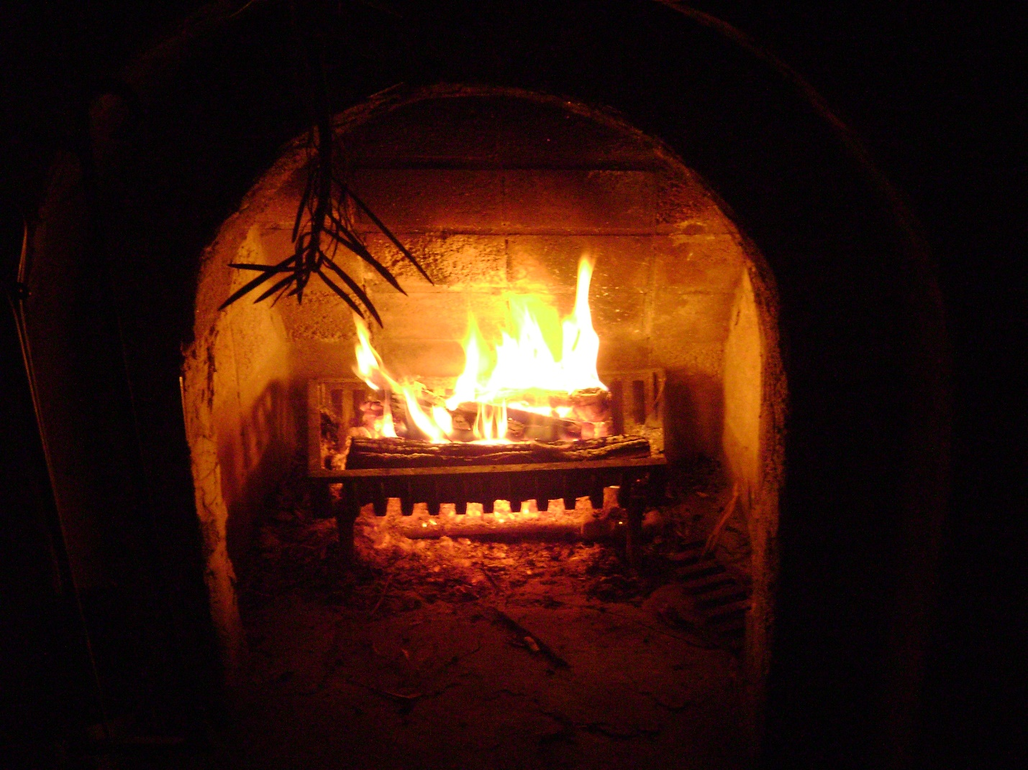
This Photo by Unknown Author is licensed under CC BY

Day 9: Seek Out the Warmth of a Fireplace
Richard J. Foster, in his book Prayer, describes the state of bliss and contentment he experienced as a seven-year-old in front of the fireplace:
“Let me describe my grateful center to you. I was seven years old, and my parents were trying to move to the West Coast. Our relative poverty, however, caught up with us, and we were forced to winter in the cabin of an uncle in the Rocky Mountains. The time was difficult for my parents, I am sure, but for me it was glory…
My most vivid memory is of the fireplace. (I had never been around a fireplace before, all our heat heretofore having come from the coal furnace in our Nebraska home.) Every night I would pull out the bed that hid in the couch by day and climb under the heavy quilts, my head less than ten feet away from the crackling warmth. Night after night I would fall asleep, watching this strange yellow blaze that warmed us all. I was in my grateful center.”
Revel in the cold for giving you a chance to savor the peaceful healing balm of warmth, whether it be a fireplace or some blankets you crawl under when you are shivering. And don’t pass up pressing your body up against the warm body of the one you love!

