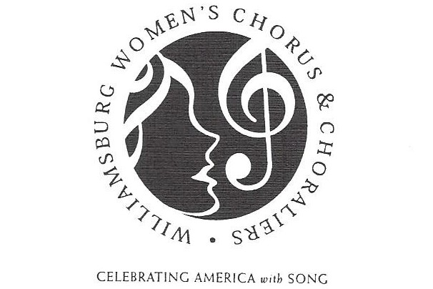

Williamsburg Women’s Chorus Scholarship Opportunity

The Williamsburg Women’s Chorus is offering two $300 scholarships to further the vocal education of two female students.

- Eligible young women are enrolled in grades 8 through 11 during the current (2017-2018) school year and reside within the greater Williamsburg postal area.
- The application deadline by which all materials must be received is midnight, February 28, 2018.
- The winner will be announced in March, and funds will be distributed directly to their music teachers at the beginning of the 2018-2019 school year.

Enclosed are eligibility Guidelines and the Application Form. PLEASE DISTRIBUTE THESE TO YOUR ELIGIBLE STUDENTS and encourage them to apply.

Each applicant will need to submit:
- Completed Application Form
- Signed copy of the scholarship guidelines
- Personal letter (see Application for more information)
- Written recommendation from her vocal/choral teacher, and
- 5-minute audio file that demonstrates vocal ability with two distinct types of music—classical and Broadway/jazz.

The winners will be invited to sing with the Williamsburg Women’s Chorus at our Spring 2019 concert.
Our Women’s Chorus appreciates the opportunity to encourage and assist talented young women in the pursuit of their vocal studies. If you have questions or need additional information, please contact me at 817-905-8987 or at stormspk84@gmail.com. Please note the application deadline has been changed to February 28th. Thank you!

Sincerely,
Kim Storms, Scholarship Chair
Williamsburg Women’s Chorus

