REGULAR MEETING
JULY 16, 2020
A Regular Meeting of the Town Board of the Town of Hampton, County of Washington and the State of New York was held at the Town Hall and via Zoom, 2629 State Route 22A, Hampton, New York on the 16th day of July 2020.

Due to the Corona Virus, occupancy inside the Town Hall is limited at this time. Supervisor O’Brien did provide a link to join the meeting via Zoom.

PRESENT: David K. O’Brien------------Supervisor
Tamme Taran----------------Councilwoman – via Zoom
Donald Sady-----------------Councilman
Andrea Sweeney------------Councilwoman – absent
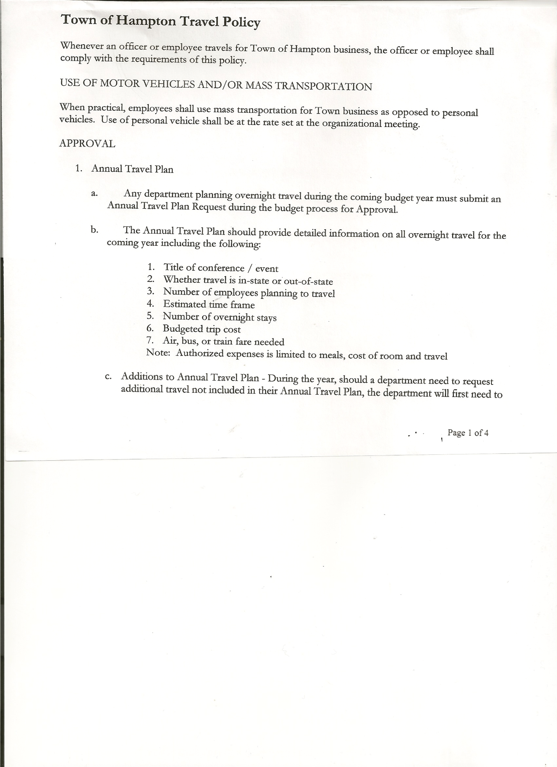
Michael Pietryka------------Councilman
Rebecca Jones---------------Town Clerk
Camilla Shaw----------------Tax Collector/Deputy Town Clerk
Herbert Sady, Jr.-------------Highway Superintendent

Planning Board Member(s): Matthew Pratt via Zoom.

Also present: Attorney Nathan Hall representing Larry Moore via Zoom
Others present at the Town Hall: John Barber, Jr.; Stuart & Lois Griffin; Artie Pratt and Leonard Reed.

The Regular Meeting was called to order by Supervisor O’Brien at 7:30pm, followed by the Pledge of Allegiance. Location of Fire Exits were given. Quorum of board members present.

Supervisor O’Brien asked for a moment of silence in memory of Hilda Hamel.

RESOLUTION NO. 55-2020
APPROVAL OF THE MINUTES
On a motion of Councilman Sady, seconded by Councilman Pietryka, the following resolution was ADOPTED:
By Roll Call Vote: Supervisor O’Brien AYE
Councilman Sady AYE
Councilwoman Taran AYE
Councilman Pietryka AYE
Councilwoman Sweeney ABSENT
RESOLVED, that the Regular Town Board Minutes for June 18th, 2020 are approved.

Larry Carman, Dog Control Officer – no report submitted

Tax Collector’s Report – no activity. Submitted Bank Statement to the Board for review and signatures.

Planning Board … no report submitted

PERMITS/SUBDIVISION

Attorney Nathan Hall via Zoom acting agent for Larry Moore submitted paperwork for a Lot Line Adjustment between Larry Moore and John Barber, Jr.

TOWN BOARD MEETING
JULY 16, 2020 PAGE 2

RESOLUTION NO. 56-2020
SHORT ENVIRONMENTAL ASSESSMENT FORM/NEGATIVE DECLARATION
On a motion of Councilwoman Taran, seconded by Councilman Pietryka, the following resolution was ADOPTED:
By Roll Call Vote: Supervisor O’Brien AYE
Councilman Sady AYE
Councilwoman Taran AYE
Councilman Pietryka AYE
Councilwoman Sweeney ABSENT
RESOLVED, that the Short Environmental Assessment Form is complete and to adopt a negative declaration and finding that there will be no adverse environmental impacts and to consider it a minor subdivision, therefore waving the public hearing.

RESOLUTION NO. 57-2020
APPROVAL OF BOUNDARY LINE ADJUSTMENT
On a motion of Councilman Sady, seconded by Councilwoman Taran, the following resolution was ADOPTED:
By Roll Call Vote: Supervisor O’Brien AYE
Councilman Sady AYE
Councilwoman Taran AYE
Councilman Pietryka AYE
Councilwoman Sweeney ABSENT
RESOLVED, to approve the Moore/Barber Boundary Line Adjustment. Mylar Map for board to sign will be forth coming.

Herbert Sady, Jr., Highway Superintendent submitted his report, copy of which, is attached.
South Road..logging area…. individual doing the logging says he will fix the road where it was damaged.

Fire on Hills Pond Road at the home of Ralph and Brandy Petty. Hampton Fire House will be open on Saturday, July 18th from 12 to 4 pm for anyone interested in dropping off any donations.

SUPERVISOR’S REPORT/COUNTY UPDATES/COMMUNICATIONS

RESOLUTION NO. 58 -2020
APPROVAL OF SUPERVISOR’S MONTHLY REPORT
On a motion of Councilman Sady, seconded by Councilman Pietryka, the following resolution was ADOPTED:
By Roll Call Vote: Supervisor O’Brien AYE
Councilman Sady AYE
Councilwoman Taran AYE
Councilman Pietryka AYE
Councilwoman Sweeney ABSENT

TOWN BOARD MEETING
JULY 16, 2020 PAGE 3

RESOLVED that, the Supervisor’s Monthly report be accepted as submitted for JUNE.
05/31/20 06/30/20
ACCOUNT BALANCE RECEIPTS DISBURSEMENTS BALANCE
General Fund $ 55,844.06 $ 15,057.95 $ 6,046.95 $ 64,855.06
Highway Fund $ 145,383.27 $ 5.87 $ 19,447.48 $ 125,941.66
Equipment Reserve $ 64,865.30 $ 2.66 $ 0.00 $ 64,867.96
Fire #1 $ 42,448.00 $ 0.00 $ 21,224.00 $ 21,224.00
Fire #2 $ 10,000.00 $ 0.00 $ 5,000.00 $ 5,000.00
Cemetery $ 1,733.80 $ 2.18 $ 0.00 $ 1,735.98
Totals $320,274.43 $ 15,068.66 $ 51,718.43 $283,624.66
All Board Members present signed Supervisor’s Report.

Budget Forms will be handed out at next month’s regular meeting.

Following a discussion regarding Speed Limit on County Route 11A, Golf Course Road, the following resolution was introduced.
RESOLUTION NO. 59 -2020
SPEED LIMIT REDUCTION
On a motion of Councilman Sady, seconded by Councilwoman Taran, the following resolution was ADOPTED:
By Roll Call Vote: Supervisor O’Brien AYE
Councilman Sady AYE
Councilwoman Taran AYE
Councilman Pietryka AYE
Councilwoman Sweeney ABSENT
RESOLVED, that the Town Board of the Town of Hampton and County Superintendent of Highways of the County of Washington hereby request the Department of Transportation, State of New York to reduce the speed limit to 35MPH on County Route 11A, Golf Course Road.

The Town Clerk’s report for June 2020 was submitted to the Board. The Town Clerk had Board Members review and sign bank reconciliation statements for the Town Clerk Account and Special Clerk Account dated June 30th, 2020.

RESOLUTION NO. 60-2020
AUDIT OF CLAIMS
On a motion of Councilman Sady, seconded by Councilwoman Taran, the following resolution was ADOPTED:
By Roll Call Vote: Supervisor O’Brien AYE
Councilman Sady AYE
Councilwoman Taran AYE
Councilman Pietryka AYE
Councilwoman Sweeney ABSENT
RESOLVED that the bills have been reviewed by the Town Board and are authorized for payment in the following amounts.
General Fund No. 64 through No. 71 $ 730.98
Highway Fund No. 67 through No. 78 $ 6,509.47
Total both funds $ 7,240.45
TOWN BOARD MEETING
JULY 16, 2020 PAGE 4

RESOLUTION NO. 61-2020
MEETING ADJOURNED
On a motion of Councilman Sady, seconded by Councilman Pietryka, the following resolution was ADOPTED:
By Roll Call Vote: Supervisor O’Brien AYE
Councilman Sady AYE
Councilwoman Taran AYE
Councilman Pietryka AYE
Councilwoman Sweeney ABSENT
RESOLVED that the meeting adjourned at 8:17pm.

Respectfully submitted,

Rebecca S. Jones, RMC
Town Clerk

