**Creating a TRAIN Account**

Anyone can create a TRAIN user account. It’s a free process and is open to all. To create account, you’ll need a few pieces of information, such as your email address and work setting. Once your account is setup, you’ll have full access to your state’s list of training courses

Important: Most of the content listed on TRAIN is generated by third parties. This means that the content may have been created across multiple platforms and the technical requirements for accessing each course may vary depending on the individual Course Provider’s preferences and settings. Please see the Minimum Technical Requirements section below.

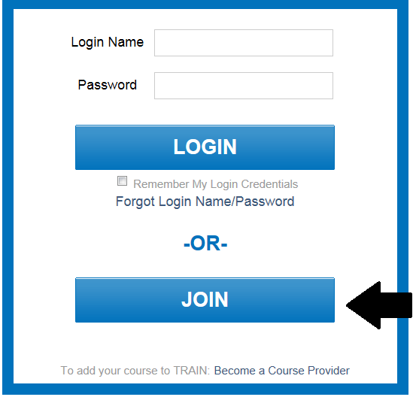TO CREATE A TRAIN ACCOUNT:

1. Locate and access your state or organization’s portal address from the State Affiliates and Organizations list. **Kentucky’s TRAIN system is located at:** [**https://ky.train.org**](https://ky.train.org)

2. Within the portal page, click the JOIN button. This will be on the left side of the page

3. Read and agree to the TRAIN Policies.

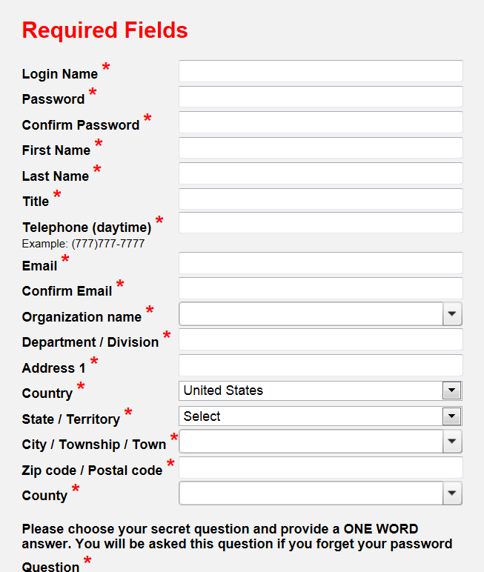4. The next page in the account creation process will guide you through providing the required information for your TRAIN account. Any field noted with a red asterisk

(*) is required – this will remain true through the site. Your TRAIN account will not be created until all required fields are provided.

Important: If you would like to receive emails from TRAIN, please consider the email receipt options carefully. There are two options for receiving email:

a. I would like to receive emails from TRAIN

b. I would like to receive notifications about the updates by email

For more information on the TRAIN email options and processes, please see the Email Receipt Options section below.

5. Once your required fields are complete, the next page displays a dynamic series of dropdown menus, available by clicking on the “Select Groups” button. This is how your group assignment is determined. Everything in TRAIN has a group assignment. Items assigned to one group, cannot access items assigned to another group. Groups can be divided in a variety of ways in TRAIN; some examples include geographically (states, counties, cities), organizationally (health department, department of corrections, police department), professionally (physicians, nurses, general public health staff), among others. Groups help ensure that the appropriate content is delivered to the appropriate users. In selecting your groups, please be as accurate as possible (you can always change your group assignment after your account is created). If you have questions about which groups to place yourself in, please contact your TRAIN affiliate administrator.

a. Within the group assignment process, you are allowed to select groups for three different TRAIN portals: your state portal; Medical Reserve Corps (MRC); and the Centers for Disease Control and Prevention (CDC)

b. It is strongly suggested that you add yourself to the corresponding state portal groups. To do so, click the ‘Select Groups’ button next to that portal on the group selection page.

c. You can also select group for CDC and MRC participation. To do so, simply click the ‘Select Groups’ button next to each portal. A popup window will appear to walk you through selecting the correct groups.

Note: Selecting “Remove Groups” will remove all groups below that portal only.

6. Next, you will describe your professional role. Use the checkboxes next to each listing and follow the onscreen instructions.

7. You’re almost done! The last required step, is to provide your work settings. Use the checkboxes next to each listing and follow the onscreen instructions.

8. The last step is demographic information and is entirely optional; but we encourage you to provide your feedback as it will help us improve the TRAIN experience. Thanks!

Important: When creating a new TRAIN account, please do not use your browser’s ‘Back’ button. If you need to navigate the account creation wizard, please use the ‘Back’ and ‘Next’ buttons provided within the interface.

Email Receipt Options

As a TRAIN user, you have the option to receive emails from TRAIN or not. TRAIN automatically sends important email reminders, updates and notifications. You can opt-out of these notifications; but in doing so, may miss vital information.

If you do not want to receive emails from TRAIN, simply follow the onscreen instructions and select No when prompted about continuing to receive TRAIN emails

If you do want to continue to receive TRAIN emails, select Yes when prompted. Next, confirm that the email we have on file for you is valid. Lastly, open you email inbox, location the confirmation message from TRAIN and click on the confirmation link in that email. This will confirm your email address and you will continue to receive emails from TRAIN.

8 If you need to change your email receipt settings later, please follow the steps outlined in the Opting Out of TRAIN Emails and Opting In to Receive TRAIN Emails sections below.

Opting Out of TRAIN Emails

1. If you are a new user setting up your account for the first time and you do not wish to receive any emails from TRAIN, leave the, I would like to receive emails from TRAIN, option unchecked. This option will appear after you agree to the TRAIN Policies.

2. If you are an existing user and you do not want to receive emails from TRAIN, login to your TRAIN account. On the home page, click the My Account link and uncheck the, I would like to receive emails from TRAIN, option. Be sure to save your settings changes!

Opting In to Receive TRAIN Emails

If you want to receive emails from TRAIN, you will first need to follow a few simple steps to confirm your email address.

TO RECEIVE TRAIN EMAILS:

1. Log in to your TRAIN account

2. On the Home page, click the My Account link

3. In the My Account interface, below the personal data fields, select the option, I would like to receive emails from TRAIN.

4. Click OK to send the confirmation email

5. Open your email account and locate the confirmation email from TRAIN. It may take a few minutes for the confirmation email to be sent. The confirmation email might also be filtered as spam, so be sure to check your junk folder.

6. Lastly, click on the link in the confirmation email and you’re done. You can now receive emails from TRAIN.

7. TRAIN will periodically (approximately every 12 months) ask you to reconfirm your email address. This is for your protection and to help prevent the delivery of TRAIN emails to those users who wish not to receive them.