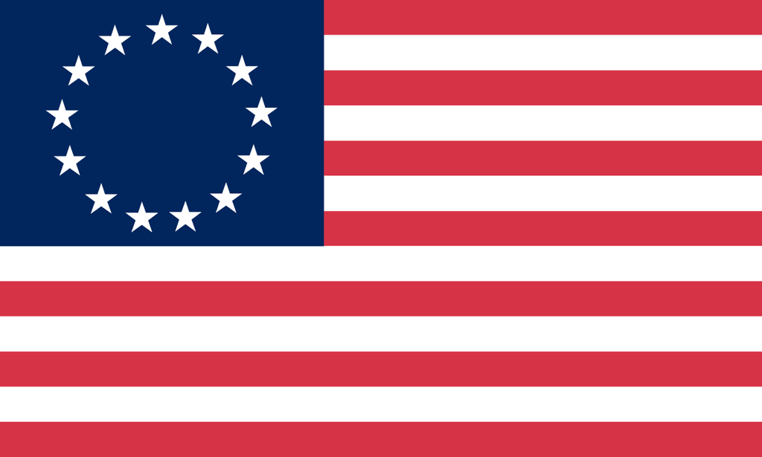U.S. History with Mr. Brown Name _______________________________ Period _____
Constitution Vocabulary Quiz
Directions: Match the vocabulary word on the left with the best definition on the right.

_____ 1 ) Popular Sovereignty  _____ 2) Republicanism  _____ 3) Federalism  _____ 4) Separation of Powers  _____ 5) Checks and Balances  _____ 6) Limited Government  _____ 7) Individual Rights | A: Government in which the people rule  B: People vote for political representatives  C: How power is divided between the National and State governments  D: Personal liberties and privileges (freedoms)  E: Everyone must obey the law even the government  F: How each branch of government checks or controls the others  G: How power is divided between the 3 branches
_____ 8) Enumeration  _____ 9) Indictment  _____ 10) Quorum  _____ 11) Revenue  _____ 12)Appropriation  _____ 13) Convene  _____ 14) Suffrage  _____ 15) Ratification | H: The minimum number of members that must be present for official business to take place  I: Income that a government collects  J: Official approval  K: An official count such as a census  L: Call together  M: Right to vote  N: A written statement from a Grand Jury charging a person with a crime  O: Public funds set aside for a specific purpose

