Bring things into balance with
Reiki Healing

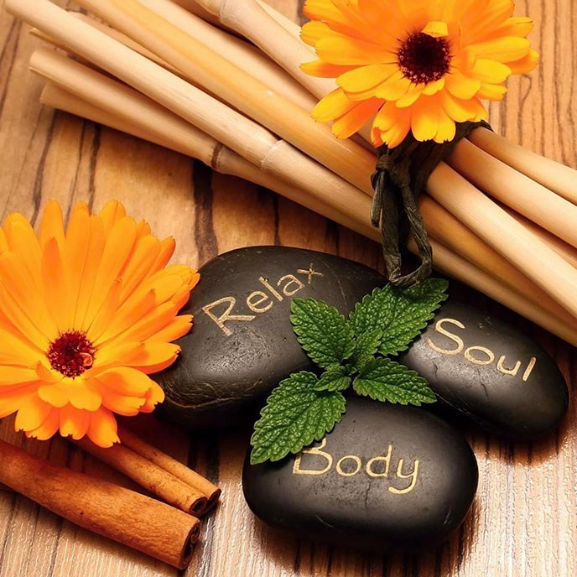

What is Reiki?

Reiki is a gentle healing technique for stress reduction and relaxation that also promotes healing. The word Reiki comes from the Japanese word (Rei) which means “Universal Life” and (Ki) which means “Energy”. Energy should be strong and free flowing allowing the body and mind to be in a positive state of health. When the energy becomes weak or blocked it could lead to symptoms of physical or emotional imbalance. Reiki aids in the balancing of energy throughout the body. Studies indicate that Reiki may provide a number of different benefits to people who participate in sessions on a regular basis.

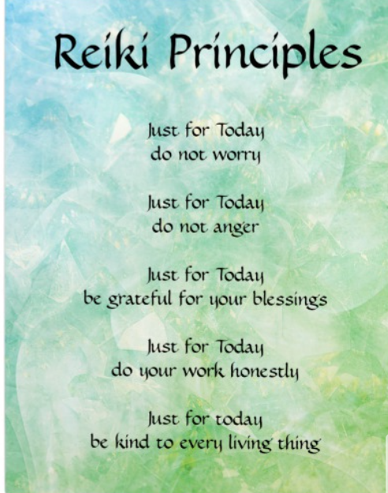

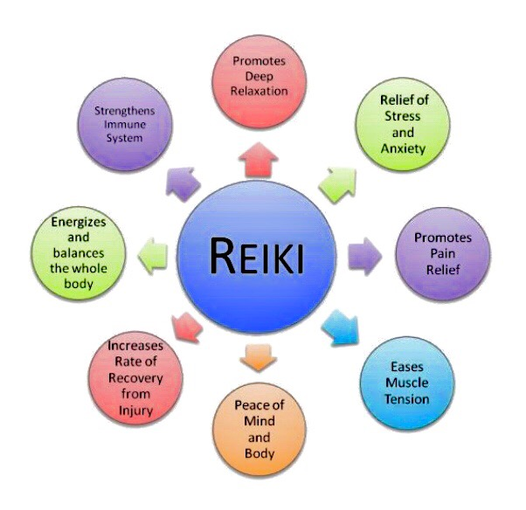

How is reiki preformed?

It is administered by "laying on hands.” The client will rest comfortably on a massage table or seated in a chair with their shoes removed. Comfortable clothing is suggested. Sessions can either be hands-on, where the practitioner will apply a light touch during the session, or hands-off where they will hold their hands slightly above your body.

Reiki and Autism

- Reports have shown exposure to Reiki may reduce feelings of stress and anxiety, which has a calming effect on individuals with ASD.
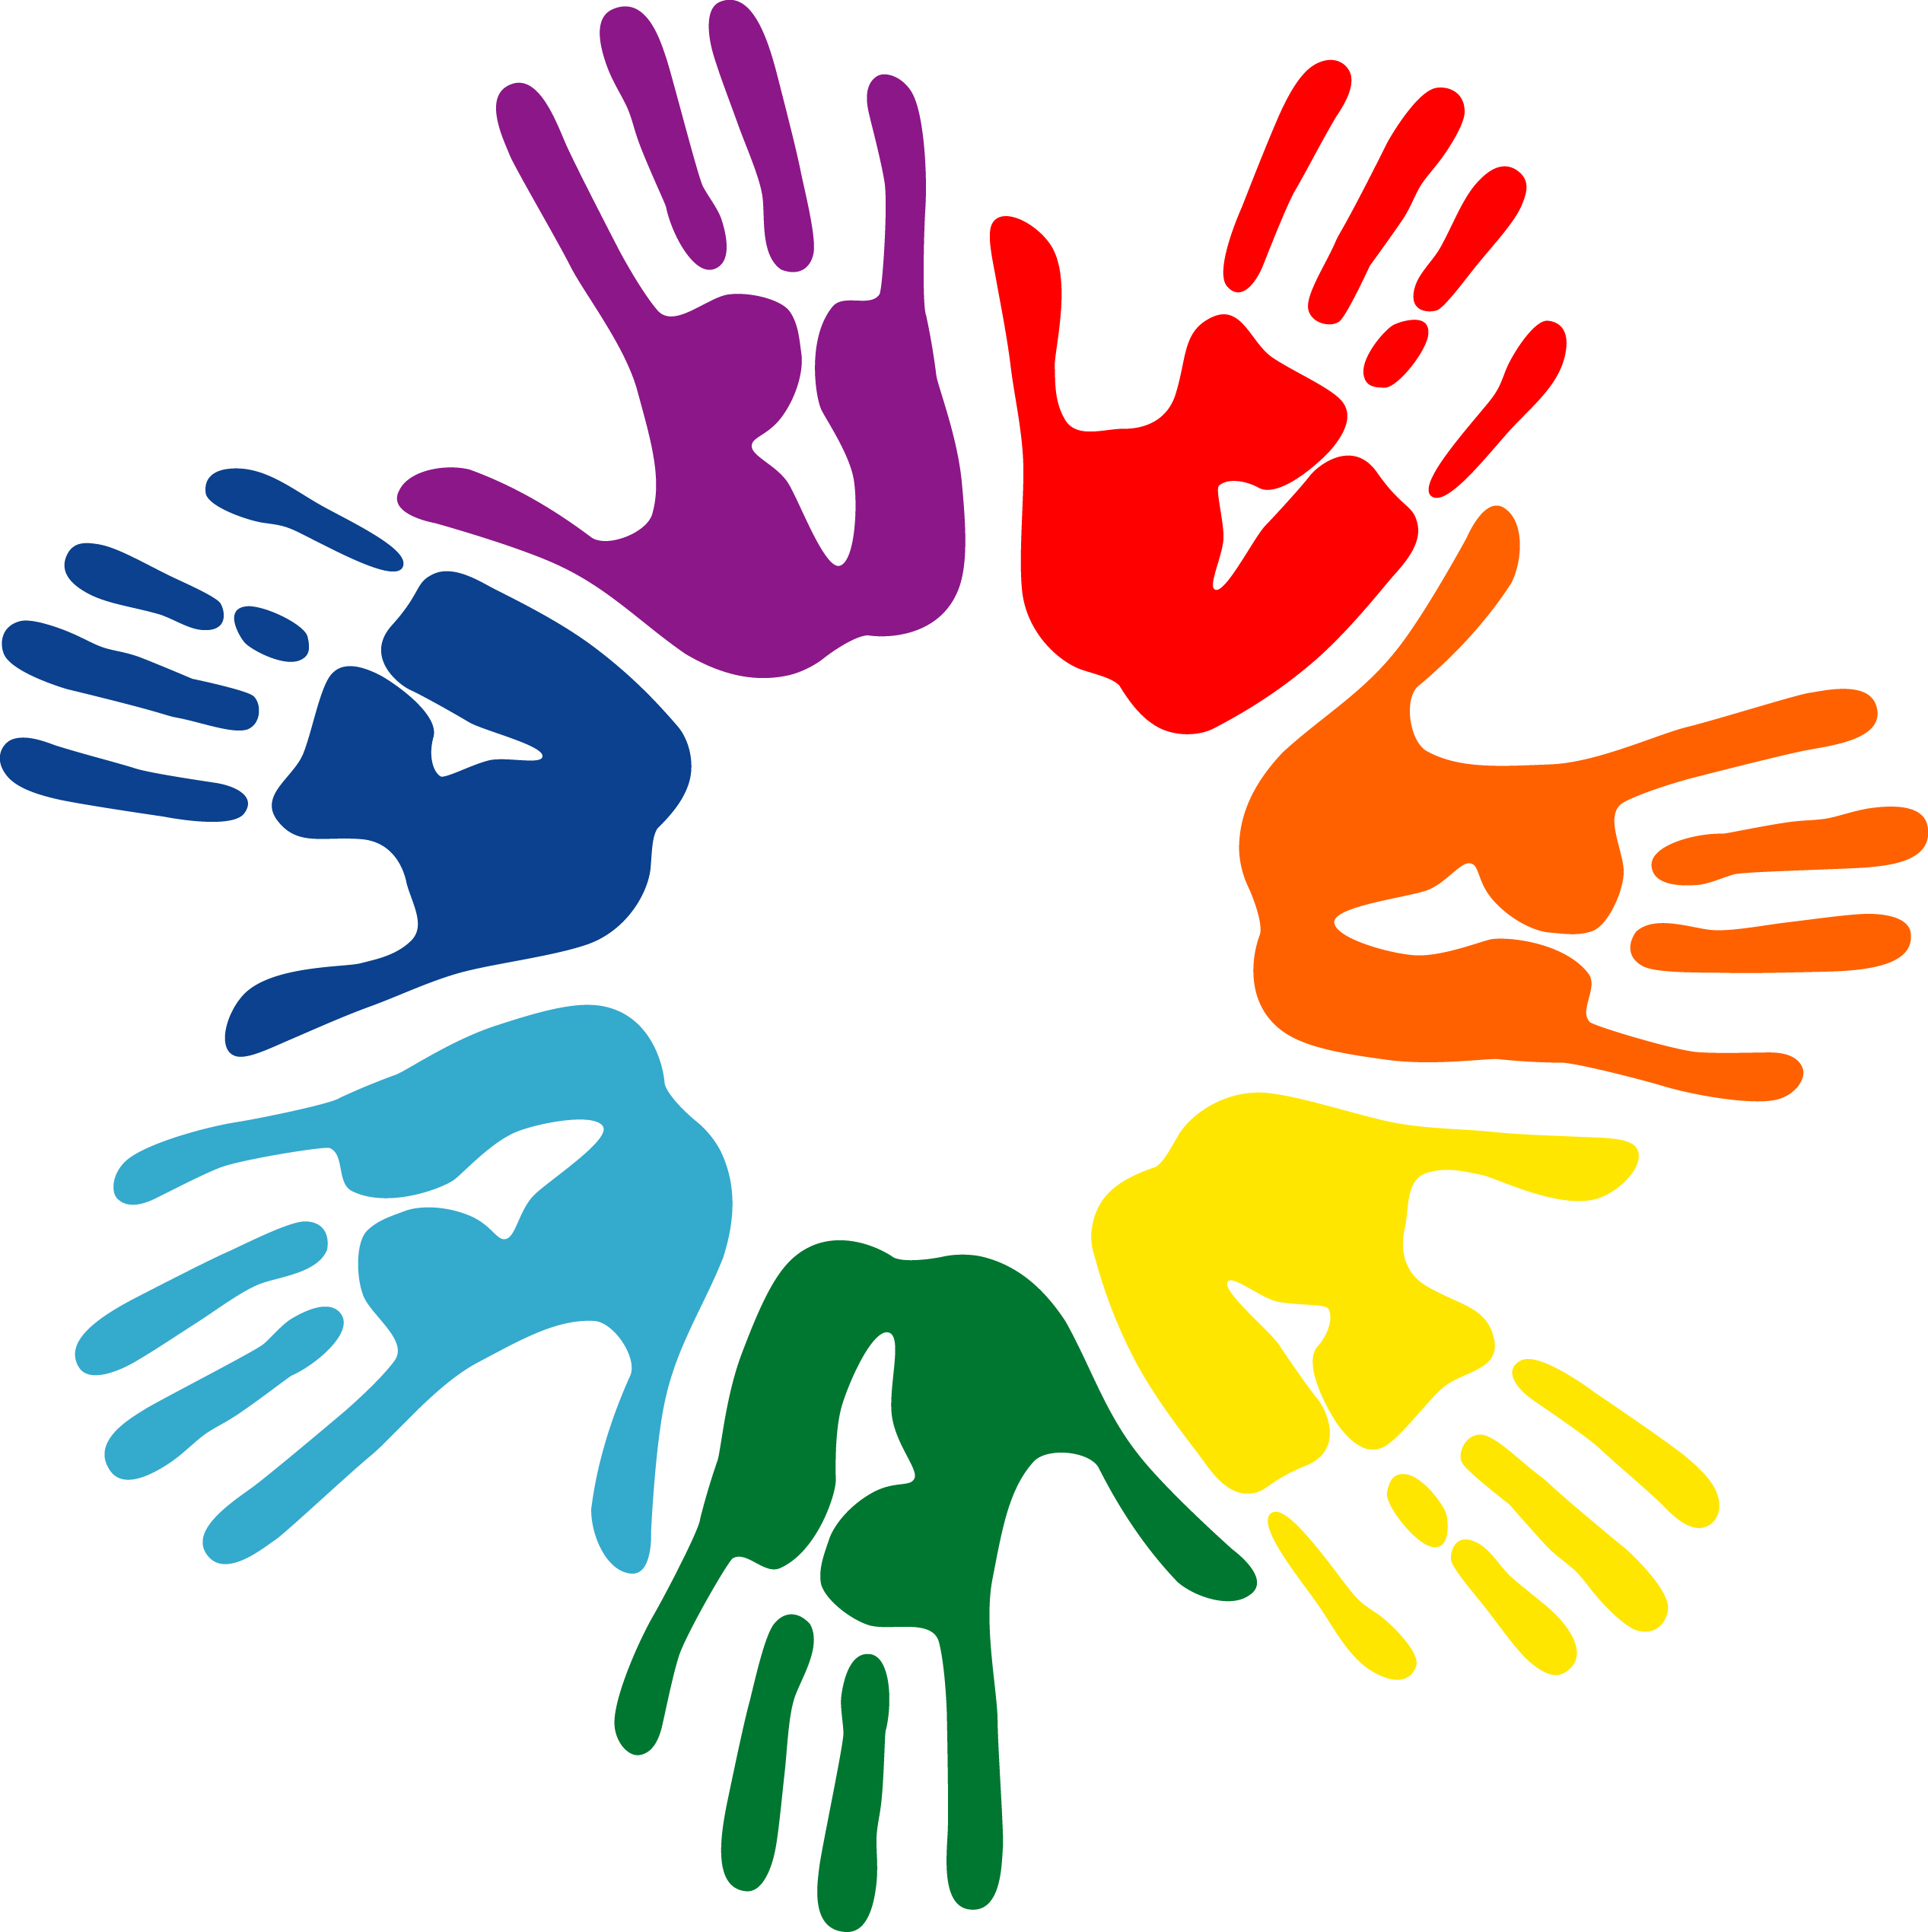
- ASD can disturb sleep patterns, which leads to exacerbated symptoms and more stress. Reiki may improve these sleep patterns, allowing a more restful, restorative sleep.
- Reiki allows the individual to connect with the practitioner in a unique way.
- Participating in sessions can help the caregiver understand the purpose of sessions, the procedure used and the nature of the results.
- Sessions allow both children and caregivers to be proactive about dealing with symptoms and improving quality of life.
- Reiki is not a substitute for medical treatment, but its effects can be beneficial to children and adults with ASD.

Book your appointment today!

Call or text: (267) 592-8555
Email: ashleyseedes@gmail.com

Sessions held:
81 Big Oak Rd, Suite 204
Morrisville, PA 19067
Reiki practitioner can come to you!
However, fees apply depending upon location.
Adult
60 minutes 100$
45 minutes 75$
30 minutes 50$

Child
45 minutes 60$
30 minutes 45$

Collaborative (Adult and Child)
60 minutes 150$
45 minutes 125$
30 minutes 100$

