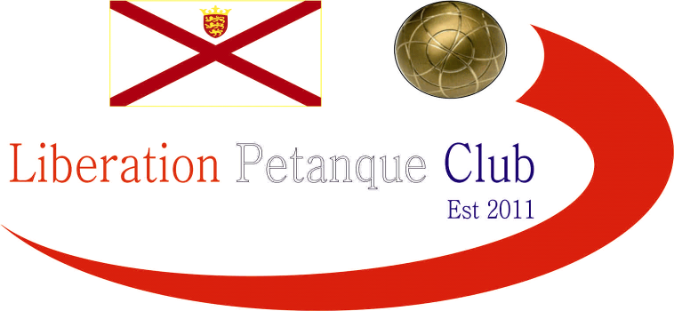

Winter 2018 / 19 Season
Charity Doubles Open
Saturday 8th December 2018
A Record 21 teams entered this year’s competition helping raise £255 towards Jersey Children’s Charity, this means we have now raised £563 with more to come from the sale of the Clubs raffle tickets.
Four rounds of matches were played before the quarter finals and Plate competition. In round one, one team took their generosity a little too far as Ross Payne & Jake Romeril let James Gennoe & Michel Morel beat them 13 – 0. There was a good win also for Matt Buesnel & Toby Northern 13 – 4 over Matt Pinel & James Rondel.
Andrew Limbrick & Stephen Leathem lost their first round match to some petanque newbies in James & Daniel Villalard. The closest match of round 1 went to 13 – 12 in the favour of Tommie Glennie & Peter Blampied over Chris & Natasha Romeril.
Round two saw Toby Northern & Matt Buesnel make it two from two with a 13 – 3 win over Chris & Natasha with Toby firing the coche on one end to pick up four points. Richard Williams & Peter Smith beat Mo De Gruchy & Stephen Stoneman 13 – 0 for the second certificate of the day but Geoffroy Buffetrille and Laurent Pellaton were leading the way with back to back 13 – 1 wins, this time over Neil Selby & Paul Bell.
Tommie and Peter had a reversal of fortunes in round two this time losing 13 – 12 to Cassie Stewart & Mark Nicol. Callum stewart & Andrew Bellamy-Burt also made it two wins beating Neil & Paul 13 – 5.
Round three saw James & Michel make it three straight wins this time over Wendy Ritzema & Gary Cowburn 13 – 10, they joined Mark Nicol & Cassie Stewart, Callum & Andrew and Geoffroy & Laurent all on three wins from three.
Ross & Jake continue their recovery from their first round loss to make it back to back wins, this time over Tommie & Peter. Alex & Jean Stewart made it two wins in a row by handing out Richard & Peter first defeat.
Round four saw Matt Pinel & James Rondel make it three wins in a row with a 13 – 6 win over Richard & Peter to finish 6th and make the quarter finals with Richard & Peter finishing 8th. They were joined by Wendy & Gary on two wins after beating James & Daniel 13 – 1 to finish 7th.
Toby & Matt Buesnel beat Keith & Joao 13 – 0 to finish 5th, finishing top though were the impressive pair Laurent & Geoffroy who conceded just 10 points in 4 matches winning their last one 13 – 3 over Ross & Jake to end the latters hopes of a top 8 finish.
Alex & Jeans hopes also evaporated with a 13 – 3 loss to James & Michel who finished third. Callum & Andrew finished second with 4 wins with + 35.
A random draw for the quarter finals saw Geoffroy & Laurent continue to dominate their opponents with a 13 – 3 win over Richard & Peter. Callum & Andrew with the former producing some excellent placing easily overcome Matt Pinel & James Rondel.
James & Michel played exceptionally well to fight back from 7 – 4 down to beat Matt Buesnel & Toby 13 – 8 but the most dramatic was a 8 – 5 win as time ran out as previously undefeated Mark & Cassie lost to Gary & Wendy who had lost two of their four qualifying matches.
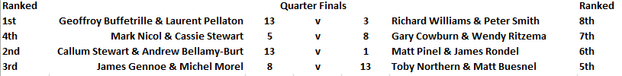
So the Semi finals were Geoffroy & Laurent against Michel & James was a much tougher match for the former as the fell at the final hurdle losing 13 – 8 to James & Michel.
The second semi final saw another shock as undefeated Callum & Andrew lost to Gary & Wendy with Gary winning the match in style with a perfect carreaux.
So could Gary & Wendy continue the shocks in the final against undefeated James & Michel, well in heavy rain they had the advantage at 10 – 9 up but a poor end saw them lose four points for James Gennoe & Michel Morel to become the Charity Doubles Open Champions and undefeated all day, congratulations to the pair, well deserved.
Thank you to all those who played and donated on the day your support was amazing on a difficult day for a great Charity.

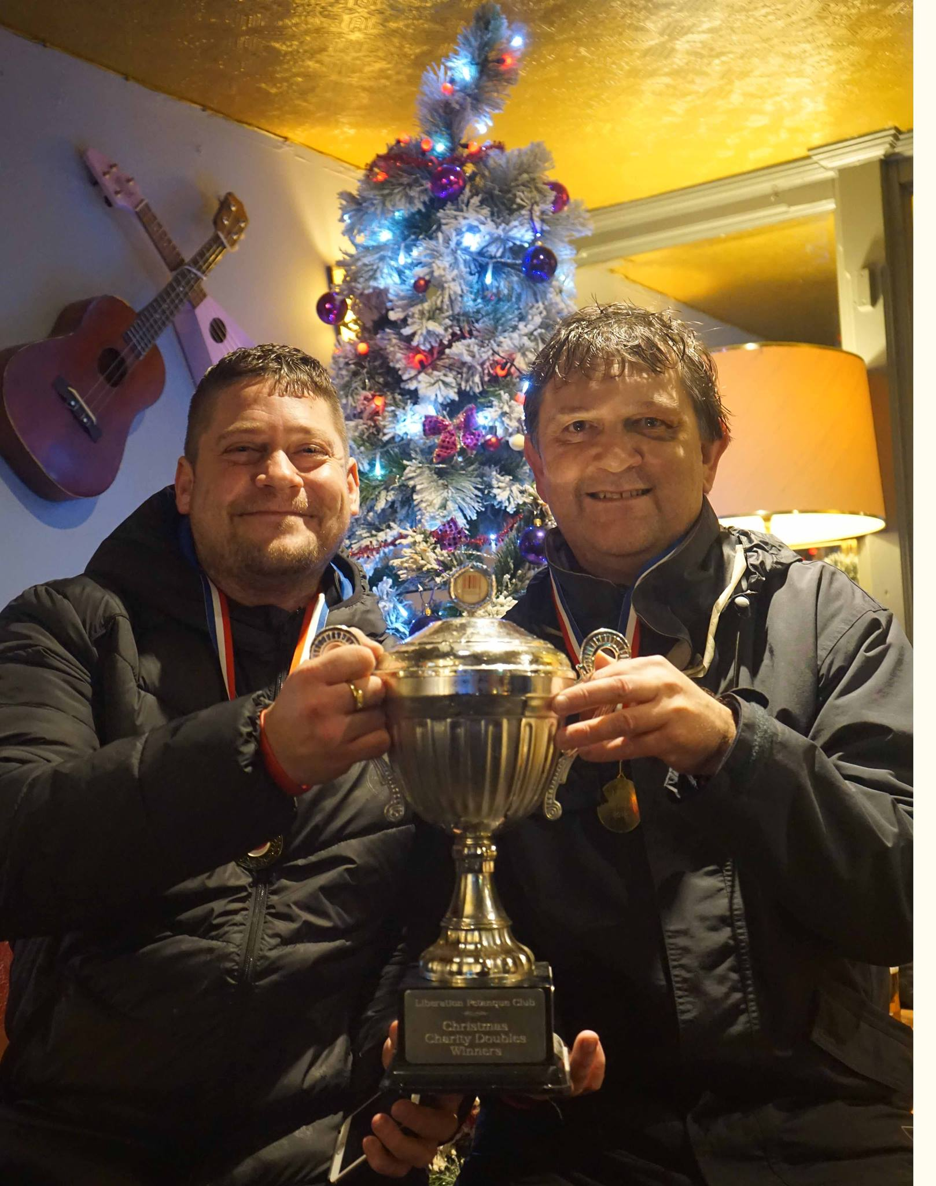

More photos on Facebook

Club email address - liberationpc@gmail.com

Club Website - www.liberationpetanque.co.uk

Kind Regards

Toby Northern

Chairman

Liberation Petanque Club

SPONSORED BY

