OVCA MUSIC QUARTER 3
Gospel Music
- At the end of this quarter, you should understand:
- You should be able to explain the meaning of the word “gospel”
- What it sounds like (e.g. choir, etc… for black gospel)
- The different types of gospel music
- The Roots of Gospel Music
- What is call and response?
- Gospel music singers, such as Kirk Franklin and Andre Crouch (contemporary), Bill and Gloria Gaither (southern), Mahalia Jackson (traditional black gospel).
- The different types of gospel music

GOSPEL MUSIC
Source: https://kids.britannica.com/kids/article/gospel-music/399963#
Gospel music is a form of African American religious music. At some Christian church services, people sing gospel music as a part of the preacher’s sermon. The word gospel means “good news,” and gospel songs often praise God or Jesus. Many gospel songs also describe struggles and hard times.
Small groups of singers, choirs, and soloists (single singers) perform gospel music. Singers are usually very emotional and expressive. A wide range of instruments—for example, organ, guitars, banjos, or brass instruments—may provide background music.
Many gospel songs have parts known as call and response. In this type of singing, the leader sings a phrase and then the group responds with a repeated line.
The roots of gospel music can be traced back to African slaves in North America in the 1700s. At that time slave owners made slaves attend church services. At these services the slaves learned Christian hymns. They made up work songs and religious songs, called spirituals, based on these hymns.
As the slaves performed backbreaking and monotonous work day in and day out, they began to raise their voices in song. Some slave spirituals began as variations on Christian hymns, but over the years many original compositions were created. Most of these songs were passed down orally, or by word of mouth, since very few slaves had access to methods of writing music. The American slaves were living lives of hopelessness, extreme physical pain, and brutality. Singing was a way of coping with awful circumstances. Their spirituals sang of a beautiful life after death as a way to inspire and uplift each other.
Source: https://www.musicianguide.com/featured_biographies/pages/cmx6f3mvkg/Child-Gospel-Brief-History-Gospel-Music.html
After the end of slavery African American preachers used music during their sermons. During the early 1900s recordings of these sermons became available. In this way gospel music spread to a wider audience. Popular singers began using the forms and sound of gospel music. In turn, popular music, such as the blues, also influenced gospel music. Some of the best-known gospel singers and songwriters were Thomas A. Dorsey, C.A. Tindley, C.L. Franklin, and Mahalia Jackson.
Types of Gospel Music
Southern gospel- Southern gospel music is a genre of Christian music. It is mainly from the Southeastern United States .Sometimes known as "quartet music" for its traditional "four men and a piano" set up. The best known group of the 1950s and 1960s was Statesmen Quartet.
Video: https://www.youtube.com/watch?v=Nx674vj11JA
Traditional Black gospel- Mahalia Jackson October 26, 1911 – January 27, 1972) was a famous Black gospel singer. She had a “powerful” contralto voice (one of the lowest singing female voice types) and nicknamed the QUEEN OF GOSPEL.
She was described by entertainer Harry Belafonte as "the single most powerful black woman in the United States".
"I sing God's music because it makes me feel free", Jackson once said about her choice of gospel, adding, "It gives me hope. With the blues, when you finish, you still have the blues."
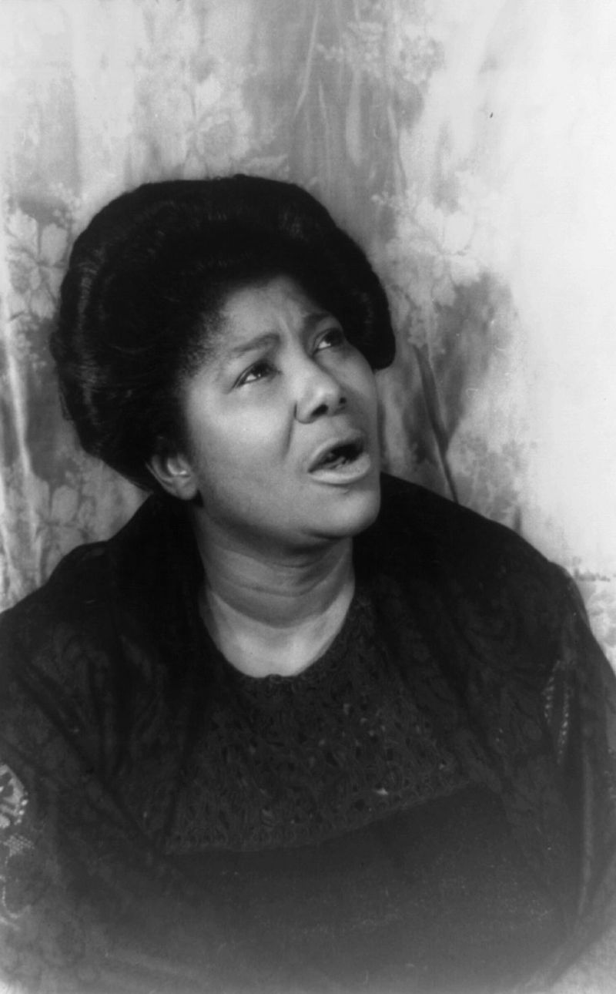
Mahalia Jackson, the Queen of Gospel- source: Wikepedia
Video of Mahalia: https://www.youtube.com/watch?v=ZJg5Op5W7yw

Contemporary gospel- is a modern form of Christian gospel music. The genre was well established by the end of the 1980s. Andre Crouch was a well known contemporary gospel artist.
Video: https://www.youtube.com/watch?v=p9Mz3P1L1w8

There are many more gospel music categories. These are only a few!

