***Transformation: 5,000 Change their Future in Zimbabwe***

If you dream amazing things, sometimes they come true.

Zimbabwe is a place where that is happening. Talk to the people in Mufakose, a high-density suburban district of Harare, about Rotary’s Zimbabwe Community Empowerment project and you’ll see evidence of it everywhere. Even the people on the street say things have changed: “The women are so different than they used to be. They smile and laugh; they walk with their heads high.” A woman in the program said, after only three months: “The training has helped us have trust in each other. I now have my own money—I didn’t think that could ever happen.”

In October 2009, a 3 ½-year Rotary Grant for Health, Hunger and Humanity (3-H Grant) was launched in five communities in Harare. The Grant was completed in May 2013; during that time, trainers and Rotarian volunteers trained 3,500 women and youth, providing a foundation with which they could direct and change their future.

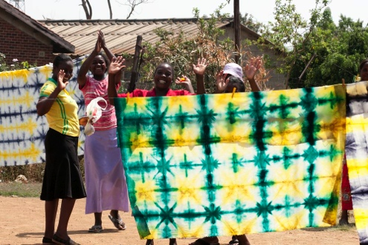

The women saved and pooled their funds, took loans from the pool to expand their personal businesses and worked together to create a group business where they learned how to analyze markets, create business plans and react to market shifts. Being part of a group is a huge benefit in their community-oriented culture; it creates bonds that support the women in financial, health and emotional crises. Many of the participants say that their group members are like sisters—sometimes better than sisters because they share so many experiences.

More than 200 women also trained to be Peer Educators for their communities, sharing knowledge about AIDS prevention and coping with the disease.

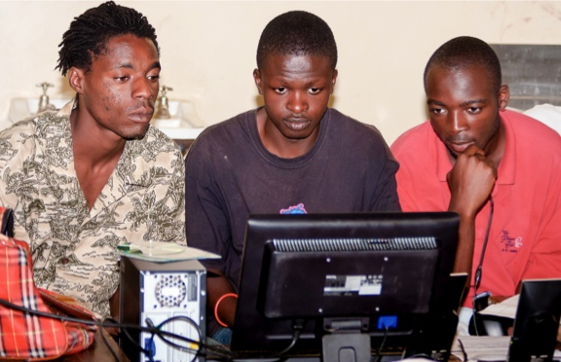The youth, mostly young men, participated in a different way.

They were trained to manage Youth Corners, overseeing the use of computers and printers but also acting as peer counselors in AIDS prevention to the young people that visit the Corners. The youth have gone well beyond that. They now act as volunteer trainers in computer skills to people who visit the Corner. Both 10-year old kids and businesswomen come to the Corners to learn how to effectively work with computers. The youth also organized two Sports Events in the communities where teams competed for trophies in soccer, volleyball and basketball. Over 1,000 kids participated in the two events. The youth in Budiriro, one of the project communities, are also in contention for a grant to create an Internet Center in Budiriro, where computers, large screen televisions, games and high-speed Internet service will be available for the first time.

How could this happen in a community with 95% unemployment and little hope for the future? What is the recipe for success?

**Community First**

Rotary had been sponsoring small projects in these communities since 2004, so the people understood the kind of help that Rotary could provide. In 2007, 340 people participated in a Community Assessment and told us what they wanted: ways to generate income, help in re-engaging the youth and efforts to increase awareness of AIDS prevention. The elements of the Grant were specifically chosen to meet the needs that the community identified.

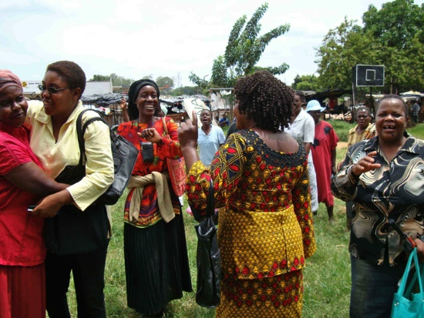Originally there were five communities included: Mufakose, Budiriro, Rugare, Kambuzuma and Crowborough North. The community leaders requested more sites; trainings were added in Glen View, Lochinvar, Kuwadzana, and Marimba, all close-by suburbs. The excitement of the newly added communities was substantial; the last training included 150 extra participants due to demand from these new communities.

**Rotary**

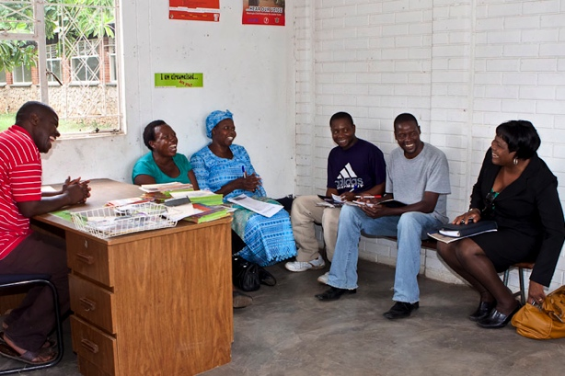Undertaking such a large project required people to plan, manage and implement the project. Rotarians in Harare and the U.S. shared responsibilities and put the project together. Carolyn Schrader of Denver Mile High Rotary took the lead in developing the elements of the project, by using the input from the Community Assessment and integrating existing and proven programs to fit the culture of Zimbabwe. Rotarians in Denver assisted in assembling the Grant elements, including financial oversight, monitoring and reporting. Rotarians in Colorado, New York and Illinois visited the project to provide specialized training, monitoring and evaluation, and documentation of the Grant.

The contribution of the Harare Rotarians was even more impressive, especially that of Stella Dongo from the lead Club, Highlands Rotary. Highlands Rotarians headed up the Grant Committee that oversaw the entire operation with the assistance of the Grant Program Coordinator. Together they monitored the 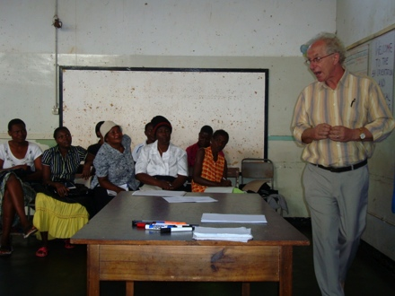monthly activities, managed Grant assets, recruited other Rotarians to mentor the Self Help Groups, and often delivered training to the group leaders.

It was this cooperation of local and international Rotarians that brought resources to the project to help the groups succeed and grow. These resources also opened new opportunities for initiatives: it was the connections of a Highlands Rotarian that led to the grant opportunity for the Budiriro Internet and Business Center.

**Local Implementation**

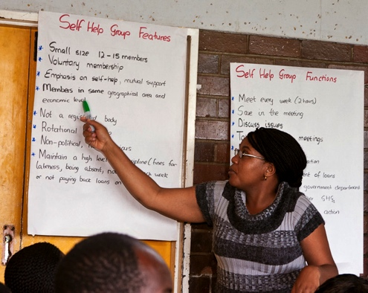Any humanitarian project needs to be connected to the local community so that it actually meets the needs of the community. Everything about this Grant is local. The Grant Program Coordinator lives in one of the communities, as does the six Project Officers from the communities who assisted the groups in their early stages of development and were resources for members who needed guidance. ICA Zimbabwe, a local non-profit, delivered the training, using material adapted specifically for Zimbabwe. The local government provided training sites and the locations for the Youth Centers. And the local Rotarians acted as mentors and specialized trainers.

**Focus on the Future**

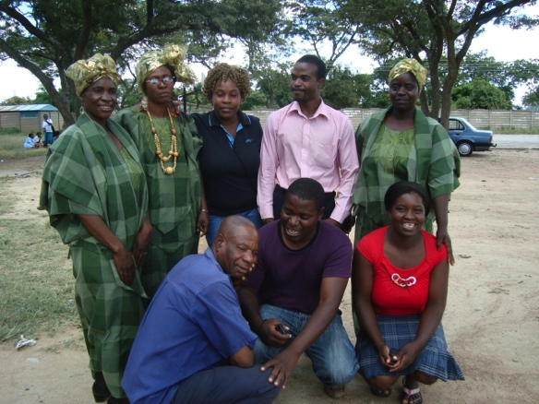This project was designed with the expectation that its impact would continue long after the funding for the training ended…to create a ripple effect that would affect the entire communities. Training for Self Help Groups spanned three years with more than 200 groups formed. As the early groups matured, they became role models to later participants, who saw their success and confidence, and understood the process and commitment needed to get there.

In 2012 four Rotary Community Corps (RCCs) were created, with the Self Help Group leaders as the key players in that development. These RCCs took on the role that Rotary had played: canvassing the community to identify needs and then finding the resources to take on projects to meet these needs. Harare Rotarians are a part of this process, acting as mentors and advisors, but make no mistake: these are endeavors of the community itself.

**Results**

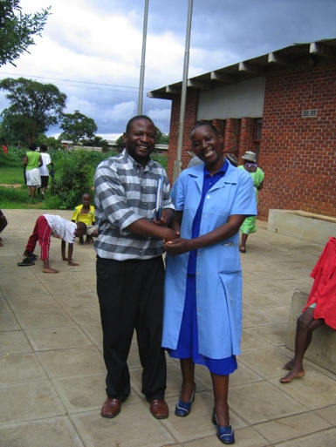This project has given the participants a sense of pride, an understanding that they can accomplish great things. It opened their minds to the possibility of a better future and they embraced it. The training facilitated their transition to success, but they created the success through commitment, cooperation and creativity. Over and over the women and youth point to the things that they have accomplished with pride. More importantly, they talk about the things that they will do. First a community cleanup, then repainting the inside of the community center—not just fresh paint, but with murals to highlight the future that they foresee.

And the collaboration between the youths and the women has had some amazing results. The original model for the Youth Corners was as a counseling center with computer access. But the youth saw the income generating skills that the women had learned and campaigned for business training for the Youth Corners as well. These members now generate income by offering business services and creating music and dance that make money to support the Corner and also themselves. Youth leaders also campaigned successfully more Youth Corners. They developed new training material and delivered it to over 100 young people to create four new Corners in 2013; there are now 24 Corners in the communities. More than 600 youth have been trained in computer skills, also developed by community youth leaders.

And the women, seeing the computer skills that the youth have learned, asked that they too be trained on computers. Over 900 women have learned basic computer skills, including creating documents, using social networks and Skype, and how to disassemble and reassemble a computer. They are so excited about this new opportunity, both for improving their business opportunities and for staying connected with family, friends and the rest of the world.

As Rotary continues to emphasize larger, more meaningful and sustainable projects, this Grant stands as an excellent model to unlock the potential that exists in under-served communities. The support, encouragement and opportunities offered by the Grant have given the people of these communities, for the very first time, a path to success. And they are following that path with pride and determination. At this point, we are walking beside them, offering occasional assistance but mostly taking pride in what they have accomplished.

*For more information, contact Carolyn Schrader at schrader407@gmail.com*