

# Winter 2017-2018 Season

# Week 9

# 6th January 2018

# Singles League

# 

# Just one match played in Division 1 this week, bottom two players Colin Myers and Alex Stewart. Most people went for either a draw or Alex to win on the Super 6 but it was Colin who took the first game 13 – 6. The second game went the other way as Alex took it 13 – 8.

# 

# Richard Williams moved top of Division 2 with two wins. First up against Matt Hutchings 13 – 7, 13 – 8 and then and advance match against Mo De Gruchy 13 – 8, 13 – 6.

# Jean Stewart also beat Mo De Gruchy to move one point off a promotion place. Below Super 6 responses.

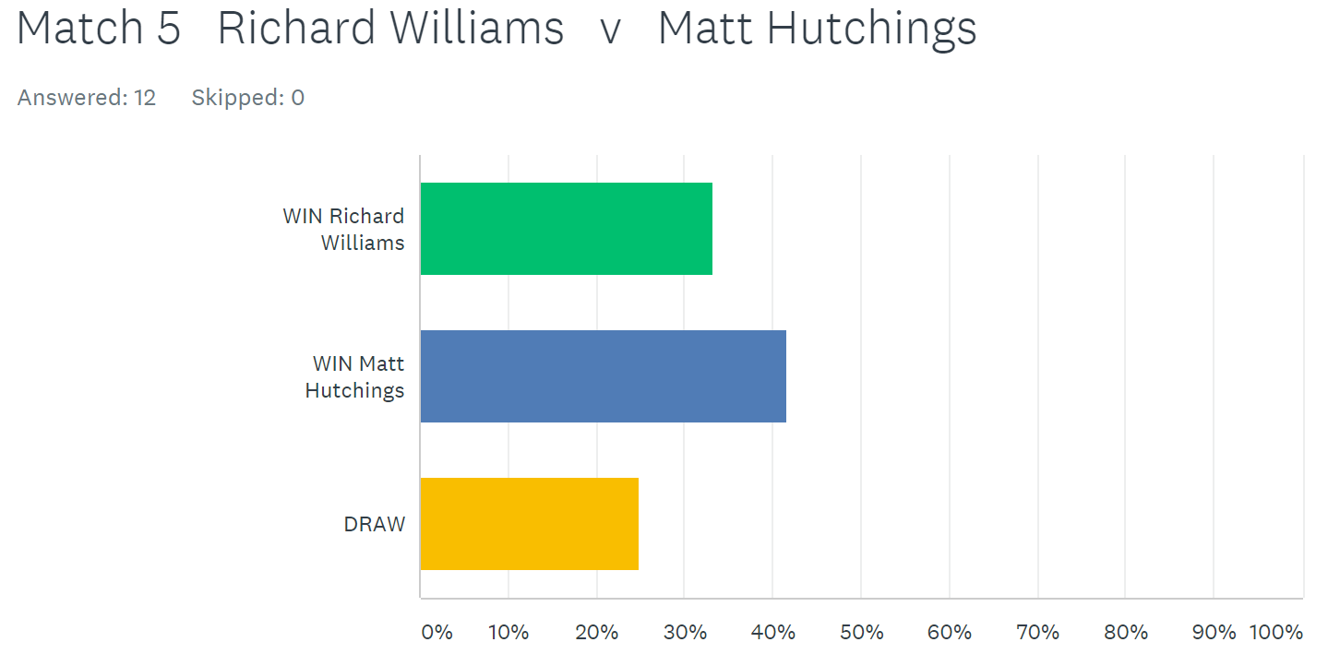

In the Premier League Matt Buesnel was looking to increase his lead at the top of the League. His first match was against Neil Selby who was without a win before today. Matt though was on top form winning comfortably 13 – 4, 13 – 6.

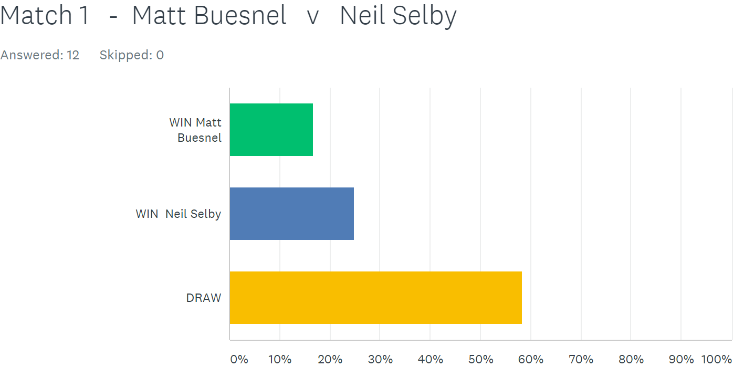

Well despite Keith handing Ross a 13 – 0 beating in his only match, no one gave him a chance against his son Matt. How wrong you were. Matt only scored 9 points losing 13 – 2, 13 – 7 as Keith remains in title contention.

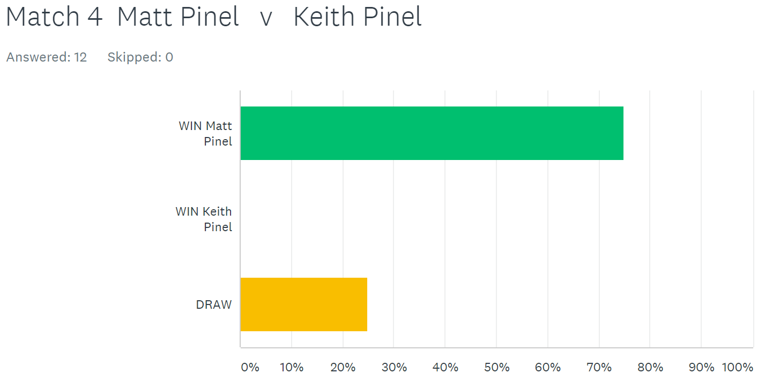

Before the start of play today David Ibitson had the advantage in the title race over Matt Buesnel just one point behind with a match in hand.

David continued his fine form at the start of the first game taking a 10 – 0 lead before eventually winning 13 – 6. The second game was much closer but David would end up rueing missed chances as Andrew took the second game 13 – 12 for a draw.

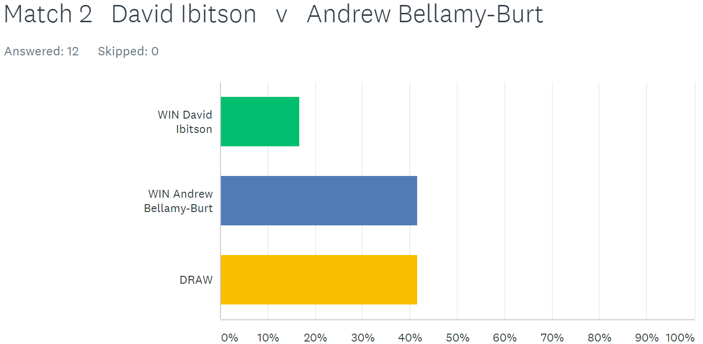

Andrews second match was against Toby and a change of terrain saw Andrew play a great game taking it comfortably 13 – 2. Andrew’s mistake though was to mention he didn’t like playing on the harder surfaces, so Toby moved him to one resulting in a big swing as Toby won 13 – 3 for a draw. Andrew has now drawn all 3 matches played but has 3 outstanding matches to play.

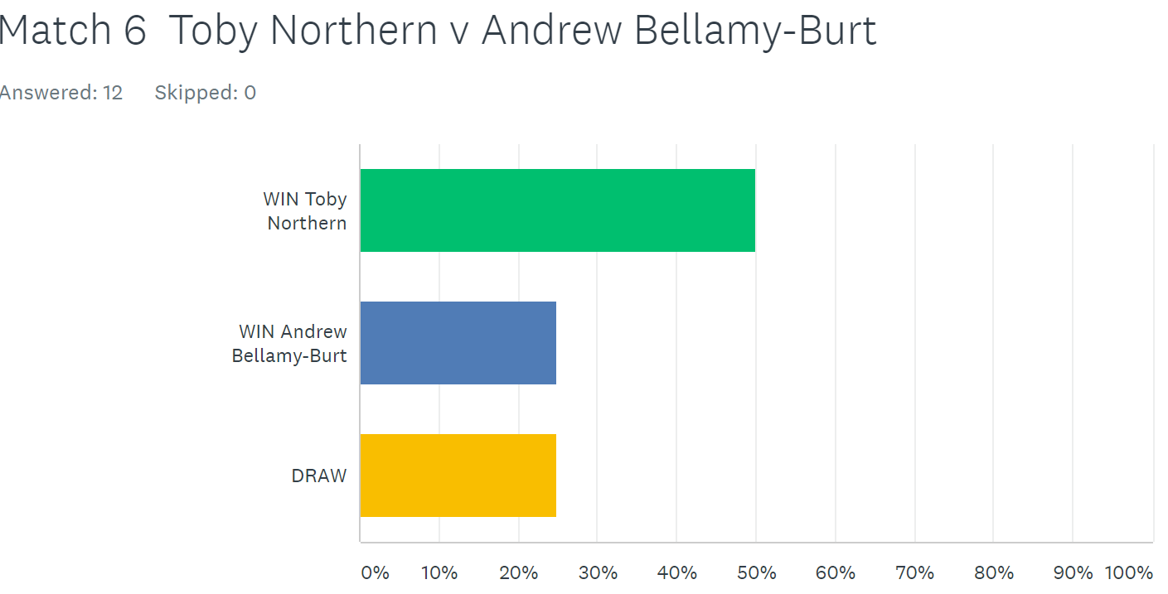

Alice Ibitson was the big winner on the day as she first beat Callum Stewart in a very close match 13 – 10, 13 – 11. Alice then moved into title contention by beating Matt Buesnel again two close matches 13 – 10, 13 – 10 coming back from 10 – 6 down in the second game and now sits on 10 points from 4 matches to become the new title favourite.

Keith Pinel took on Callum Stewart looking for 3 wins out of 3, but couldn’t do it losing 13 – 11 in the first game but recovered to get a draw 13 – 8 in the second. Keith last won the title in Winter 2013 / 14 season.

David Ibitson’s title chances took a bigger hit following his draw against Andrew then lost to Matt Pinel who recovered well from his thrashing by dad Keith. But another incredibly close match with Matt just winning 13 – 12, 13 – 11.

Toby had early beaten Ross taking 3 points on the first end of the match by firing all three of Ross’s boules out and never looked back winning 13 – 3, 13 – 4. Ross sits bottom of the league with just 1 point and minus 61 points difference. Ross needs 3 wins and 2 draws from his last 5 matches to have a chance of staying up.

***NEXT WEEK -* Doubles League**

**WEBSITE** [**www.liberationpetanque.co.uk**](http://www.liberationpetanque.co.uk)

**EMAIL** [**liberationpc@gmail.com**](mailto:liberationpc@gmail.com)

**Kind Regards**

**Report Editor - Toby Northern**

**Liberation Petanque Club**

# SPONSORED BY

# http://nebula.wsimg.com/135a1bd6338e1b589a50cdec98bd84d1?AccessKeyId=C6E923731F1A482DD910&disposition=0&alloworigin=1