RSAI 2023 Legislative Priority:
Transportation Equity

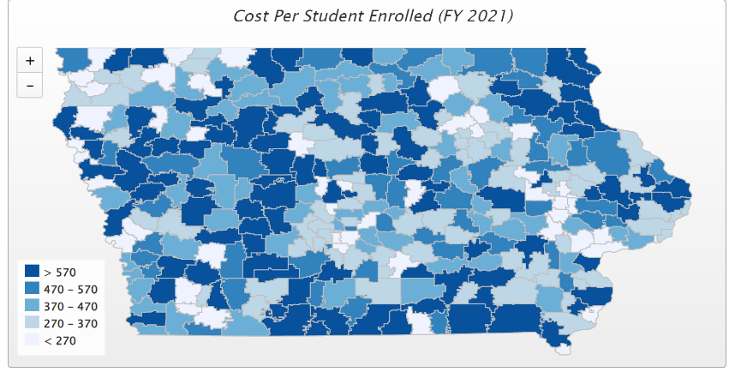
Background: In the 1950s, Iowa had over 4,000 school districts. Students walked to their neighborhood school and transportation costs were nonexistent for Iowa school districts. As budgets have tightened and enrollments declined, Iowa now has 327 districts (FY 2023) with varying square miles, disparate costs per pupil enrolled, and different challenges in geography that impact transportation costs, leading to vastly varying transportation costs.
Iowa’s foundation formula does not recognize the sparseness of population, square mileage or route miles for school districts, the number of students transported, or variance in road or geographic conditions. Transportation costs are paid out of the general fund.
Recent Progress: The Legislature has made strong progress in closing the transportation expenditure gap:
- SF 455, enacted in 2018, provided $11.2 million to 143 districts with the highest transportation costs in the state, a good start, but did not provide certainty.
- Every year from 2019 through 2021, the legislature continued to invest state funding toward resolving transportation inequity, getting closer to to reimbursing every district with transportation costs above the state average for those excess costs. That goal was achieved with the 2022 enactment of HF 2316 School Funding (SSA) which applied a 2.5% increase to the state cost per pupil (SCPP). The bill also appropriated the amount needed to get all districts to the statewide adjusted average. The funding increased to $29.5 million, an increase of $2.0 million, or a 7.28% increase. Going forward, the appropriation will grow at the same rate as the categorical SCPP rate, absent any legislative action to the contrary.
Current Reality: the following describes transportation inequities offset by the Transportation Equity Program, according to the 2020-21 Annual Transportation Report:
- According to the DE’s Report, transportation expenditures per pupil ranged from $27 per pupil to $1,012 per pupil. Thanks to the transportation equity funding commitment, all districts with high expenditures were reimbursed down to the state average of $353 per pupil.
- Districts must track and report expenditures in order to provide the DE with the details necessary to calculate the equity payments and provide transportation data to state policymakers.
- General fund dollars spent on busing would otherwise pay for staff and teachers (salary, benefits, training, support), curriculum, programs, technology, and energy. RSAI members are grateful for this investment in equity and will watch that any changes to the formula maintain or improve upon transportation equity.
- Lack of resources in these areas creates an unequal educational opportunity for students in districts with high transportation costs.
Transportation Equity: maintain the commitment to transportation equity support without burdensome reporting requirements. General fund directed at transportation is not available to spend on teachers, curriculum and opportunities for students.

