Rock City Church Unoffendables
Curriculum

Contents

Introduction………………………………………………………………………..........Page 4

Table of Contents

Lesson 1: “A Clean Heart”……………………………………..………………….....Page
Lesson 2: “It’s Not Fair”...........…………………………………………………….. Page
Lesson 3: “Mad at Dad: When Fathers upset us.…………………………..Page
Lesson 4: “Because I say so”………...……………………………………….........Page
Lesson 5: “Stronger than the Giants”…………………………………………..Page
Lesson 6: “A Precious Stone”…………..…………….………………………........Page
Lesson 7: “Building others up”..………………………………..…………..........Page
Lesson 8: “Forgiving others” ………………………...........................................Page
Lesson 9: “He is My Defender”………….………………………………………...Page
Lesson 10: “Don’t Judge Others”……………………………………………........Page
Lesson 11: “Getting It Right”.........………………………………………………..Page
Lesson 12: “Will you Forgive Me?”……………………….................................Page
Lesson 13: “Walking in Forgiveness”…………………………………………...Page

Don’t Judge Others Luke 6:37

KINGDOM KADETS: FALL LESSON 10
AGE: NURSERY (INFANTS & TODDDLERS 0-2)
Adopted From Bait of Satan by John Bevere

Lesson Topic: Don’t judge others

LESSON | WHAT CHILDREN DO | SUPPLIES | PREPARATION
1  Getting Started | Introduction/Ice Breaker:  Freeze! | CD Player or Speaker. | No Preparation Needed
2  Bible Exploration.  Key Verse Activity | Key Verse:  Bible Story: | No Supplies Needed  Kids Bible | No Preparation Needed
 | Bible Activity for Toddlers:  Coloring Page | -Coloring pages.  -Crayons. | Make copies of the last page and make sure you have crayons in the classroom.
LESSON | WHAT CHILDREN DO | SUPPLIES | PREPARATION
3  Weaving Faith  Into Life | Craft/Make and Take For Infants & Toddlers:  See the Good in Others (Pipe Cleaner Glasses) | -Craft Pipe Cleaners in different colors.  -Small mirror | Gather enough pipe cleaners, you’ll need two per child.
Prayer Points:
Asking God to remove a critical spirit from you.

4  Lasting Impressions | Faith at Home:  Talk about how to share what they learned with their families. |  | What parents can do at home:  Read Matthew 7:1-5 and explain to your kid/s what Jesus says in this scripture.

Lesson Topic: Don’t judge others

Lesson Background/Foundation for Teachers:
Opportunities for judging others are readily available. A summons for jury duty expects us to impartially judge the culpability of an individual. During an election we judge, by comparison, each candidate’s integrity. Televised court cases entertain, while allowing the viewer to “judge” the defendants or the wisdom of the judge’s verdict. Pronouncing judgment upon others seems human nature!
Our fondness of judging others extends far beyond legal or civic matters. People are especially good at speaking out against all kinds of things they find offensive. Sadly, their focus may center on the person, instead of the action.

Introduction Activity: Freeze!
Choose a good song and turn up the volume. Ask them to dance until the music stops. When it does, they have to freeze in whatever position they find themselves in – even if they have one leg up. Toddlers in particular love this game.

Praise & Worship:
- Song 1: Brand New Day (Little Praise Party)
- Song 2: Hosanna Rock (Little Praise Party)
- Song 3: Stop and Go (Little Praise Party)

Key Verse: Luke 6:37 New International Version (NIV)

`Judging Others
³⁷ “Do not judge, and you will not be judged. Do not condemn, and you will not be condemned. Forgive, and you will be forgiven.

Bible Story: Don’t judge others

Scripture Reference: John 8:1-8

Narrative of Story: John 8:1-8 New International Version (NIV)
8 ¹ but Jesus went to the Mount of Olives.² At dawn he appeared again in the temple courts, where all the people gathered around him, and he sat down to teach them. ³ The teachers of the law and the Pharisees brought in a woman caught in adultery. They made her stand before the group ⁴ and said to Jesus, “Teacher, this woman was caught in the act of adultery.⁵ In the Law Moses commanded us to stone such women. Now what do you say?”⁶ They were using this question as a trap, in order to have a basis for accusing him.
But Jesus bent down and started to write on the ground with his finger. ⁷ When they kept on questioning him, he straightened up and said to them, “Let any one of you who is without sin be the first to throw a stone at her.” ⁸ Again he stooped down and wrote on the ground.

Bible Activity for Toddlers: Make copies of the last page for each kid to color.

Craft/Make & Take for Infants & Toddlers:
- Title: See the Good in Others (Pipe Cleaner Glasses)
Activity from 123homeschool4me.com

- Supplies Needed: Craft Pipe Cleaners in different colors, Small mirror.

- Directions: Make the Glasses with each child while you tell him/her what Jesus says about judging others, when done give them the mirror so they can see themselves wearing the glasses.

1.Fold your first pipe cleaner in half.

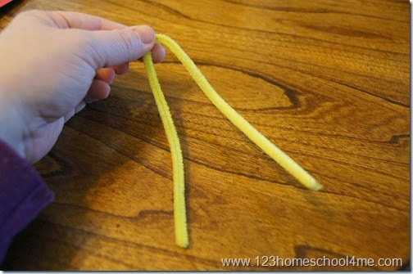

2.Now on one half leave a small gap and then make a circle, twisting the end around the circle to hold in place.

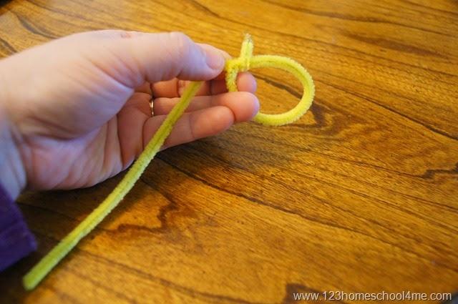

3.Repeat with the other side

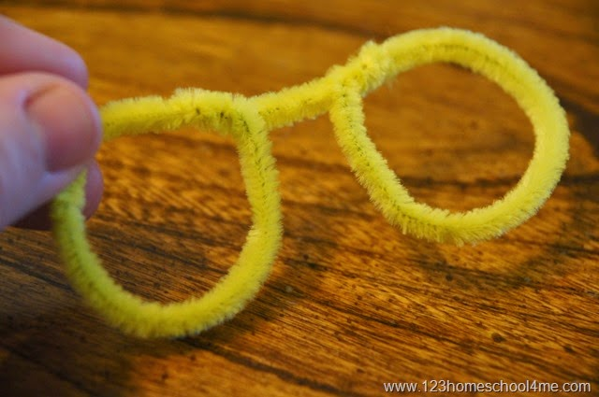

4.Now using another pipe cleaner cut it in half.

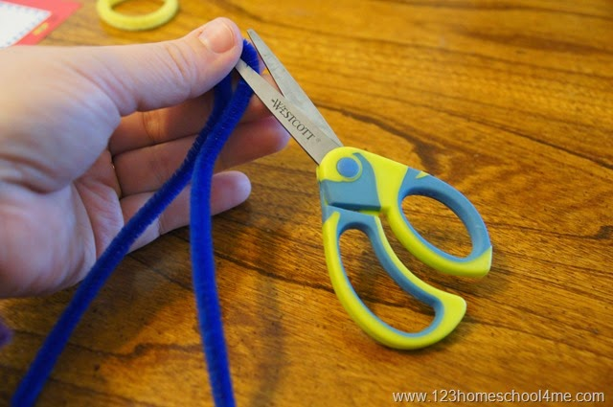

5.With one of the halves twist the end several times around the yellow circle. Fold back other end of blue pipe cleaner so it can sit on your ear

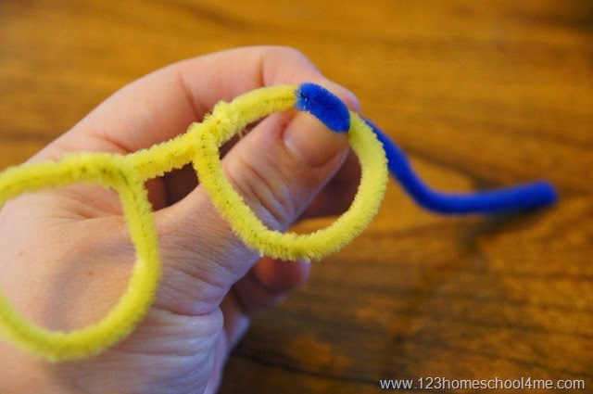

6. Repeat with the other side. Now you have your glasses.

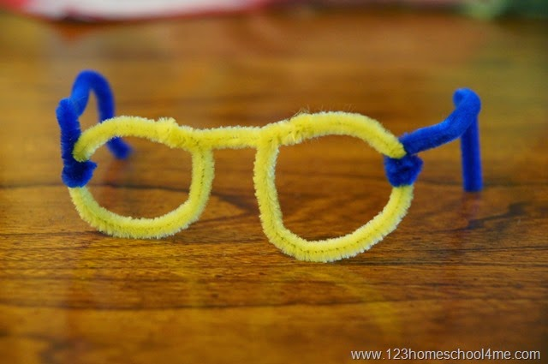

Closing Prayer: Asking God to remove a critical spirit from you.

Faith At Home:
- Description: Read Matthew 7:1-5 and explain to your kid/s what Jesus says in this scripture.

Don’t judge others
³⁷ “Do not judge, and you will not be judged. Do not condemn, and you will not be condemned. Forgive, and you will be forgiven. Luke 6:37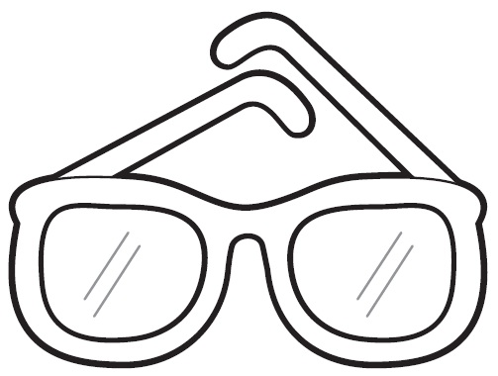
Focus on positive things; see the good in others.

