RSAI Position Paper Extend State Penny for School Infrastructure
A 2019 Legislative Priority

Background: The State Penny for School Infrastructure, established in 2008, expires on Dec. 31, 2029. The original 20-year timeframe matched the typical bonding period for property-tax backed construction projects. State penny has helped schools address the age-old problem of equity and adequacy for school facilities. Use of the local option tax from 1998-2008 and the state penny sales tax for school infrastructure since have together:
- Funded school safety improvements and technology to protect students and staff
- Funded technology expansions in districts
- Elevated student learning (science labs, STEM, CTE and the arts, to name a few)
- Upgraded fine arts performance areas to encourage student/community connection to school
- Resulted in fewer days lost due to extreme temperatures
- Returned saved energy dollars to the educational program
- Purchased items otherwise requiring PPEL levy increases or new Bond Issues
- Improved condition of otherwise aging bus fleet
- Reduced property taxes and provide additional property tax equity through dedication of use tax to property tax relief.

Current Reality: Ten years later, schools are feeling the pinch of a shortened bonding period:
- With only 11 years remaining, a shortened bonding stream has left approximately $700 million of borrowing capacity on the table, compared to a full 20-year period.
- With low interest rates and unmet needs, this is the wrong time to turn to property taxes rather than sales taxes to continue facilities repair and construction.
- The replacement cost of Iowa schools is estimated to be $16.4 billion (July 1, 2014). The state penny provides an annual investment of 2.55%, a reasonable amount to maintain and update Iowa schools, including funding for technology, equipment, buses and additional property tax relief.
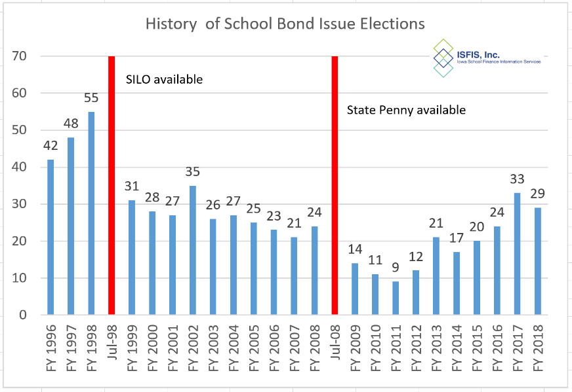
- Fallback will always be property taxes. Inequity in valuations means that districts access to PPEL/Debt Service property taxes bears little relationship to enrollment or need. Iowa will return to the infrastructure mess that delivered inadequate school facilities and unequal student resources.
History of the number of bond issues approved by voters annually proves the point: fewer bond issues elections were held since the start of the state penny. That track record will continue if the penny can be bonded against for the full 20 years. Absent that action, as the time frame shortens, the number of bond issues backed by property taxes is growing.

RSAI calls on the Iowa Legislature to extend or repeal the sunset of the state penny for school infrastructure. Since voters in Iowa’s 99 counties approved the sales tax for public schools, any change in use of the revenue should be dedicated to educational purposes.

