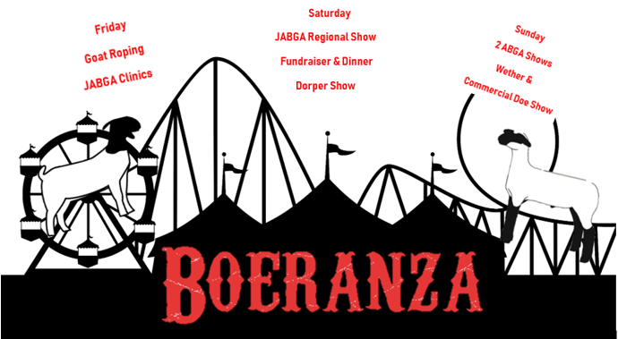
Sponsorship Levels
- Platinum Sponsor ………………………………………$5,000
Ad on show website and Facebook page, vendor spot, announced at show, banner in show rings.
- Gold Sponsor………………………………………………$2,500
Ad of website and Facebook, vendor spot, announced at show, banner in show rings.
- Silver Sponsor……………………………………………..$1,000
Announced at show, vendor spot, announced at show, banner in show rings.
- Bronze Sponsor…………………………………………..…$500
Banner in show rings
- Banner Sponsor…………………………………………….$250
Banner in show rings
- Buckle Sponsor ……………………………………………….$150
- Junior Show Award Sponsor…………………………….$100

If you want to sponsor one part of the show at any level please let us know!!
Email to radiantredsproductions@gmail.com
Mail to Radiant Reds Productions
P.O. Box 97, Bella Vista CA 96008

Name :
Sponsorship Level:
Contact #:
Email:
Website link:

