**ACC Bio 169 Virtual Class notes 8/27**  
1. Asked if there are any questions re the goals questions or Pearson.  
2. Reviewed the gross structure of the ear as discussed in yesterday’s lecture class  
 and explored in lab class using the ear models.  
3. Discussed in more detail the structure of the ear, concentrating on the cochlea, the vestibule and the semi-circular canals.  
**A bit about sound waves…**Sound waves are really just pressure waves. Waves are measured in wavelengths/ peak to peak (just like light waves). Frequency is the number of waves (also called cycles) that pass a single point in a given time. High frequency sounds have a short wavelength/many wave cycles…low frequency sounds have longer wavelength/fewer wave cycles. We process frequency as pitch. The number of cycles per second is measured in Hertz (Hz). Average human hearing range is 20 – 20,000 Hz. Most conversations fall into the 1500-4000Hz range.   
Waves also have different intensities/amplitudes. A greater amplitude = louder sound.   
So it is the frequency and amplitude of the sound wave that is processed and perceived as pitch and intensity.   
  
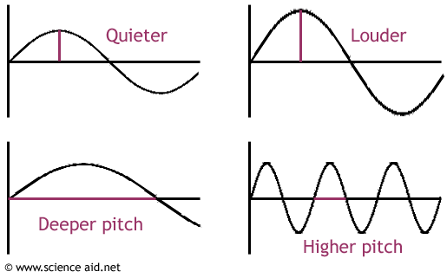  
  
Now let’s chat about the inner ear…  
Cochlea: exhibits bony labyrinth shaped like a snail shell with **membranous labyrinth** separating upper and lower **bony labyrinth** compartments. The bony labyrinths contain **perilymph.** The membranous labyrinths contain endolymph. The upper bony labyrinth (the part of the cochlea that starts at the oval widow and goes to the apex of the cochlea (cochlear **apex** = helicotrema) is called **the vestibular duct or the scala vestibuli.** I remember this cause it starts at the vestibule). The lower bony labyrinth that runs from the apex to the round window is called the **tympanic duct or scala tympani.** These two scalae are really one long perilymphatic chamber because they are connected at the apex…one just flows into the other. (remember Dorothy and the yellow brick road??) The membranous labyrinth is called the **scala media (media = middle) or the cochlear duct**. The cochlear duct exhibits the **organ of corti**. This is pretty confusing unless you can couple this description with a pic of these structures. Try this one…  
In this pic, the cochlea, which coils/spirals about 2 and a half times, is straightened out a bit to make it easier to see…  
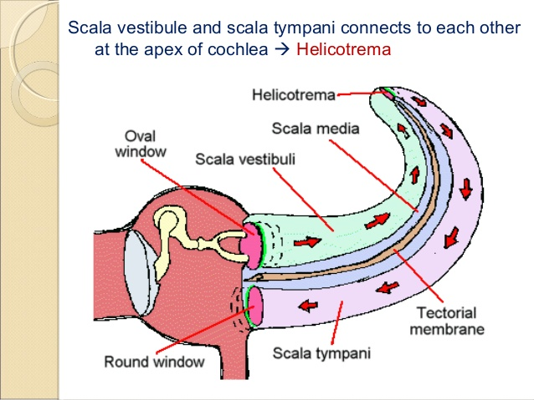  
  
  
  
  
  
  
  
  
  
  
  
  
And this one…  
  
The dark tan is bone.   
The light tan is the bony labyrinth, a cavity filled with perilymph.  
The blue is the membranous labyrinth filled with endolymph that sits inside the bony labyrinth.   
  
 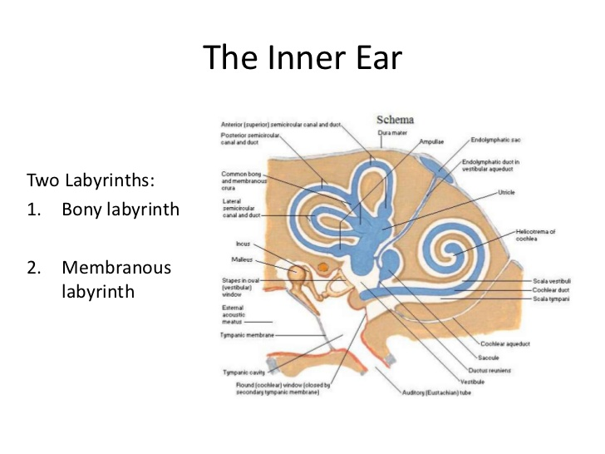   
  
  
  
  
  
  
  
  
  
  
  
  
  
  
  
  
  
and this one…  
  
  
  
an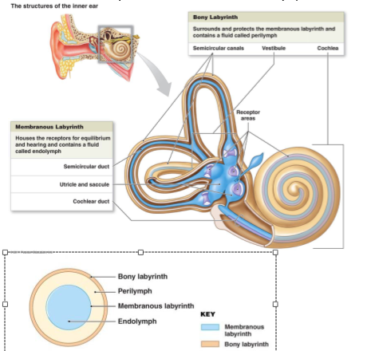  
  
  
  
  
  
  
So, now that we chatted on some gross details of the structure, let’s talk get into the finer details of the membranous labyrinth of the cochlea called the **scala media or cochlear duct.** This is where we find the **organ or corti** which is the sensory portion of this system.  
  
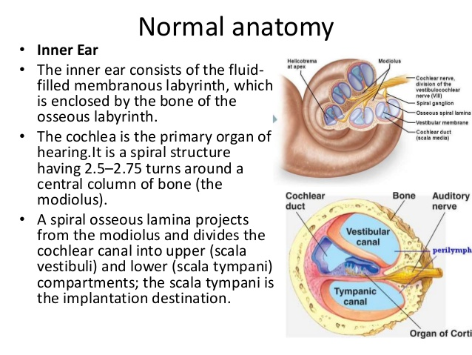  
  
Between the vestibular duct and the cochlear duct is a membrane called the **vestibular membrane.** Between the cochlear duct and the tympanic duct is a membrane called the **basilar membrane.**   
  
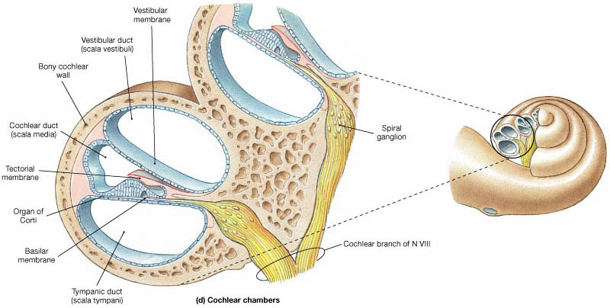  
  
Lying on top of the basilar membrane is the **organ of corti.** You see the **hair cells** with the **stereocilia** on the pic below?   
So , here’s how all of this works.  
The process by which mechanical/vibrational energy is converted to electrical energy is called **transduction.** When a wave action in the perilymph displaces the basilar membrane, the stereocilia of the hair cells positioned on top of this membrane are going to be pressed against the **tectorial membrane**, a stationary structure. The wave action came from the **oval window** that started vibrating when the ossicle/**stapes** moved against it. The oval window vibrating initiated a wave in the perilymph of the vestibular duct which was transferred to the basilar membrane at the surface of the tympanic duct.   
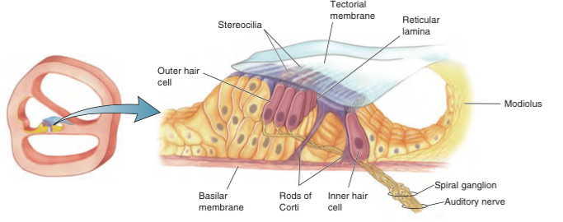  
  
When the stereocilia of the hair cells are pressed against the tectorial membrane, ion channels in the plasma membrane of the hair cells open. This permits **K+** to rush in, changing the membrane potential/depolarizing the hair cells, releasing neurotransmitter to adjacent bipolar sensory neurons. Btw…the K+ is from the endolymph which has a high K+ concentration. What’s also cool is there are several rows of these hair cells. Soft sounds displace only a few of the hair cell’s stereocilia. Louder sounds produce a greater response from these hair cells and also disturb neighboring hair cells in other rows. Info re the intensity of sound/loudness is based on the number of hair cells that are stimulated.   
High frequency sounds with short wavelength vibrate the basilar membrane closer to the oval window…low frequency sounds vibrate the basilar membrane nearer the apex. So the frequency of the sound is determined by where the basilar membrane is distorted. Intensity/amplitude is determined by how much the basilar membrane moves.   
btw…the pressure from the wave action is released via the **round window** which is found at the end of the scala tympani, the descending portion of the cochlea.   
  
After discussing hearing, we explored how the semicircular canals and the elements of the vestibule collect information used to process/maintain static and dynamic equilibrium.  
  
 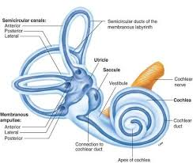  
At the base of each of the three semicircular canals sits an enlarged node called an ampulla. Inside each ampulla, there’s a **crista** which exhibits hair cells embedded in a mass called a **cupola.** When the position of the head changes, the endolymph in the membranous labyrinth of the semicircular canals lag behind and sloshes over the cupola, which deflects the **stereocilia** of the hair cells beneath it. When the stereocilia of hair cells are moved, ion channels open at their tips long enough for ions to rush in causing the hair cells to depolarize. Depolarization of hair cells leads to a release of neurotransmitters and the stimulation of the vestibulocochlear nerve. The specific gravity of the cupula is similar to the endolymph so the cupula isn’t displaced by gravity.  
The anterior semicircular canal detects movement such as nodding your head.  
Lateral semicircular canals detects rotation around a vertical axis such as shaking your head from left to right.  
Posterior canals detects movement such as moving your head to touch your shoulders  
or doing a [cartwheel](https://en.wikipedia.org/wiki/Cartwheel_(gymnastics)).  
   
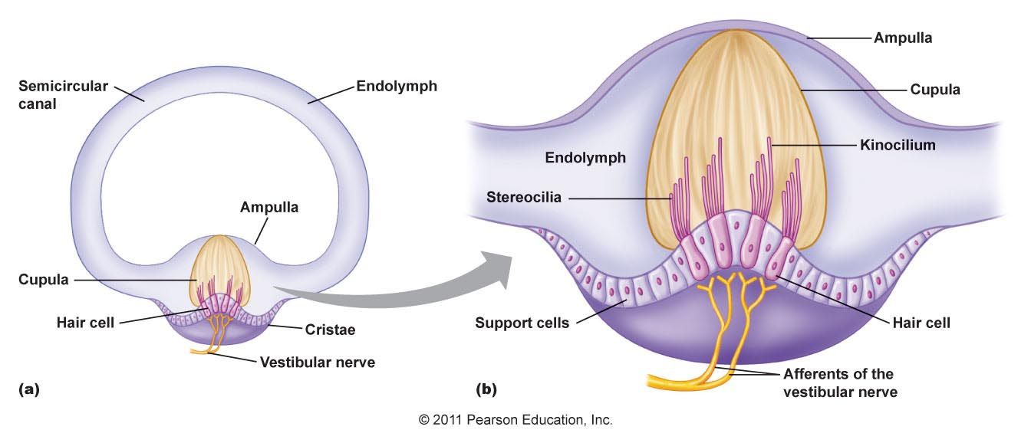  
  
  
Another set of structures provides information re horizontal and vertical linear acceleration. Unlike the crista, these structures are gravity dependent.   
In both the **utricle and the saccule** (parts of the vestibule) there are areas called   
**maculae** which contain **otolith organs.** These otolith organs exhibit **otoliths,** small shards of calcium carbonate which sit atop a gelatinous matrix within the endolymph of the vestibule. Movement of the head (acceleration/deceleration) cause the otoliths to slide, displacing the stereocilia of the hair cells and then….well, you know the rest…  
   
  
 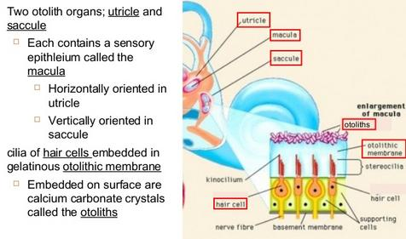  
  
Next class, virtual Tuesday, 9/1, we’ll review this info and then discuss how we smell and taste. If we have time Tuesday, we’ll also being the Endocrine System.

Have a great weekend…😉