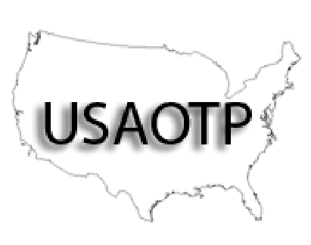
USAOTPTM

The UNITED STATES ASSOCIATION of OPIOID TREATMENT PROVIDERSTM

2023
NEW MEMBERSHIP & RENEWAL APPLICATION
**DUE 1 WEEK BEFORE FIRST CONFERENCE ATTENDED IN 2023**

PLEASE PRINT CLEARLY

NAME OF PROGRAM or INDIVIDUAL: ______________________________________________________

NUMBER OF LOCATIONS IN TEXAS: ______

NUMBER OF LOCATIONS OUTSIDE OF TEXAS: ______

NAME OF PROGRAM REPRESENTATIVE: ___________________________________________________

CONTACT ADDRESS: _____________________________________________________________________

CONTACT PHONE: ____________________________CONTACT FAX:_____________________________

CONTACT E-MAIL: ____________________________________________________
USAOTP WILL NOT GIVE YOUR E-MAIL ADDRESS TO ANY ENTITY.

NEW DUES STRUCTURE!

We have changed our dues structure and conference registration fees. Dues are minimal to be a member of USAOTP, and with a small per person registration fee to attend conferences (on a separate conference registration form). Whether you join as an individual or an entity the membership dues are $100.00, regardless of the number of locations or clients served.

YOUR COMMENTS & SUGGESTIONS? ______________________________________________________________________

_________________________________________________________________________________________

PLEASE REMIT $100.00 WITH THIS FORM TO
USAOTP
c/o Kirk McLaughlin 806-790-0006
2701 19th Street, Lubbock Texas 79410
Email: usaotp@yahoo.com

CHECK #: ________ CHECK DATE: ___________

PLEASE KEEP A COPY OF THIS FORM FOR YOUR RECORDS.

USAOTP was created by TMTA to better serve our neighboring states.
Visit us at USAOTP.org

