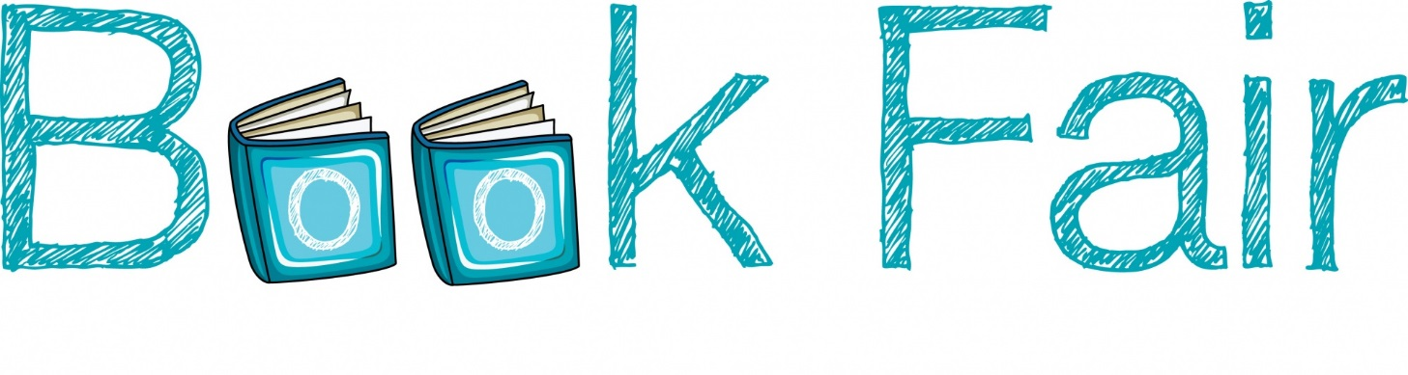

Come visit our book fair in the library!

**BOOK FAIR HOURS:**

**Come in anytime to purchase!**

Tuesday **August 20** 10:30AM-4:30PM

Wednesday **August 21** 8:30AM-4:30PM

Thursday **August 22** OPEN ALL DAY 8:30AM-8PM

Friday **August 23** 8:30AM-10:30AM

***The proceeds of this fundraiser are for the purchase of books for our library***

***We appreciate your support of our school and students***