Regents Review: Ecology

Define the following:
Abiotic – nonliving parts of the environment
Autotroph – an organism that produces its own food; the source of energy for all
other living things on Earth
Biodiversity – the variety of species in an area
Biosphere – all of Earth’s ecosystems, collectively; the biologically inhabited
portions of the Earth, including all of the water, land, and air in which
organisms survive
Biotic – the living parts of an ecosystem
Carnivore – an organism that survives by eating animals
Carrying Capacity – the largest population of any single species that an area can
support
Community – a combination of all the different populations that live and interact
in the same environment
Competition – the struggle between organisms for the same limited resources in a
particular area
Consumer – an organism that obtains its energy from producers
Decomposer – an organism, generally a bacterium or fungus, that consumes dead
organisms and organic wastes
Deforestation – forest destruction that results from human activity
Direct Harvesting – the destruction of an organism or the removal of an organism
from its habitat
Ecological Niche – the specific role played by an organism or a population of
organisms in the ecosystem
Ecological Succession – the process by which an existing community is replaced
by another community
Ecology – the study of how living things interact with one another and with their
environment
Ecosystem – all the living and nonliving things that interact in a specific area; a
subdivision of the environment
Energy Flow – the movement of energy through an ecosystem
Energy Pyramid – a diagram showing how food energy moves through the
ecosystem
Environment – every living and nonliving thing that surrounds an ecosystem
Food Chain – a representation that identifies the specific feeding relationships
among organisms
Food Web – a representation of many interconnected food chains that shows the
feeding relationship among producers, consumers, and decomposers
Fossil Fuel – a fuel, such as coal and gas, that comes from the remains of
organisms that lived millions of years ago
Global Warming – an increase in Earth’s average surface temperature caused by
an increase in greenhouse gases
Habitat – the place where an animal or plant lives
Herbivore – an organism that eats only plants
Heterotroph – organism that cannot make its own food; a consumer
Host – the organism in a parasitic relationship that provides a home and/or food
for the parasite
Industrialization – the process of converting an economy into one in which large-
scale manufacturing is the primary economic basis
Limiting Factors – any factor in the environment that limits the size of a
population
Nonrenewable Resource – any resource, such as fossil fuels and minerals that
cannot be replaced
Nuclear Fuel – an energy source that results from splitting atoms (radioactivity)
Ozone shield – the layer of ozone gas in the upper atmosphere that protects Earth
from some of the sun’s radiation
Parasite – an organism that survives by living and feeding on other organisms
Pollution – a harmful change in the chemical make-up of the soil, water or air
Population – all the individuals of a single species that live in a specific area
Predator – an animal that hunts or kills other animals
Prey – an animal that is hunted and killed by predators
Producer – an organism that makes its own food from light energy and inorganic
materials
Renewable Resource – Earth’s resources, such as our food supply and solar
energy, which, given time, can be replaced
Scavenger – a carnivore that feeds on the bodies of dead organisms
Technology – all of the practical scientific knowledge that has been used to meet
human needs
Trade-off – an exchange or agreement made to reach a compromise
Water Cycle – the process by which water continuously moves from Earth’s
surface to the atmosphere and back

Describe the difference between abiotic and biotic factors. List three examples of each.

Abiotic factors are nonliving such as temperature, weather, water, salt, rocks, soil
Biotic factors are living or byproducts of living things like birds, trees, cows, bacteria

Classify each as a habitat, population, organism, community, biosphere, abiotic or biotic from the list below:

One deer – biotic, organism
Sun – abiotic
A hardwood forest – habitat, abiotic and biotic
Maple, oak and pine trees – community, biotic
Flower - biotic, organism
Earth – biosphere, abiotic and biotic
A herd of deer - biotic, population
Decaying log – biotic, habitat/organism
Water - abiotic
A mushroom – biotic, organism
Rocks - abiotic
A group of herbivores – biotic, community

Describe competition:

When one or more organisms compete for a limited resource (ex. Shelter, food, breeding partners, space, water)

Describe two relationships between predator and prey:

Cat (predator) → Mouse (prey)
Rabbit (predator) → Berry Bush (prey)
What happens to a population before it reaches carrying capacity? At carrying capacity? Over carrying capacity?

Before – population increases because resources are plentiful
At – population alternates between increasing and decreases based on resources available
Over – population declines (death or migration) due to the lack of resources necessary

Name three organisms and describe the habitat in which they live and their niche:

Beaver – freshwater pond ecosystem, niche is to make dams in streams to create ponds
Bacteria – moist warm environment, decomposer
Palm tree – warm tropical ecosystem, producer

Draw a simple food chain below showing a producer, two consumers and a decomposer.

Grass → rabbit → cat → hawk → bacteria (hawk has died)
Apple tree → deer → human → mountain lion → Fungus (lion has died)

Identify which consumer is a herbivore and which is a carnivore in the above food chain. What does an omnivore eat?

Herbivores (eats plants only): rabbit, deer
Carnivores (eats meat only): mountain lion, hawk, cat
Omnivores (eats plants and meat): human
Decomposers (breaks down dead material): bacteria, fungus

Draw a more complex food web below (notice which way the arrows point to show the transfer of energy!)
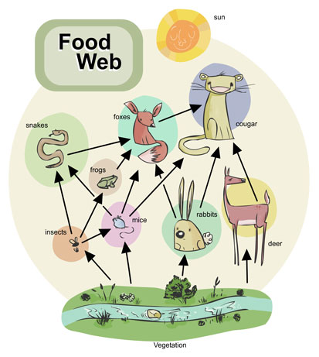

What are some common decomposers?

Bacteria and fungi

What does a scavenger do for an environment? Name a common example.

A scavenger, like a crow or worm, eats the bodies of dead animals and helps to reduce the amount of dead material that could build up in an ecosystem (“garbage man of the forest”)

Describe the relationship between a parasite and a host:

A parasite lives in or on a host. The host is harmed while the parasite benefits from this relationship (+/-) known as parasitism

Draw a stable energy pyramid. Describe the change in energy as you travel up the pyramid.
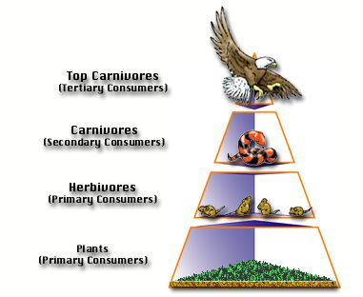
As you go up the pyramid from the grass to the hawk: biomass decreases, energy available decreases and number of organisms decreases

Draw an unstable energy pyramid.

What are the three main cycles we learned about? Describe each.

Water, carbon, nitrogen cycles… (see packet with turtle, cow and mountain drawings)

Why is biodiversity a good thing? What can we do to preserve it?

Allows us to have a healthier ecosystem which is more stable if faced with disease, disaster or change. Also, provides us with alternative sources for food, medicine, energy, etc. Preservation can be accomplished through protecting the organisms and their habitat as well as through education and creating laws.

Show the primary ecological succession of bedrock to a climax forest:
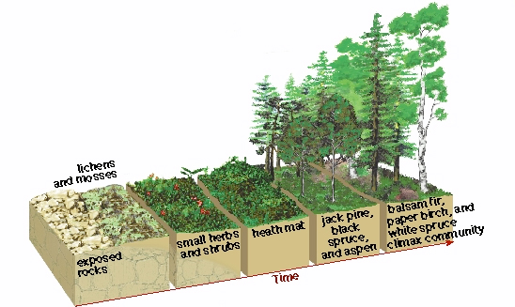

Show secondary succession of an abandoned farmer’s field:
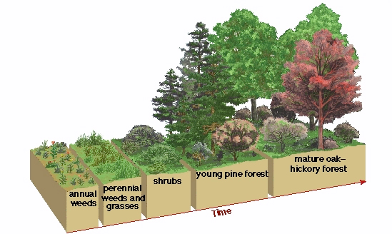

Describe the difference between renewable and nonrenewable resources. Give examples of each.

Renewable resources can be replaced within a short amount of time (ex. food, solar energy). Nonrenewable resources take hundreds to thousands of years to reform and supplies will run out (ex. freshwater, oil, fossil fuels).

What can we do to preserve nonrenewable resources?

Decrease the use of the product by limiting how much we use or finding other resources to substitute for it.

Name ways in which pollution occurs, both natural and human influenced:

Natural: dead organisms, organisms wastes, release of CO₂ from organisms
Human influenced: CO₂ from coal power plants, garbage in lakes/oceans, fertilizer

How does pollution affect the water cycle? Soil formation? Cycling of nutrients? Energy flow?

Contaminates the water and is spread to the ground water which is used by plants and animals. Contaminated water can also be transported to other ecosystems when clouds move with the weather patterns

Soil formation is affected if pollutants kill plants whose roots keep the soil intact and prevents the wind and water from washing it away

Nutrients can be destroyed by pollutants in the air, water, ground or in organisms and prevent the proper cycling within an ecosystem

Energy is transferred between the sun and producers/consumers in an ecosystem. Pollutants can interrupt the transfer of this energy. Blocking the sun or preventing producers from creating the energy that is passed onto consumers can be harmful to an ecosystem

How is human population growth out of control? What will this lead to?

Humans are extremely above their carrying capacity because of our ability to control our environment around us and within us. This will lead to a decrease in necessary resources that are needed resulting in massive die offs in certain populations

What are ways human activities directly result in the loss of biodiversity?

Examples like hunting, over harvesting, pollution, over population, habitat loss, fragmentation, poaching

What are some positives and negatives on the environment from technology?

+ technologies: solar energy, biodiesel, wind energy
- technologies: wastes generated from gas vehicles, coal burning power plants, factories

How has industrialization influences water pollution, toxic wastes, thermal pollution and air pollution?

Industrial sites release pollutants directly into the air, local waterways, and into the soil. Also thermal pollution is caused in local waterways when it is pumped into pipes which circulate around machines to cool them, adding the heat to the water which is then returned into the local waterway

Describe what is meant by the term “global warming”:

Overall the temperature of the Earth is rising each year due to the increase in greenhouse gases such as carbon dioxide

What is causing our ozone to deplete (breakdown)?

Increased levels of air pollutants and CO₂

Does how we live today and run our society affect our future generations?

If we destroy our ecosystems, there will be nothing here to support future generations

Regents Practice Questions

Some interactions in a desert community are shown in the diagram below.
Which statement is a valid inference based on the diagram?
(1) Certain organisms may compete for vital resources.
(2) All these organisms rely on energy from decomposers.
(3) Organisms synthesize energy.
(4) All organisms occupy the same niche.

One biotic factor that affects consumers in an ocean ecosystem is
(1) number of autotrophs
(2) temperature variation
(3) salt content
(4) pH of water

Which component of a stable ecosystem can not be recycled?
(1) oxygen (3) energy
(2) water (4) nitrogen

Increased industrialization will most likely
(1) decrease available habitats
(2) increase environmental carrying
capacity for native species
(3) increase the stability of ecosystems
(4) decrease global warming

A food web is represented in the diagram below.
Which population in this food web would most likely be negatively affected by an increase in the mouse population?
(1) snake (3) wolf
(2) rabbit (4) hawk

Years after the lava from an erupting volcano destroyed an area, grasses started to grow in that area. The grasses were gradually replaced by shrubs, evergreen trees, and finally, by a forest that remained for several hundred years. This entire process is an example of
(1) feedback
(2) ecological succession
(3) plant preservation
(4) deforestation
A five-year study was carried out on a population of algae in a lake. The study found that the algae population was steadily decreasing in size. Over the five-year period this decrease most likely led
(1) to a decrease in the amount of nitrogen
released into the atmosphere
(2) to an increase in the amount of oxygen
present in the lake
(3) to an increase in the amount of water
vapor present in the atmosphere
(4) to a decrease in the amount of oxygen
released into the lake

Which result of technological advancement has a positive effect on the environment?
(1) development of new models of computers each year, with disposal of the old computers in landfills
(2) development of new models of cars that travel fewer miles per gallon of gasoline
(3) development of equipment that uses solar energy to charge batteries
(4) development of equipment to speed up the process of cutting down trees

Species A, B, C, and D are all different
heterotrophs involved in the same food chain in an ecosystem. The chart below shows the population of each species at the same time on a summer day.
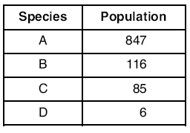
Which statement best describes one of these species of heterotrophs?
(1) Species A is the most numerous
because it can make its own food.
(2) Species B probably feeds on species D.
(3) Species C and B interbred to produce
species A.
(4) Species D is most likely the top
predator in the food chain.
Students conducting a study on an insect population placed 25 insects of the same size in a box. The amount of food, water, and shelter available to the insects was kept constant. Each month, students removed and counted the number of
insects present, recorded the total, and returned the insects to the box. The graph below shows the number of insects in the box over a 12- month period.
What inference can be made regarding this
insect population?
(1) All the insects in the box are the same
age.
(2) The insects hibernated from January to
April.
(3) The population has carnivorous
members.
(4) The population reached carrying
capacity by January.

Identify one farming practice that could be a source of environmental pollution.

Using fertilizer, having livestock which produce large amounts of wastes which leak into waterways or into ground water as well as release air pollution, use of machines which leak oil, gas and air pollutants into the ecosystem

Over the past few decades, many oil companies have discovered oil below the seafloor near the coasts of many states. Some states, however, refuse to permit offshore oil drilling, fearing it might damage the environment. Discuss both sides of this issue. In your answer, be sure to:
• state one way in which offshore oil drilling might have a long-term negative effect on the environment

Will cause the destruction of marine ecosystems and species who live there. Could throw off seasonal migrations of species. If oil was released or leaked into the ocean it would affect ecosystems for thousands of miles.

• state one way in which offshore oil drilling could benefit society

Decrease the need of relying for oil from foreign companies, lowering gas prices. Decrease the need to drill in Alaska and run pipelines through more land than it would to drill down into the ocean.

