Machine Quilting Classes with Kathleen Riggins
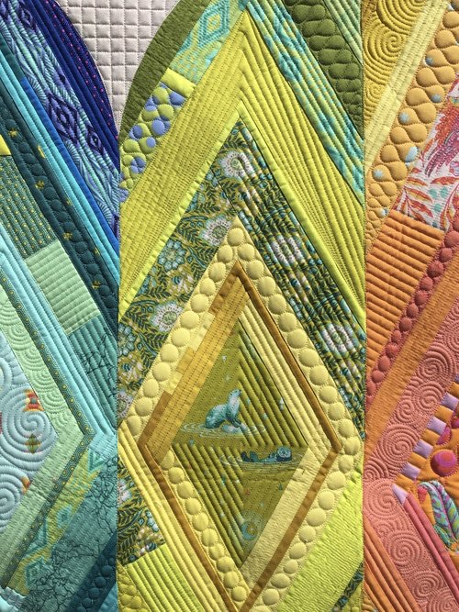
Cheaters Guide to Quilting
Fri Nov 2/18 - 6:30 pm - 9:30 pm
$47.50 for members

This class is also called Quilting For the Lazy. Learn Kathleen’s go to designs, then learn her favorite variations to make it seem like you know ALL the quilting things. Gain confidence with some versatile designs that you can use again and again.

Designs for Lines (And Other Shapes That Don’t Rhyme)
and Combining Designs in Modern Ways
Sat - Nov 3/18 9:00 am - 4:00 pm
$95.00 for members - $125.00 for non-members

Learn Kathleen's go-to designs for the shapes she finds in quilts the most often. Learn designs for lines, designs for squares, designs for triangles & designs for odd shapes. Use these easy-to-quilt designs in your quilts to easily create beautiful quilting. Then, once we know these basic designs, we will learn to combine them in interesting ways which can open a whole new world of quilting. Join Kathleen as she walks you through some of her favourite ways to combine designs, helping you to create stunning quilts.
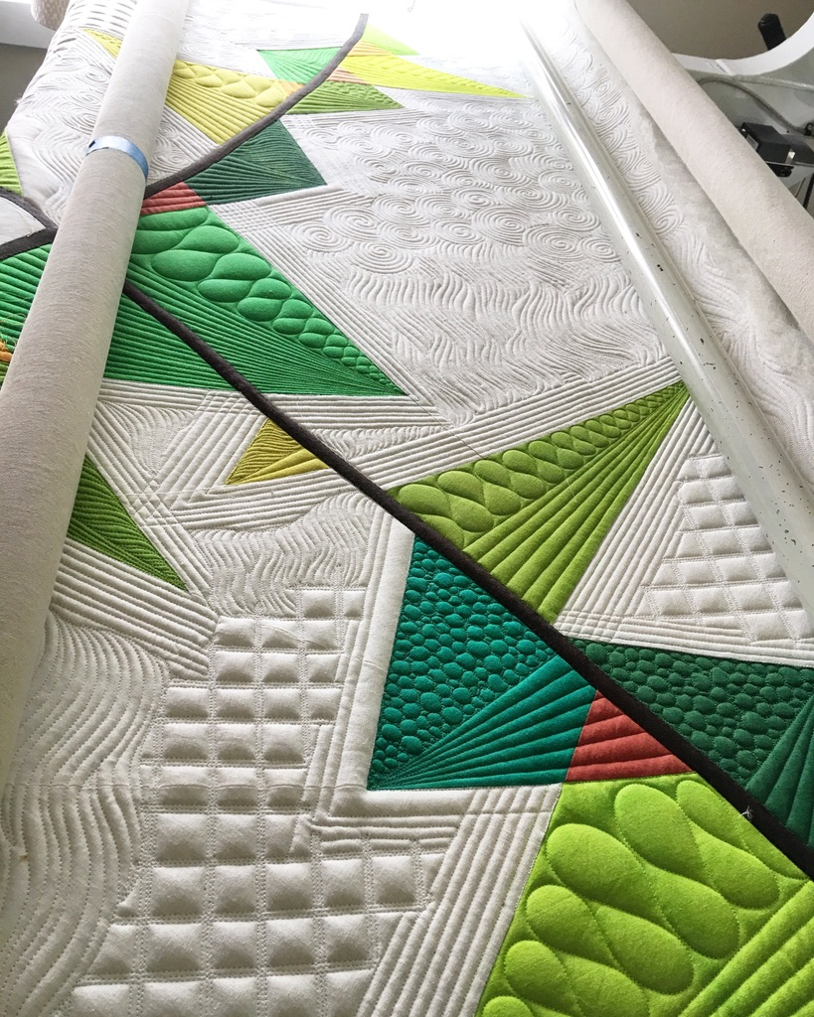
Using Rulers on your Domestic Machine
and Quilting for the Crazy
Sun - Nov 4/18 9:00 am - 4:00 pm
$95.00 for members - $125.00 for non-members
Use your domestic machine to create professional looking quilting. Kathleen shares how to get perfect straight lines while in Free Motion mode on your sewing machine allowing you to easily stitch-in-the-ditch and create geometric quilting designs. Ruler foot and ruler required (can be purchased through Kathleen for most machines). More information on feet and rulers to follow. In the afternoon we will learn to mark lines and shapes to fill in some of those pesky negative spaces. It may seem time consuming but it’s not particularly difficult. Let Kathleen show you how!!
REGISTRATION
REGISTRATION WILL BE OPEN AT THE SEPT 2018 GUILD MEETING. YOU MAY REGISTER AFTER THAT MEETING BY CONTACTING DONNA VIA EMAIL.
PLEASE NOTE….YOU ARE NOT FULLY REGISTERED UNTIL PAYMENT HAS BEEN RECEIVED.
CONTACT DONNA at baja@ssimicro.com
ALL CLASSES TO BE HELD AT THE QUILTED RAVEN

