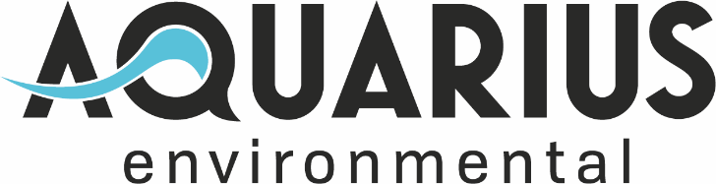
Main Office:  2117 NE Oregon Street  Suite 502  Portland OR, 97232 | Phone: (503) 828-0265  info@aquariusenv.com  www.aquariusenv.com

Services
INNOVATION IN WATER, WASTEWATER AND STORMWATER
Aquarius Environmental is an engineering and consulting firm specializing in water quality and resources. We are committed to providing our clients services that lead to responsible environmental stewardship that are economical and efficient.
Water  - Use/Demand Reduction  - Membrane Process Optimization  - Membrane High Recovery  - Energy and Control Audits  - Water Quality Assessment  - Ultra-high Purity Systems  Wastewater  - Pretreatment System Design  - Chemical Reduction/Optimization  - Metals Pretreatment System  - NPDES Permitting  - Engineering Reports  - Conveyance System Capacity Analysis  - Water Re-Use Systems  - Feasibility/Pilot Studies  Business Consulting  - Product Development Technical Assistance  - Product Design Development  - Performance Validation  - Technical Marketing Strategy | Stormwater  - Treatment/Reclamation System Design  - Stormwater Pollution Prevention Plans  - Rainwater Harvesting and Reuse  - Value Engineering  - BMP Performance Assessment  - Pilot Testing  - Spill Control and Countermeasure (SPCC) Plans  Construction Services  - Project Management  - As-built drawings  - Procurement Strategy  - Construction Stormwater Plan  - Temporary Discharge Permitting  Monitoring  - Automated Sampling Systems  - Sampling Strategy
