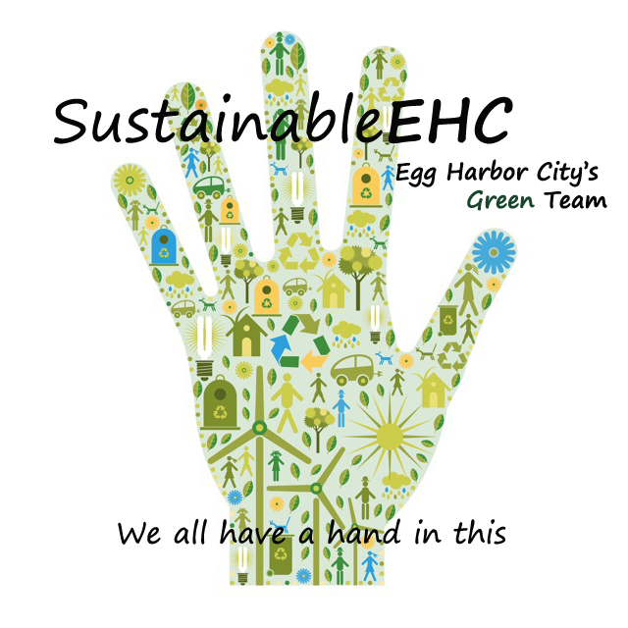
SustainableEHC

Tuesday, Nov. 22, 2016
Agenda

I. Welcome & Introductions

II. Approve minutes of Sept. 27 meeting

III. Financial Report

IV. Farmers Market

V. Tree Grant
Mark Demitroff – Certified Tree Expert

VI. Update Sustainable Jersey Website

VII. Comments

VIII. Next Meeting, Dec. 19 or Jan. 23

www.sustainableehc.org

