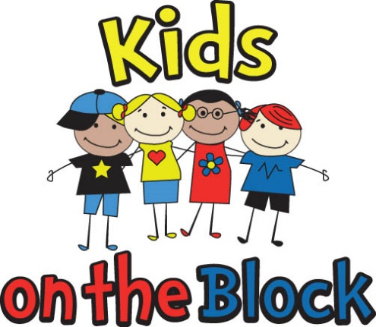

2016-2017
Year-end Report

Presented by:
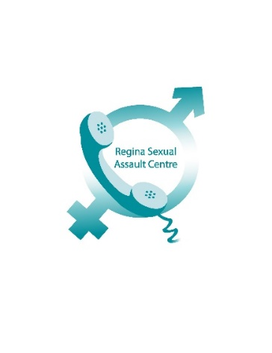
Prepared by Lisa Miller
Community Education Coordinator
March 2017

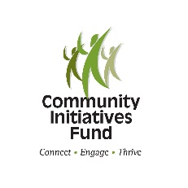

Summary
The Kids on the Block (KOTB) is an international puppet-based program, for children 5-12 years, which educates children on a wide variety of topics relating to safety, wellness, diversity and social issues.
Children and youth are the most vulnerable populations to all forms of violence and abuse. Saskatchewan continues to have one of the highest rates of family violence and child sexual abuse in the country. Qualifying and quantifying child abuse can be a challenge, as many incidents go unreported; however the personal and monetary costs associated to child abuse cannot be understated. Nearly $16 billion is spent annually in Canada on issues related to child abuse, including addictions, incarceration, unemployment, mental health and suicide (The Economic Costs and Consequences of Child Abuse in Canada, 2003). Statistics illustrate a need for communities to provide programming which focuses on education and prevention, in order to give children the skills to be knowledgeable and empowered to speak out and self-protect.
In 2014, through a pilot project partnership between the Regina Sexual Assault Centre and Saskatchewan Towards Offering Partnership Solutions (STOPS) to Violence, the Kids on the Block program was established in the Regina community to deliver children’s presentations focused on personal safety, bullying and abuse awareness and prevention. The program supports the Regina Sexual Assault Centre’s strategic priority of education and awareness in order to reduce and prevent incidents of interpersonal violence, abuse and sexual assault.
The pilot project delivered presentations between April and June 2015 and, due to positive feedback, continued in Fall 2015. Kids on the Block is offered free of charge through schools and community-based organizations that deliver services to children. The majority of presentations are delivered between September and June, when children are in school.
Each presentation is 30-60 minutes in length and includes two short puppet skits on the topic area, interactive question and answer periods with puppet characters, and facilitated learning activities. The presentation is supplemented with support materials for group leaders, which include resource information and classroom activities that reinforce program messages to maximize outcomes. KOTB staff remain available for follow-up after presentations to assist group leaders in finding resources or information. In 2016, the program developed support materials for students, including an activity book for ages 7-10 years and a Safety Card for children ages 5-8 years. The activity book was made possible by a generous donation from the Downtowners Optimist Club of Regina.
The Centre has received an ongoing funding commitment from the Ministry of Justice for a half-time Coordinator salary; the funding from the City of Regina supports the remainder of the contract wages for the full-time Coordinator. Remaining funding is used for project supplies, volunteer recognition and student giveaways, such as branded pencils, stickers and activity books.
The program saw steady growth in 2016-2017, in both schools and community-based organizations. KOTB delivered a successful presentation at a Four Directions (RQHR) Focus on Fathers group and continues to deliver 3-4 presentations per year at the YWCA Children Exposed to Violence program, indicating KOTB is compatible and complementary to existing programs. Collection of data about the number on Indigenous and newcomer participants began, in order to inform funders on these priority populations.
There were minor changes to program content, including the undertaking of developing a more flexible facilitation portion, to meet various needs and developmental levels. Changes to presentation delivery and information aim to create presentations which are relatable and relevant for all children, regardless of socioeconomic factors.
Feedback from teachers and counsellors, through evaluation forms and emails, assist the Coordinator in ensuring the program remains high-quality and relevant to children from a variety of backgrounds. The program has proven to be very effective at engaging children and opening up communication about sensitive and sometimes difficult topics. There are disclosures of bullying (including children who acknowledge participating in bullying behaviour) in approximately three-quarters of the Bullying presentations. There are disclosures of feeling uncomfortable about an adult’s behaviour in approximately one-third of the Safety presentations. There have been disclosures of abuse and/or child safety related issues in nearly all of the Abuse Prevention presentations.
Although the presentations do not encourage children to disclose personal experiences, they often frame their experiences as questions. The nature of the conversations can create vulnerability for children, but also awareness that others have troubles, which may reduce feelings of isolation and shame. It also offers opportunities for children to demonstrate compassion and empathy for their peers, and this has been observed in a number of presentations.
The program adheres to the Provincial Child Abuse Protocol and the Coordinator works closely with school counsellors and educators when scheduling and delivering presentations, in order to ensure supports and follow-up are in place in the event of a disclosure.
There has been increasing interest in the program from a number of communities in the Regina area; however, Regina remains the priority population at this time.
There is ongoing communication and information sharing with the KOTB program in Windsor, ON, which has been delivering presentations since the 1980’s and works in tandem with Children’s Aid Society to provide abuse prevention education to children; the Saskatoon Sexual Assault Centre, which offers their My Body Belongs to Me abuse prevention program, and which is partially funded by the Saskatoon Public and Separate school boards; and the STOPS to Violence Kids Matter puppet-based education program, which was started in 2016.
Activities for 2017-2018 include continuing to build awareness of the program in schools that have not received presentations, continuing to build a skilled volunteer base and identifying a tool to quantitatively measure outcomes in children who have received a KOTB presentation.
The following pages contain summaries and evaluations for the Kids on the Block Regina program for April 1, 2016 to March 31, 2017.

- Statistics

- Participating Schools/Community-Based Organizations

George Ferguson St. Mary
Seven Stones Community School McDermid
Transition House Arcola
St. Michael’s Ethel Milliken
Wilfred Hunt Albert School
W.F. Ready St. Peter
Grand Road Regina Friendship Centre
Regina Housing Authority Four Directions Health
Ruth Pawson Kitchener School
Thompson School St. Gregory
George Lee Walker Elementary
Davin St. Joan of Arc
Deshaye Gladys McDonald
Marion McVeety MacNeill
YWCA Lakeview
St. Jerome YWCA – Children Exposed to Violence
Early Learning Centre

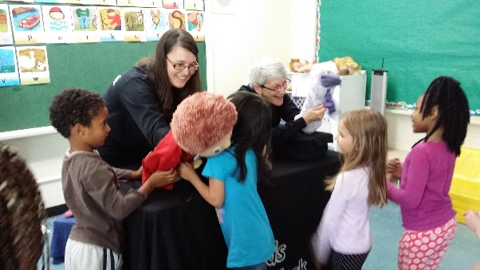

- Analysis of Presentations

Presentation Type |  |  |  | School Board/CBO |  |  |  | Attendance
 | Bullying | Safety | Abuse | Public | Separate | Private | CBO | Child/Adult
April 1, 2015 – March 31, 2016 | 61 | 65 | 2 | 23 | 3 | 2 | 8 | 2,619/349
April 1, 2016 – March 31, 2017 | 67 | 69 | 25 | 19 | 7 | 0 | 7 | 4,007/383

- Summary of Evaluation Form Numerical Ratings
During 2015 and early 2016, evaluation forms were handed out at the beginning of presentations and collected at the end. There was a supplementary online survey which people could participate in, if they chose. In September 2016, existing evaluation forms were changed to be more comprehensive and include questions from the online survey, rather than trying to conduct the survey separately. Forms were handed out at the end of presentations and collected a few days later by an educator or counsellor. It offers educators a chance to reflect on content and student responses, although there were fewer forms returned.
Was the presentation: | Poor | Average | Good | Excellent
Geared to Children’s Level? | 0 | 0 | 11 | 47
Enjoyable and Interesting? | 0 | 0 | 7 | 51
Properly Introduced and explained? | 0 | 0 | 7 | 51
Able to meet learning outcomes? | 0 | 0 | 7 | 51
How do you rate the presentation overall? | 0 | 0 | 8 | 50

Additional data gathered from the revised forms:
Did the presentation: | Poor | Average | Good | Excellent
Explain the topic in a clear way? | 0 | 0 | 2 | 26
Increase awareness of safe and unsafe behaviours and situations? | 0 | 0 | 4 | 24
Increase awareness of safe adults to talk to? | 0 | 0 | 4 | 24
Increase awareness of safety strategies? | 0 | 0 | 5 | 23

Were the presenters: | Poor | Average | Good | Excellent
Ready to start on time? | 0 | 0 | 2 | 24
Well-prepared and organized? | 0 | 0 | 0 | 28
Speaking audibly? | 0 | 0 | 1 | 27
Able to answer questions appropriately? | 0 | 0 | 0 | 28

- Comments from Evaluation Forms:
Safety Presentation
- Kids said they thought it was entertaining. Helped them learn who to turn to for help.
- The children were very engaged and grasped concepts. Safety, safety, safety!
- Thank you for coming. It was wonderful.
- The students love this presentation! They are engaged and the puppets are wonderful. The information is relevant and presented in a way that is interesting and holds the students’ attention. It was also suitable for a multi-ability classroom and students with intensive needs and supports were also able to participate and learn.
- Both kids and dads enjoyed. Many more topics to be discussed regarding safety, staying home alone, bullies, friends, etc. It was really great for the kids and dads to be together – safety messages can be reinforced. Facilitators were patient, respectful and knowledgeable. Thanks so much!
- Kids loved it and can relate and are engaged. It’s fun! Such an important topic especially in this area.
- I used the activities that were in the pre-show package and I know some teachers were using them in their classes.
- It would be great to have teacher resources on your website.
- Yes, it was an enjoyable, interactive way to present a potentially “heavy” health and safety outcome to Grade One.
- Love, love, love this program! The students are so engaged and happy when the puppets come to the school. What a fabulous way to educate young children on sometimes challenging and serious topics. Thanks guys!
- Great way to address topics of safety, etc. Motivating and engaging for kindergarten students.
- They were great. The kids loved that the teacher was involved in the show.
- Thank you very much for your presentation! It was engaging for the students, entertaining and educational!
- Great presentation, students loved the lighthearted personalities of the puppets! Thanks.
- They covered safety issues in a way that young kids would understand and kept the students engaged by including many activities and great discussions.
- It is important that children are aware of safety strategies. Puppets are excellent in keeping their attention.

Abuse Presentation:
- Engaged and presented in a kid-friendly manner.
- Speakers engaged the kids. Let them know there are safe adults to talk to, it’s okay to tell, parents will get help, not go to jail.
- Thank you Kids on the Block for your wonderful presentations and important information!
- Thank you so much for coming and spending time with my students, they got a lot out of your wonderful presentations! Thank you so much!!!
- Informative. Engaging. Not too long or too short. The handout could be directed more towards an older age.
- The kids really enjoyed the presentation and felt “it was a great way to teach students about this” as put by them. They enjoyed the seriousness mixed with humour.
- The students were highly engaged and it opened up more discussion. Thanks a lot!
- It was very informational in a safe and comfortable way.
- It fit well into our safety, home, respect and violence units in gr. 3. The students had the prior knowledge.
- It’s a message that needs repeating.
- Both presentations were excellent! The students loved the puppets.
- Well done and the students were engaged. Thank you!!

Bullying Presentation:
- Presenters were very easy to listen to, they answered questions that the kids asked at the kids’ level. The presenters were very thorough in their discussion of the topic of bullying. I’d like to see presentations in the other topics they have.
- Thank you for the interactive puppet show. The kids loved it! The students enjoyed the puppets a great deal. They continued to talk about them all day. This was a fantastic review to our bullying unit – thank you!!
- It would be helpful to include in the discussion the difference between what is and what isn’t bullying a little more in depth. This may be based on individual need (for my own group), but just a thought.
- The show engages this age group with puppets and audience participation! Excellent presentation!
- Students really enjoyed it. The activity booklet was great, presenters were well prepared.
- Excellent show! Teachers indicated that they received the pre-show packages a bit too close to the presentation time so some classrooms did not have the information beforehand.
- They were at level and engaging. Do two shows per group (per year).
- The students were engaged and seemed to really enjoy it.
- Awesome! Engaging and fun!
- The students were engaged. The topic was very relevant and is something that always needs to be discussed. Thank you very much for your time and knowledge!
- Kids loved the puppets and were engaged. They were able to take some strategies from the presentation and hopefully use them if needed.
- It was a good presentation. The lecture was a good one.
- I enjoyed the realistic situations. The way the students were involved. The students were thoroughly engaged. Thank you for coming out and sharing with us. This was my first kids on the block presentation. I will definitely do it again.
- The children seemed to enjoy the puppets and most of them took home the message.
- Quotes from the kids “I love the puppets”, “We learned a lot of vocabulary”, “They helped us out with bullying”, “I enjoy puppet shows”, “I liked how they explained it”, “It helped me with my bullying experience”. Would like to see Kids Help Phone printed on bottom of postcard. Questions were answered well.
- My class was really engaged with the presentation. Bullying is a reality for many students so it made them aware of what bullying is. Include more suggestions of what students could do if they are being bullied.
- Great show. Discussions on how bullies can be helped or changed.
- It was very age appropriate. The speaker and performance were at the levels of our students. Our students had a lot of positive comments afterwards. They were quick to answer questions based on the performance.
- The kids enjoyed the presentation and were able to engage with the presentation during and discuss after. I’d like to see a bit more on the topic of abuse since I don’t always feel as knowledgeable about addressing it with this age group.
- Positive, engaging. The kids LOVED it! Length of presentation was perfect for the little guys.

Summary of emails from educators, counsellors and group leaders:
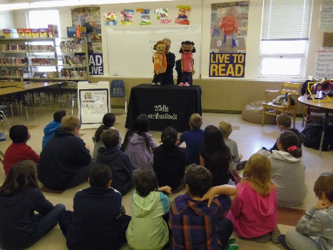
Thanks for presenting to my class last week. They were all so engaged. What a great support for my health curriculum! It’s great when kids get the same message from different places. Your puppeteers were fantastic.
We heard wonderful things about your presentation from our students and staff…there was even a group of grade 2 students talking about it on the way to the bus on Friday. It was really cute but also nice to see that the message was powerful enough to inspire conversation and thought. You are doing very important work. We would love to have you return next year!

A quick email to thank you for coming to our Sparks last Tuesday. I believe all the Sparks enjoyed the
Puppet show very much. We will do other activities pertaining to Safety at future meetings.

Thanks again for the fantastic presentation and I look forward to working with you again next year!
Thanks for being here. The feedback from the staff this morning was very positive!
Thanks! Always such a job well done and the students so enjoy it!
Thank you so much for Coming! All the classes really enjoyed it! When I'm done interning and have a place to call home base I will be utilizing all the shows. The safety one is so important.

- Volunteer Recruitment

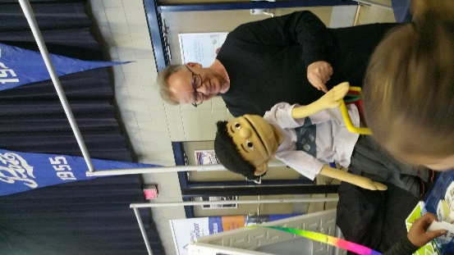
In January 2016, there were seven active volunteers. In order to increase program capacity, particularly for the Abuse Prevention show, the Coordinator undertook a number of activities to recruit new volunteers. These activities included: revising the volunteer poster into two versions, one that is designed to address the interests of post-secondary students; mass distribution of the volunteer poster; increasing activity on the KOTB Facebook page, which includes a callout for volunteers; and contacting the Faculties of Education and Social Work to make educators aware of volunteer opportunities for students.

In December 2016, the program had increased its volunteers to eleven (2 discontinued, 6 started). The program is fortunate to have recruited a highly diverse volunteer base, which is an important reflection of the diversity in the city of Regina. Volunteers include registered social workers, social work and education students, and retired educators.

As most of the volunteers were returning from the previous year, a fall training session was organized. This allowed new volunteers to participate and observe, which increases their understanding of how the program works. Unless the program experiences a shortage of volunteers, having them start in Fall appears to be a more structured and effective way of getting them engaged with the program and other volunteers.

The Coordinator organizes a twice-yearly appreciation gathering, which allows volunteers to learn about each other on a personal level, share experiences and provide feedback about the program. In 2016, a volunteer feedback form was developed and distributed via an online, anonymous method. Seven of the eleven forms were returned.
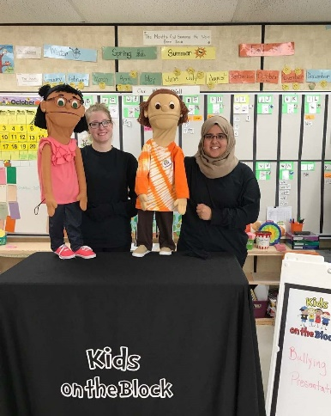
- Summary of Volunteer Feedback

What are the main reasons you joined this program as a volunteer?
- To teach kids the sort of stuff I wish I would have known.
- For volunteer hours through my ECS 200 class.
- Helping kids in a fun, positive way.
- Wanted to try something new. Build my public speaking. Sounded fun and rewarding.
- Because you got me interested in the program.
- As a child life specialist by education, this opportunity allows me to keep my play skills polished. I wanted my volunteer experience to be driven by passion and not accumulation of hours. I consider myself creative and so I am drawn to puppeteering in its various forms.
- I enjoy working with children and I like to volunteer to make my community a better place.

What are some of the main satisfactions you get from doing this volunteer work?
- Helping kids.
- Getting to meet teachers, principals and students. Getting to see different schools and be in different environments.
- The children’s participation/enthusiasm and thanks from the teachers.
- Interactions with students. Increasing my own awareness about abuse, bullying, personal safety
- Being able to feel like I’m making a difference in the lives of children.
- Knowing that I am part of a program designed to protect children gives me great satisfaction. Seeing the children engaged in the shows and voicing their opinions warms my heart, so do the smiles, giggles and curious expressions.
- Seeing the smiles on children.
What are some of the main frustrations?
- Not being able to reach different demographics.
- None
- Forgetting lines. Other than that it’s generally smooth going.
- None, except sore arms. Lol
- I don’t have any.
- I would say anticipated frustrations were my school and transportation. Honest feedback. It’s not a frustration but as this survey gives you an insight to how volunteers feel, I am curious as to what the children and teachers think of this program, do they see any benefits, what works and what doesn’t.
- No frustrations.
Have you recommended joining this volunteer program to friends/family?
Six “Yes” responses. One “No” response.
What aspects of the program do you feel would encourage new volunteers?
- Help kids. Be the adult you wish you had when you were a kid.
- The different environments.
- Flexible, fun, satisfying, helping and being a little creative.
- It would encourage volunteers who want to work with children. Being able to choose your own time to volunteer. Not very demanding in terms of work. Flexibility of availability.
- The understanding that you are truly making a difference in some children’s lives.
- More advertising so more university students know about it.
- The flexibility and the people involved in the program.
What aspects of the program do you feel would discourage volunteers?
- Performing in front of people.
- Weight of the puppet, acting, subject matter.
- Having to drive around to schools, too show to do puppet shows, do not really know what to expect.
- It could potentially be nerve wracking for new volunteers who have never worked with puppets or performed for anyone.
- Nothing’s coming to mind at the moment.
Two respondents skipped this question.
Do you plan on continuing to volunteer for this program for the next 6-12 months?
Six “Yes” responses. One “Hopefully” response.
Please rate each of the following on a scale of 0 to 5:
 | Poor | Average | Fair | Good | Excellent
Training | 0 | 0 | 0 | 5 | 2
Acceptance and support by Coordinator | 0 | 0 | 0 | 1 | 6
Recognition | 0 | 0 | 0 | 0 | 7
Opportunities to learn skills and information | 0 | 0 | 0 | 5 | 2
Opportunity to make a difference in your community | 0 | 0 | 0 | 3 | 4
Opportunity to have input in the program content | 0 | 0 | 0 | 6 | 1

Would you, as a volunteer, welcome additional outside training opportunities or other incentives to reward time and commitment? If so, what types of incentives would you be interested in?
- A few more puppeteering “acting” tips.
- I think for the little work and how enjoyable the work is, we don’t need too many incentives…However, maybe to attract more volunteers there would be for ex: for every 10 presentations, your name is entered into a draw for a gift card.
- Yes, I would welcome additional training if it helps improve my skills. Incentives: personal thank you notes. Feedback from the schools we work with.

The remaining respondents either skipped the question or responded “No”.

- 2017-2018 Goals and Objectives

Goal 1 – Establishing a recurring KOTB program in schools and identifying new opportunities for program delivery.

- Attend school counsellor meetings to promote awareness and ongoing involvement.
- Create a quarterly newsletter and start-of-year correspondence for educators and group leaders.
- Assess parent/child presentations to determine future direction and strategy, including organizations which support newcomers.
- Establish contact with summer event coordinators for community events which promote or include children’s activities.
- Contact Community Associations for opportunities to present to both youth groups and parent/child groups.
Goal 2 – Research and develop a method of quantifying program outcomes
- Research similar programs to determine methods of measuring program learning outcomes.
- Work with the Community Research Unit at the University of Regina to develop a program measurement tool.
Goal 3 – Continue to research new sources of volunteers
- Ongoing contact with the University of Regina and Saskatchewan Polytechnic for service learning hours.
- Researching and connecting with community groups who are engaged in theatre, social justice and child education/welfare.

- Community Support

The program would like to acknowledge and thank the following funders and sponsors who have contributed, past and present, to the development and success of the Kids on the Block Regina Program:

The City of Regina Ministry of Justice
Downtowners Optimists Club Community Initiatives Fund
Affinity Credit Union RCMP Family Violence Fund
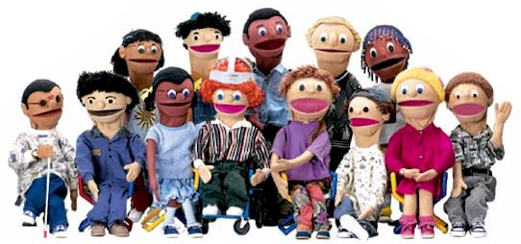

Kids on the Block Regina
1830 MacKay Street
Regina, SK S4N 6R4
306-522-2777
kotbregina@gmail.com
www.reginasexualassaultcentre.ca

