**Lake Central High School**

**ITS Troupe #2536**

**PROUDLY PRESENTS**

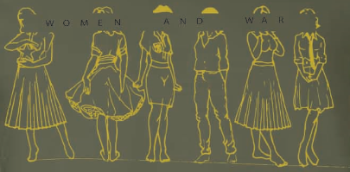

Women and War (One Act)

**By**

**Jack Hilton Cunningham**

“Women and War (One-Act)” is produced by special arrangement with Samuel French, Inc., a Concord Theatricals Company.

**December 16, 2019**

**Lake Central High School Auditorium**

**7 P.M.**

**Tickets: $5 each**