- Step by step for a deal
  - MARKET FOR PROPERTIES
  - RECEIVE LEAD (SQUEEZE PAGES, VIRTUAL ASSISTANT, LIVE ANSWERING SERVICE, PERSONAL )
Use Script SCRIPT (SELLER LEAD)
  - RUN THE NUMBERS
GET COMPS (SITEXDATA.COM)
  - Analyze Deal (Than’s Deal analylzer)
  - CONTACT THE OWNER FOR APPOINTMENT
  - GET REPAIR ESTIMATES
  - MAKE OFFER
  - PROPERTY UNDER CONTRACT (PURCHASE AND SALE AGREEMENT Send to title company or closing attorney)
  - CREATE SCOPE OF WORK (SEE EXAMPLE FROM CLASS)
  - Get Bid for rehab and hire contractor (can happen before or after “K”)
  - Close
  - FUND- Use Hard Money, Private Money, Creative Financing or Bank Financing
  - FIX
HIRE CONTRACTORS (Contractor Interview)
6 CRITICAL DOCUMENTS- Contractor and Subcontractor
- Independent contractor agreement
- Scope of work
- Insurance indemnification form
- Payment Schedule
- W-9
- Lien Waver

  - MARKET FOR BUYERS FROM DATABASE- Use text Blast and/or Email Blast (use wholesale packet)STRATEGY

- Marketing:
Primary
  - Divorce
  - Probate
  - Bankruptcy
  - Free and clear
  - Eviction
  - Out of State Owners
Secondary
  - Craig's List Marketing
  - Online Social Media
  - Bandit Signs
  - MLS offering System
  - News Paper Ads
  - Video Marketing
  - Door Knocking
  - Building Code Violation-Mailers
  - Cash Buyer Leads
  - Private Lender Leads
  - Tired Land Lords Leads
  - Referral Marketing Attorney
  - Mortgage Broker
  - Realtor
  - Appraisers
  - Contractors

- 3 Types of Income
Active: Wholesale and Flips solves money problems Temporarily
Passive: Rentals (residential/commercial) Solves money problem Permanently
Interest: Retirement, Cushion, Legacy
****Flip first for Cash then put into the down payments for passive any cash not being used put into interest income (Hard money funds, Private Money, Tax Lines, Discount notes) and Use a self directed Roth Ira for deals you don’t like wholesale deals.

- Segment Market- https://www.nar.realtor/research-and-statistics/housing-statistics/metropolitan-median-area-prices-and-affordability
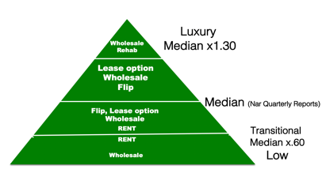
- The Seven:
- Sense-the idea
- Logical-will the idea play out as anticipated
- Profitable-after all expenses
- Ethical-what you believe
- Moral-what you practice
- Legal
- Want to do it

- Funding primary sources:
- Hard Money Lenders:
List of: https://www.scotsmanguide.com/
Residential/Lenders/Hard Money/State/Dollar Amount/Non owner occupied or Legal entity/Property Type-Single Family/Loan Characteristic-Fix-and-Flip
Questions to ask: Points, Interest, Fees, Loan to Value
If they tell you they can’t give you that information unless you have property just tell them I know and we both know to run the numbers and be profitable I need something to plug-in so can I get a ballpark range.

- Community Banks:
https://www.icba.org/
President or Vice President of Commercial Lending
What is needed to qualify for a Commercial Loan – Find one that you feel you get to faster maybe bank there also
Ask What Debt Coverage Ratio (DCR) they want for commercial
What they are loaning on and not loaning on for residential and commercial
Terms and Conditions for those properties
Can you see CRA Book?
- Private Money
  - Find the lender- Create or Current
    - Creating Lender
      - Approach with Look what I learned
      - Show articles for retirement
        - https://www.forbes.com/sites/halahtouryalai/2012/10/23/more-americans-say-80-is-the-new-retirement-age/#2fa103ab43b9
        - https://nypost.com/2013/11/16/80-is-the-new-60-when-it-comes-to-retirement/
      - Show Inflation
        - https://www.cnbc.com/id/42551209#
      - Go to inflation Calculator
        - https://www.vertex42.com/Calculators/inflation-calculator.html
      - Retirement Gamble 25:44
        - https://www.youtube.com/watch?v=ok1S8NHUiX8
    - Current Lenders
      - Download list from list brokers (Google List brokers private money)
      - Send postcard “dude your current investments make you 15% return if not go to www. Whatever the name of your squeeze page is.com
      - Have a CRM
      - Send out mass text message “$xxxxxx needed 15% return sending out to xxxx amount of people)”
      - Remember:
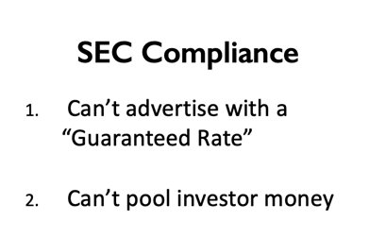

  - Meeting-Terms and Conditions
    - Length of Loan
    - Interest Rate
    - Payment terms
  - Identify property – Send out Mass text message
  - Sign Docs and Close (Attorney Office or Closing Company)
    - Promissory Note- Attorney (Secures)
    - Hazard Insurance Policy-Insurance Agent (Insures)
    - Listed as “Loss Payee”
    - Mortgage Deed or Deed of Trust- Closing Attorney or Title Company (Collateralize)

  - Wholesale or Rehab
  - Pay the lender

- Gap Funding: Options
- Retirement accounts (personal or from others PML)
- Equity Lines of Credit
- Peer-to-Peer Lending (online search)
- Creative Financing (using one of the above to make payments then getting a loan from Hard Money Lender or Bank)
- Owner Financing
- Heloc

- “Getting a Yes” Tool:
Lists
Marketing Collateral
Squeeze pages
Credibility Packets
Power Points
Scripts
Sop
Checklists
Squeeze Pages
Main Website
CRM
Templates

- Loan Packet
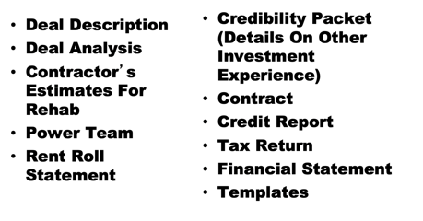

- Definitions:
Gross income- Income before all expenses
Profit- income after all expenses
Cost vs value- cost is what we pay value is our return
Bad debt – you working for money pay debt
Good debt – the asset pays for the debt
Accredited Investor - $1 million net worth or $200,000 single $300,000 married two years in a row
Net worth- Assets minus liabilities
Cash flow- income minus expenses

- Websites from Class:
Click2mail.com – mailing house
Icba.org- List of Community Banks
Scotsmanguide.com -hard money lender search engine
Usa.com-demographic information
Infusionsoft.com- CRM
Sitexdata.com- comparables
Google Drive – storing documents
Drop Box – storing documents
Quarterly Reports:https://www.nar.realtor/research-and-statistics/housing-statistics/metropolitan-median-area-prices-and-affordability

- Formulas for commercial

