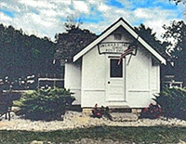
Russells Point Orchard Island post office

open house
sunday, july 10
1:00pm – 5:00pm
The Indian Lake Area Historic Society will host an open house Sunday, July 10, 2016 to rededicate the original Russells Point Orchard Island Post Office. It will be open from 1:00 PM to 5:00 PM.

The Post Office was in operation from 1912 through 1926. The interior has been furnished with period items. The furnishings reflect an actual working post office from that time period at Russells Point.

The Post Office is located on the small park Island between Orchard Island and Wolfe Island. It is ½-mile north of Spend-A-Day Marina.

If you love history, especially local history, you will appreciate seeing this historic landmark.

