`Early Risers

ALL DAY BREAKFAST!

STEAK&EGG …$7.50
2 eggs, seasoned prime rib, prime sauce, aus jus,& potatoes
DENVER ...$6.75
3 eggs, ham, onions, mushrooms, tomato, green pepper, cheddar
FIESTA ...$6.75
2 eggs, black beans, cheddar, onions, salsa, sour cream, avocado (optional: cilantro &jalapeño)

GREEK ...$6.75
3 eggs, bacon, spinach, red onion, feta, tomato

CLASSIC ...$6.75
3 eggs, cheddar cheese, and choice of bacon, sausage, or ham

BAGEL or CROISSANT

Bacon, Egg& Cheese ...$4.75
Ham, Egg &Cheese ...$4.75
Sausage, Egg &Cheese ...$4.75
Egg & Cheese ...$4.00

OTHER STUFF
French Toast ...$4.00
Bagel & Cream Cheese ...$2.50
Hashbrowns ...$2.00
Breakfast Potatoes ...$2.00
Cinnamon Roll ...$3.50
CHIPS & SALSA ...$3.00

New

FISH TACO DINNER ...$8.00
Two grilled fish tacos dressed with salsa, onions, cilantro, and sour cream
served with your choice of coleslaw or amish potato
salad

Quesadillas
Served with sides of salsa & sour cream

CHEESE ...$5.75
white cheddar cheese, onions
(add chicken or taco meat for $1.00)

Nachos
CHEESE ...$5.75
blue corn chips, cheese, black beans, salsa, onions
(add chicken or taco meat for $1.00)

Proudly serving
– freshly roasted in Milwaukee, Wisconsin!

We would love to cater your next event! Call us for details!

Find Us Online!

www.wrapitupmanitowoc.com

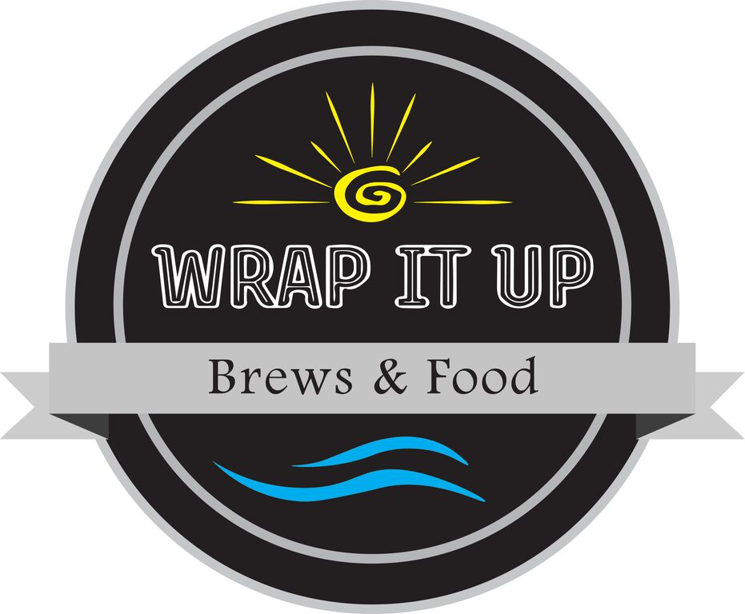

M-TU: 7:00AM – 7:00PM
WED-SA 7.00AM – 8.00PM
SUN: 9:00AM – 5:00PM

At Wrap It Up, our mission is to serve you delicious, healthy, and innovative food in an inviting atmosphere. Our menu consists of a variety of entrees that include the highest quality ingredients with a local emphasis, made with care by our friendly staff.

Randy & Barb Lueptow

920-242-6445
Paninis
Served on your choice bread:
White, Whole Wheat, Naan or Focaccia
(Gluten free available for $1.00)

CHEDDAR BACON BRAT ...$6.00
ketchup, mustard, and onion

TEXAS RANCH CHICKEN ...$6.00
fired up chicken, pepperjack cheese, red onion

TURKEY PANINI ...$6.50
turkey, bacon, lettuce, mayo, and cheddar

HAM AND SWISS ...$6.00
ham, swiss cheese, and spicy brown mustard

B.L.T. ...$6.00
applewood bacon, lettuce, tomato, and mayo

TUNA MELT ...$6.00
jazzed up tuna, and cheddar cheese

PRIME RIB {as a wrap add $1} ...$7.00
Shaved seasoned prime rib, prime sauce, aus jus,

GRILLED CHEESE ...$4.50
sharp white cheddar cheese

Cold Wraps

Served on your choice of tortilla:
White, Whole Wheat, Tomato Basil, or Spinach

B.L.A.T ...$7.00
bacon, lettuce, tomato, mayo, avocado

CHICKEN CAESAR ...$7.00
chicken, lettuce, parmesan cheese, caesar dressing

CHICKEN BACON RANCH ...$7.00
chicken, lettuce, bacon, ranch dressing, cheddar

TUNA ...$7.00
jazzed up tuna fish, lettuce

SPICY VEGGIE ...$7.00
Pepperjack cheese, spinach, tomato, black beans, mushrooms, avocado, and jalapeno

SPINACH & FETA CHEESE ...$7.00
spinach blend, red onion, green peppers, cucumber, tomato, feta & Homemade Greek Dressing.

TACO SALAD ...$7.00
lettuce, black beans, taco meat, cheddar, onions, salsa, sour cream, blue corn tortilla chips

Hot Wraps

Served on your choice of tortilla:
White, Tomato Basil, or Spinach

LOADED BURRITO ...$6.00
black beans, cheddar, onions, brown rice, sour cream, lettuce , salsa (add chicken or taco meat for $1.00)
TERIYAKI CHICKEN ...$7.00
choice of meat, jasmine rice, veggie blend &teriyaki
SAUTEED VEGGIE ...$7.00
jasmine rice, sautéed onions, mushrooms, broccoli, zucchini, carrots

HULI HULI …$7.00
jasmine rice, chicken, pineapple,
sweet Hawaiian sauce
CHEESEBURGER ...$7.00
seasoned beef, tomato, cheese, onions, pickles, mayo, lettuce, ketchup

BUFFALO CHICKEN ...$7.00
lettuce, bleu cheese, choice of mild or wild sauce
TEXAS RANCH ...$7.00
fired up chicken, lettuce, red onion, pepperjack cheese

BAKED COD ...$7.00
battered cod, jazzed tartar, lettuce
JERK CHICKEN ...$7.50 tropical habanero sauce, pepperjack cheese, red onion, romaine lettuce, and pineapple

