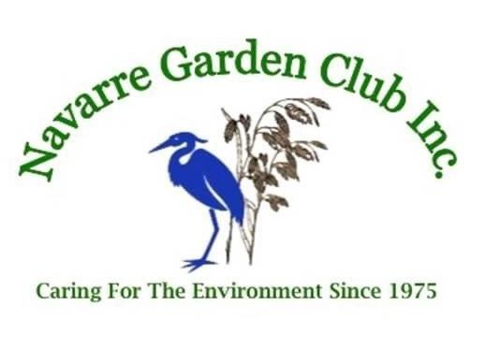 Membership & Renewal Application
Name:______________________________________________________________________
Address :__________________________________________City_______________________
Phone: Cell # Home #________________________________
Email Address:________________________________________________________________
Birthday (Month/Day) _______________________/____________
Interest and Expertise:__________________________________________________________________
__________________________________________________________________________________________________________________________________________________________________________
Please indicate your Volunteer interest: (Chair will contact you about your level of involvement)
Community Service: ____ Civic Development ____Scholarship Committee
____Thanksgiving Centerpiece Workshop
Education: ____ Craft Workshops (making items) ____Environmental ____Floral Design
_____Flower Show ____ Horticulture Workshops ____Junior Garden Club Activities
Administrative: ____Advertising/Promotion ____Social Committee (Teas, Parties, Luncheons)
____Sunshine (card sending) ____Yearbook (members Handbook) ____Membership (enrollment)
____Finance (budget)
Fundraising: _____Green Thumb (Plant Sale) _____Spring Fling _____Santa’s Workshop
_____Ways & Means (selling crafted items)
Annual Dues: $30.00 single / $50.00 couple Make checks payable to:
Navarre Garden Club, Inc.
P.O. Box 5606
Navarre, FL 32566
Amount enclosed__________________ Date_____________________
D D / M M / Y Y Y Y

