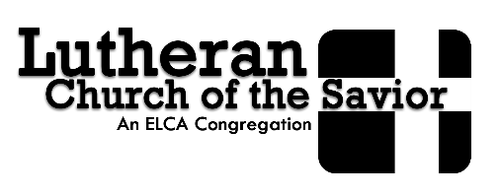

Lutheran Church of the Savior located at 3616 E ‘G’ Avenue, Kalamazoo invites you to attend:

Day Camp - June 22 to June 26, 2020 from 9am to 3pm.
Day Camp is an opportunity for your child to engage the gospel daily in ways that are educational, transformative, and exciting.

Presented By - Living Water Ministries
An energetic staff of young adults trained by Living Water Ministries, delivers a fun, community centered program focused on sharing God’s love and forgiveness to youth ages 5-12.

Partnered With - African Christian Fellowship Church
Founded and led by Congolese Christians, African Christian Fellowship strengthens African Families and their ties to the Kalamazoo community through vibrant worship and community support.

This Year’s Theme - “This is Our Prayer”
Through this theme we will explore our own hearts, and the heart of faith through prayer, games, crafts, music, songs, and fellowship with others!

How to Register and Questions – It’s FREE (snack and lunch provided as well)
Please complete attached paperwork and return to Lutheran Church of the Savior (3616 E ‘G’ Avenue, Kalamazoo, MI 49004). Any questions or concerns contact: Jill LeBeau at 269-342-0069 or email at lcoskalamazoo@gmail.com.

Deadline to Ensure Spot - June 9, 2020 (if spots available may register up until day of Camp).

